Wishing you all a very peaceful and Blessed Christmas and New Year. Do try and join us as we celebrate the birth of Jesus Christ.

For further details of Christmas services or any other
Church activities please contact :

Vicar : Rev. Hugh Lervy
Tel : 771329
Mobile : 07976 725644
email: thevicar@fsmail.net
Parish website: www.stdavidsmorriston.co.uk
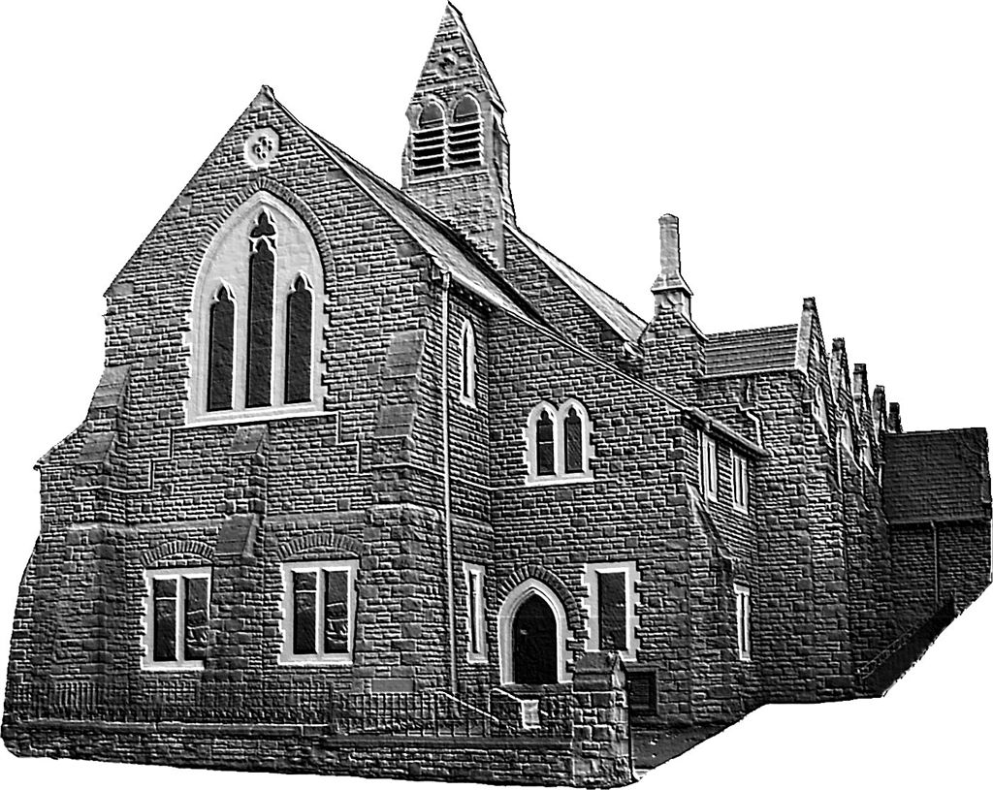
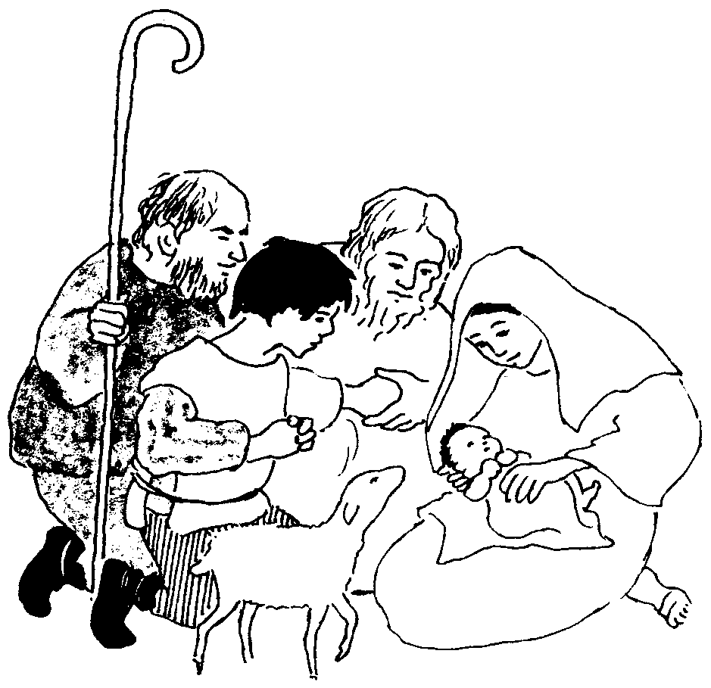
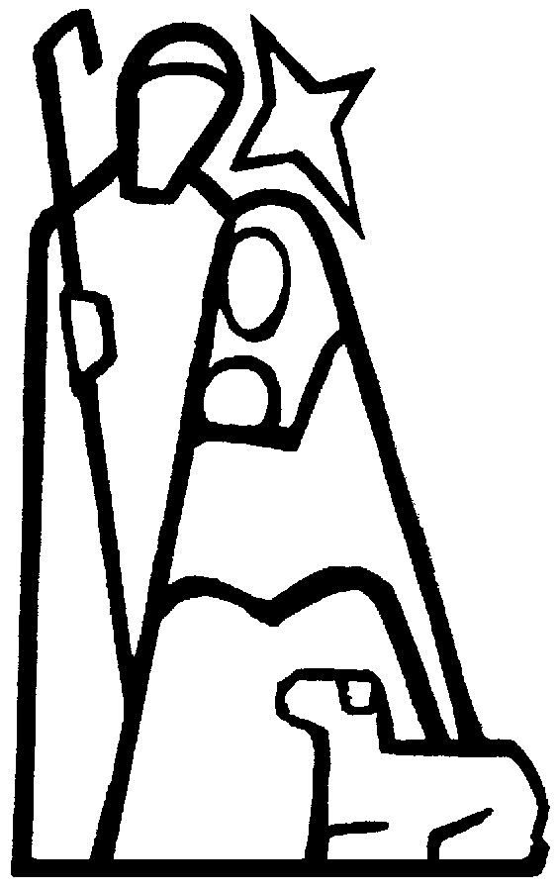
Where you will find our weekly Church bulletin with
Christmas Services 2009
details of all church groups and activities.
Parish of Morriston
Registered Charity 1131686
www.churchinwales.org.uk

St. David’s Church

Woodfield Street

All this took place to fulfil what the Lord had spoken by the prophet: ‘Behold, a virgin shall conceive and bear a son, and his name shall be called Emmanuel (which means God with us)’
St. Matthew’s Gospel
The First Christmas

( as written in St. Luke’s Gospel Account )

And there were shepherds living out in the fields near by, keeping watch over their flocks by night. An angel of the Lord appeared to them, and the glory of the Lord shone around them, and they were terrified. But the Angel said to them, “Do not be afraid. I bring you good news of great joy that will be for all people. Today in the town of David a Saviour has been born to you; he is Christ the Lord. This will be a sign to you: You will find a baby wrapped in clothes and lying in a manger.”

Suddenly a great company of the heavenly host appeared with the angel, praising God and saying:

GLORY TO GOD IN THE HIGHEST, AND ON EARTH
PEACE TO PEOPLE ON WHOM HIS FAVOUR RESTS.

When the angels had left them and gone into heaven, the shepherds said to one another, “Let us go to Bethlehem and see this thing that has happened, which the Lord has told us about.”

So they hurried off and found Mary and Joseph, and the Baby, who was lying in a manger. When they had seen him, they spread the word concerning what had been told them about this child, and all who heard it were amazed at what the shepherds said to them. But Mary treasured up all these things and pondered them in her heart. The shepherds returned, glorifying and praising God for all the things they had heard and seen, which were just as they had been told.

A prayer for Christmas

God our Father, whose Word has come among us in the Holy Child
of Bethlehem: may the light of faith lighten our hearts
and shine in all our words and deeds;
through him who is Christ the Lord. Amen.

Christmas Services 2009

All services and activities will take place in

St. David’s Church and all are welcome to join us.

SUNDAY 29th NOVEMBER
6 p.m. Advent Service of hymns and readings

FRIDAY 4th DECEMBER
4.30 pm Switching on of TREE OF LIGHT and
Carol singing around the tree

5.00 pm Christmas Fete ( in the church crypt)
including Santa’s Grotto !

SATURDAY 12th DECEMBER
11 a.m. Council of Churches Carol singing
in grounds of St. David’s

SUNDAY 13th DECEMBER
6 p.m. Service of Christmas Praise
( with the Salvation Army band and songsters )

TUESDAY 16th DECEMBER
7 p.m. ABM Hospital Trust Carol Service for the Bereaved

SATURDAY 19th DECEMBER
10 a.m. – 12 midday CHRISTMAS CRAFT MORNING
All children welcome. There is no charge.

SUNDAY 20th DECEMBER
4 p.m. CHRISTINGLE SERVICE AND NATIVITY PLAY

THURSDAY 24th DECEMBER ( CHRISTMAS EVE )
6.30 p.m. FAMILY EUCHARIST
11.30 p.m. SUNG EUCHARIST (Midnight Mass)

FRIDAY 25th DECEMBER ( CHRISTMAS DAY )
10.00 a.m. Holy Eucharist ( ½ hour service )

SUNDAY 27th DECEMBER
9.30 am Parish Eucharist

