Parish of Morriston Weekly Bulletin
St. David’s Church
www.churchinwales.org.uk
www.stdavidsmorriston.co.uk
Registered Charity : 1131686
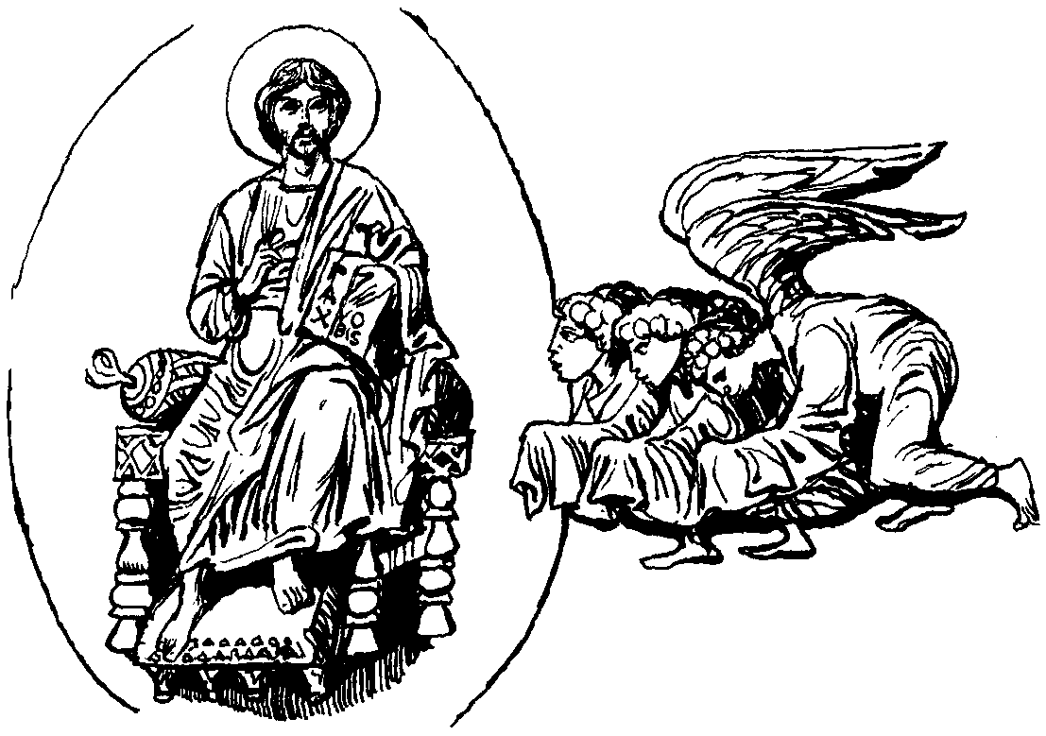

Vicar : Rev. Hugh Lervy

Tel. : (01792) 771329

Mobile : 07976 725644

e-mail : thevicar@fsmail.net

Would you please let the Vicar know of people who
need visiting at home or in hospital. Thankyou

22nd November 2009

Today is the feast of Christ the King ( Kingdom 4 – the Sunday before Advent )

Hymns at Eucharist : 12 , 436 , 551 , ( 195 , 438 , 580 ) , 644

TODAY 9.30 am Parish Eucharist with Sunday School

11.15 am Cymun Bendigaid

6.00 pm Evensong

MONDAY 10.00 am Parent and Toddler group

TUESDAY 2.00 pm Mother’s Union. Speaker : Anne Jackson on :
Favourite Graces

WEDNESDAY 7.00 pm Bible Study Group at 2 Mynydd Garnlwyd Rd.
- every fortnight – please ask for details

THURSDAY 10.30 am Holy Eucharist
Followed by refreshments in the crypt
6.00 pm Youth Club for school years 4,5,6 ( Crypt )
6.00 pm Clergy Surgery for booking of baptisms, banns and
weddings etc. No appointments necessary.

FRIDAY 10.00 am Prayer Fellowship ( crypt ) – all welcome

NEXT SUNDAY Advent 1
Readings : Jer. 33:14-16, 1 Thes. 3:9-13 , Lk. 21:25-36
9.30 am Parish Eucharist with Sunday School
6.00 pm ADVENT SERVICE OF HYMNS , READINGS , PRAYER AND REFLECTION – DO TRY AND JOIN US.

Thankyou : to Diane Richardson who organised the trip to Worcester yesterday. We hope you all enjoyed.

Santa Trip: This year we will be visiting Santa at the Gower Heritage Centre on Sunday 6th December. The children are being paid for by
the Church and one adult per child will be admitted free. The coach will leave the Church at 12.30 p.m. and return at approx 4.30 p.m. Please give your names a.s.a.p to Diane Richardson.

Parish New Year Meal and entertainment : Friday 8th January 2010 in THE OLD BARN (behind the Hospital) 7 for 7.30 p.m. All are welcome ( do invite family and friends to join us ) : the cost is £12 per head. Starters : soup or melon. Main course : Turkey / Beef or Vegetarian. Desert : Christmas Pudding or Fudge Cake. Please sign the list as soon as you can with the choice of your food.

Christmas Fete : will take place on Friday 4th December from 5 p.m. We are collecting items for the stalls ( tins, toiletries , craft items etc. BUT NOT WHITE ELEPHANT PLEASE). Items for the fete can be brought to church. Further details in the next few weeks. Raffle tickets for the fete are now available and help to sell them would be appreciated. The tree of light will also be switched on Friday 4th December at 4.30 p.m. For those wishing to sponsor bulbs in memory of loved ones forms are now available at the back of church.

Swansea Philharmonic Choir : a concert celebrating the works performed by the choir during 50 years of music making. In the Brangwyn Hall on Saturday 5th December at 7.30 p.m. ( tickets are £15 , £12 , £10 ). Please ring Eira on 528322 for tickets / details or the Grand Theatre Box Office on 475715

Christmas Praise Service : with the Salvation Army joining us on Sunday 13th December at 6 p.m.

Christmas Craft Morning : for all children on Saturday 19th December from 10 a.m. to Midday. If you can help out please speak to Diane Richardson. Thanks.

Christmas CD : Gordon Morgan has kindly produced copies of his Christmas CD for us again this year. They are available at £3 each and sales are in aid of our church funds.

Advent and Christmas Service leaflets : are now available. Please take as many copies as you will be able to distribute to family , friends , neighbours. etc. Thankyou.

