Parish of Morriston Weekly Bulletin
St. David’s Church
www.churchinwales.org.uk
www.stdavidsmorriston.co.uk
Registered Charity : 1131686
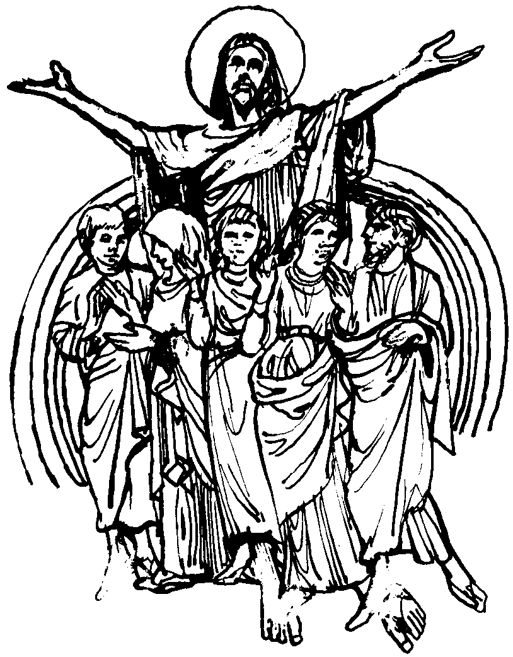

Vicar : Rev. Hugh Lervy

Tel. : (01792) 771329

Mobile : 07976 725644

e-mail : thevicar@fsmail.net

Would you please let the Vicar know of people who
need visiting at home or in hospital. Thankyou

1st November 2009 Today is All Saints’ Day

Hymns at Eucharist : 551 , 314, 754 , ( 686 , 384 , 506 ) , 398

TODAY 9.30 am Parish Eucharist with Sunday School
Followed by Refreshments – all welcome 2.30 pm
2.30 pm City and County of Swansea Annual Service of
Remembrance of the departed ( Crematorium
Chapel ) – all are welcome to attend.
4.30 pm PCC Meeting
6.00 pm Holy Eucharist

MONDAY 10.00 am Parent and Toddler group
10.30 am All Souls’ Day Holy Eucharist
7.30 pm Evening M.U. : Speaker : John Yardley
“Antiques Fayre”

TUESDAY 2.00 pm Mother’s Union. Speaker : Dr. Penny Sartori
on Near Death Experiences
6.30 pm Men’s Society ( Welcome Inn )

WEDNESDAY 7.00 pm Bible Study Group at 2 Mynydd Garnlwyd Rd.
- every fortnight – please ask for details

THURSDAY 10.30 am Holy Eucharist
Followed by refreshments in the crypt
6.00 pm Youth Club for school years 4,5,6 ( Crypt )
6.00 pm Clergy Surgery for booking of baptisms, banns and
weddings etc. No appointments necessary.
7.00 pm Holy Eucharist

NEXT SUNDAY REMEMBRANCE SUNDAY
Readings : Jon. 5:1-5,10, Heb. 9:24-28 , Mk. 1:14-20
9.30 am Parish Eucharist with Sunday School
11.15 am Cymun Bendigaid
6.00 pm Evensong

All Souls’ Day Eucharist : tomorrow at 10.30 a.m. during we which remember all the departed. For those you wish to remember by name please add their names to the list near the door. Do try and join us for our service as we share these prayers together.

Remembrance Sunday : acts of remembrance will take place during our morning services next Sunday.

Charity Coffee morning : in aid of Age Concern will be held on Thursday 12th November at 11 a.m. Tickets are £1 and are now available. Help to sell them would be appreciated.

Christmas Fete : will take place on Friday 4th December from 5 p.m. We are collecting items for the stalls ( tins, toiletries , craft items etc.). Items for the fete can be brought to church. Further details in the next few weeks. Raffle tickets for the fete are now available and help to sell them would be appreciated. The tree of light will also be switched on Friday 4th December. For those wishing to sponsor bulbs in memory of loved ones forms will be available soon.

Traidcraft : the Christmas catalogue is now available on the table at the back of church. If you wish to place any orders form the catalogue please speak to Joan Lewis.

Meeting regarding “Safeguarding”/Child Protection: a Diocesan meeting for all involved in working with young people and vulnerable adults on Thursday 19th November in St. Illtyd’s Church, Fforestfach at 7 p.m.

Visiting: can I remind you to please continue to let me know of those in need of visiting. We have many people who are ill with the various seasonal bugs , there are also many who are away on holidays at this time. This makes it difficult to keep track of where people are and who needs to be visited. Your help in keeping in touch with those are missing is greatly appreciated and I am grateful for all who let me know of those who need to be seen – and of course when you are able we are always glad to see you in church !! Your understanding that there that there is a limit to how many visits can be done in a week is also appreciated !.

Swine Flu : As a precaution you have the option to receive the bread and wine as usual with the chalice, or to receive just the bread. The Bread should not be dipped into the wine.

