Parish of Morriston Weekly Bulletin
St. David’s Church
www.churchinwales.org.uk
www.stdavidsmorriston.co.uk
Registered Charity : 1131686
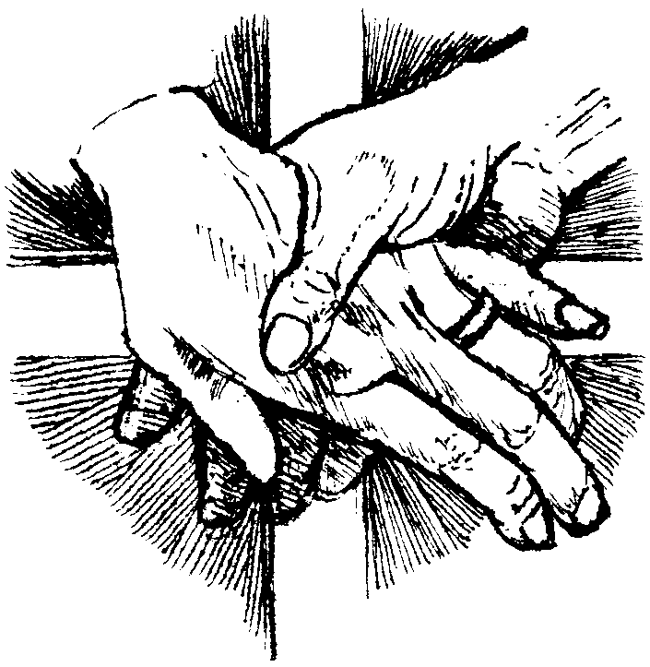

Vicar : Rev. Hugh Lervy

Tel. : (01792) 771329

Mobile : 07976 725644

e-mail : thevicar@fsmail.net

Would you please let the Vicar know of people who
need visiting at home or in hospital. Thankyou

11th October 2009

Today is the eighteenth Sunday after Trinity

Hymns at Eucharist : 756 , 66 , 691 , ( 70 , 29 , 374 ) , 727

TODAY 9.30 am Parish Eucharist with Sunday School
11.15 am Cymun Bendigaid
2.00 pm Baptism
3.00 pm Baptism
6.00 pm Parish Evensong
6.00 pm Deanery Gymanfa Ganu at Ystalyfera
– all are welcome

MONDAY 10.00 am Parent and Toddler group

TUESDAY 2.00 pm Mother’s Union. Speaker : Mrs Ruth Clancy

WEDNESDAY 7.00 pm Bible Study Group at 2 Mynydd Garnlwyd Rd.
- every fortnight – please ask for details

THURSDAY 10.30 am Holy Eucharist
Followed by refreshments in the crypt
6.00 pm Youth Club for school years 4,5,6 ( Crypt )
6.00 pm Clergy Surgery for booking of baptisms, banns and
weddings etc. No appointments necessary.

FRIDAY 10.15 am Diocesan Clergy Synod Day ( Brecon )

NEXT SUNDAY Luke the Evangelist
Readings : Is. 35:3-6 , 2 Tim. 4:517 , Lk. 10:1-9
9.30 am Parish Eucharist with Sunday School
2.00 pm Deanery Children’s event at
Cwmrhydyceirw School
6.00 pm Evensong

PARISH NOTES

Thankyou : to all who worked so hard to prepare our Church and Harvest lunch last Sunday – it was very much enjoyed. Thankyou to our Sunday School who led our morning worship. Thankyou to all who gave gifts and donations for our charities helping the Swansea homeless and the charity Self-help Africa.

Disaster Box : following the tragic Tsunami in Asia last week we have sent a donation from our Disaster fund to Oxfam to assist with the relief work taking place. If you wish to place a further donation in the disaster box for this cause they will be sent as soon as we can.

200 Club : subscriptions of £20 are now being collected for those who wish to join for the coming year which should be paid THIS WEEK if you wish to be included. All family and friends are also welcome to join.

PCC Meeting : Sunday 1st November at 4.30 p.m.

Parish Shopping Trip to Worcester : Saturday 21st November and the cost is £10:00. A deposit of £5:00 is payable as soon as possible. We will leave Morriston at 8:30a.m. and leave Worcester at 5:30p.m. All enquiries to Diane Richardson Tel: 517606.

All Soul’s Service : Holy Eucharist will be celebrated at 10.30 on Monday 2nd November. If you wish any of the departed to be remembered by name please add their name to the list at the back of church.

Best Wishes : to Preb. And Mrs. Basil Jenkyns who are moving to a new home in Norfolk next week to be closer to their family. We thank them for all they have brought to our church family in Morriston and wish them well for their move.

Swine Flu: the Bishop has now given permission for the chalice to be used again. You have the option to receive the bread and wine as usual with the chalice, or to receive just the bread. The Bread should not be dipped into the wine.

Church Giving : Father O'Malley answers the phone. 'Hello, is this Father O'Malley?' 'It is!' 'This is the Inland Revenue. Can you help us?' 'I can!' 'Do you know a Ted Houlihan?' 'I do!' 'Is he a member of your congregation?' 'He is!' 'Did he donate £10,000 to the church?' 'He will.'

