Parish of Morriston Weekly Bulletin
St. David’s Church
www.churchinwales.org.uk
www.stdavidsmorriston.co.uk
Registered Charity : 1131686
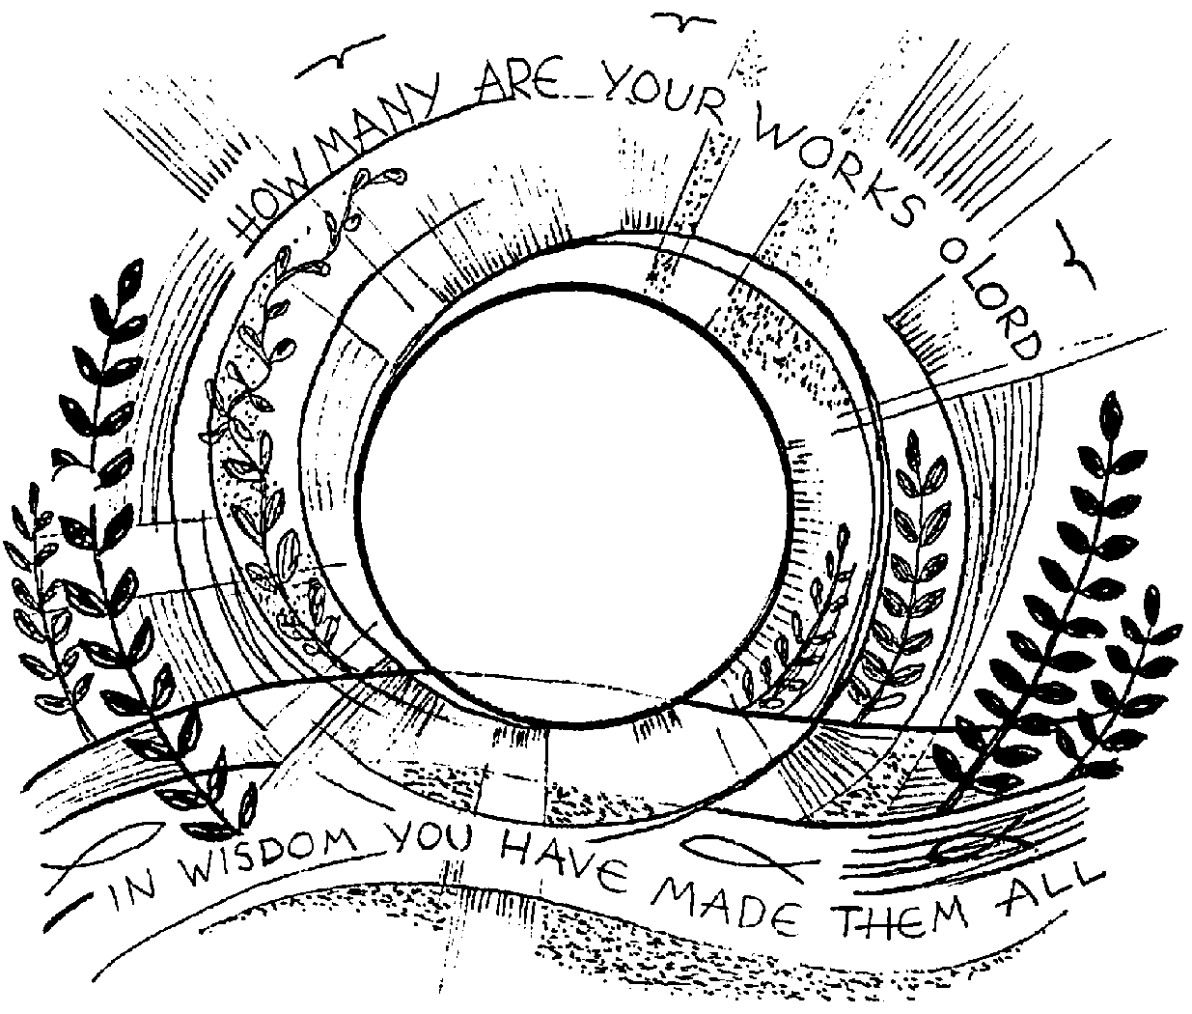

Vicar : Rev. Hugh Lervy

Tel. : (01792) 771329

Mobile : 07976 725644

e-mail : thevicar@fsmail.net

Would you please let the Vicar know of people who
need visiting at home or in hospital. Thankyou

4th October 2009 Today is the Seventeenth Sunday after Trinity
( Harvest Festival )

Hymns at Eucharist : 558 , 804 , 900 , ( 559 , 566 , 890 ) , 525

Evensong : 133 , 719 , 696 , 474 Psalm 67 BCP p. 530

TODAY 10.00 am Family Eucharist led by our Sunday School

Followed by refreshments at the back of church

and then Harvest lunch in the crypt.

6.00 pm Harvest Evensong

Guest Preacher : Canon Rowland Edwards

MONDAY 10.00 am Parent and Toddler group
7.30 pm Evening M.U. : Speaker : Jill Lewis on
“Prison Experience”
7.30 pm Council of Church Harvest Service at Tabernacle

TUESDAY 2.00 pm Mother’s Union
6.30 pm Men’s Society at the Welcome Inn :
Speaker : Archdeacon Robert Williams

WEDNESDAY 2.30 pm Diocesan Clergy Meeting ( Brecon )
7.00 pm Bible Study Group at 2 Mynydd Garnlwyd Rd.
- every fortnight – please ask for details
7.00 pm Mother’s Union Deanery Festival ( Ystradgynlais)

THURSDAY 10.30 am Holy Eucharist
Followed by refreshments in the crypt
6.00 pm Church Grounds working party
6.00 pm Youth Club for school years 4,5,6 ( Crypt )
6.00 pm Clergy Surgery for booking of baptisms, banns and
weddings etc. No appointments necessary.

FRIDAY 10.00 am Morriston Primary School Church visit

SATURDAY 10.00 am Diocesan Conference ( Brecon Cathedral )
NEXT SUNDAY Readings : Amos 5:6-15, Heb. 4:12-16 , Mk. 10:17-31
9.30 am Parish Eucharist with Sunday School
11.15 am Cymun Bendigaid
2.00 pm Baptism
3.00 pm Baptism
6.00 pm Parish Evensong
6.00 pm Deanery Gymanfa Ganu at Ystalyfera – all are welcome

WELCOME : to all who join us for our Harvest Festival Services today.

200 Club : subscriptions of £20 are now being collected for those who wish to join for the coming year which should be paid as soon as you can if you wish to be included. All family and friends are also welcome to join. The first draw of the new year will be in October. Congratulations to September’s winners : no. 122 Sian Popham , no. 120 Nessie Isaac , no. 125 John Richardson.

PCC Meeting : Sunday 1st November at 4.30 p.m.

Thankyou : to all who have helped on the rota to keep our church open each day throughout the summer as we enable any who wish to come in for quietness and prayer. The scheme now stops until March 2010 . Thankyou to John Richardson who co-ordinates the volunteer list.

Deanery Children’s Day : Sunday 18th October from 2 p.m. to 4.30 p.m. in Cwmrhydyceirw Junior School. All young people are very welcome. Please speak to Diane on 517606 for details.

Working Party : if you can help on Thursday evening it would be good to see you as we pick up the leaves and rubbish from around our grounds.

Charity Number : our parish is now a registered charity ( as required by the Charity Act ). Our number is 1131686.

Parish Shopping Trip to Worcester : Saturday 21st November and the cost is £10:00. A deposit of £5:00 is payable as soon as possible. We will leave Morriston at 8:30a.m. and leave Worcester at 5:30p.m. All enquiries to Diane Richardson Tel: 517606.

Swine Flu: the Bishop has now given permission for the chalice to be used again. You have the option to receive the bread and wine as usual with the chalice, or to receive just the bread. The Bread should not be dipped into the wine.

Wrong door : A Catholic guy goes into the confessional. He notices on one side a fully equipped bar with Guinness on tap. On the other wall is a dazzling array of the finest Cuban cigars. Then the priest comes in. "Father, forgive me, for it's been a very long time since I've been to confession, but I must first admit that the confessional box is much more inviting these days." The priest replies "Get out. You're on my side."

