Parish of Morriston
St. David’s Church
Weekly Bulletin
www.churchinwales.org.uk
www.stdavidsmorriston.co.uk
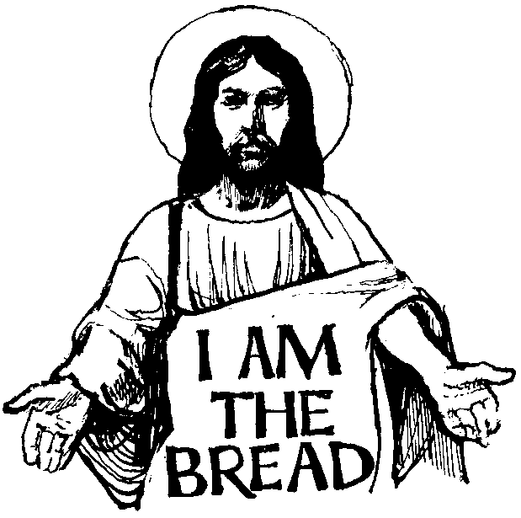

Vicar : Rev. Hugh Lervy

Tel. / Fax. : (01792) 771329

Mobile : 07976 725644

e-mail : thevicar@fsmail.net

Curate:
Rev. Edwin Phillips
(01639) 886784

Would you please let the Vicar know of people who
need visiting at home or in hospital. Thankyou
The Church is open Monday to Friday from 10 a.m. to 12 midday for quiet prayer. Please feel free to come in at any time.

2nd August 2009

Today is the eighth Sunday after Trinity

Hymns at Eucharist : 163 , 166 , 381 , ( 87 , 540 , 926 ) , 299

TODAY 9.30 am Parish Eucharist Followed by refreshments –

all welcome to stay

6.00 pm Holy Eucharist

MONDAY 10.00 am Parent and Toddler group and Sunday School trip
to Folly Farm. The bus leaves the Red Lion Car
Park at 10 a.m. and leaves Folly Farm for return
journey at 3.30 p.m.

WEDNESDAY 7.00 pm Bible Study Group at 2 Mynydd Garnlwyd Rd.
- every fortnight – please ask for details

THURSDAY 10.30 am Holy Eucharist
Followed by refreshments in the crypt
6.00 pm Clergy Surgery for booking of baptisms, banns and
weddings etc. No appointments necessary.
7.00 pm Holy Eucharist

NEXT SUNDAY Readings : 1 Kings 19:4-8, Eph. 4:25-5:2, Jn. 6:35
9.30 am Parish Eucharist
11.15 am Cymun Bendigaid
6.00 pm Evensong

Precautionary Action regarding Swine Flu : In response to a letter issued by the Archbishop of Canterbury and advice on the Church in Wales website we will not be sharing the chalice at our Eucharist services. This is purely a precautionary measure and should not cause alarm. This advice has been issued following consultation between the Government and faith communities aimed at reducing risk. The communion bread will be received in the usual way. For full details of this advice please see the Church in Wales website where you will also find further links to documents on this matter.

200 Club winners July 2009 : 1st no. 81 Ada Blackmore , 2nd no. 52 Meuryl Lewis , 3rd no. 69 Molly Caton. Congratulations to this month’s winners.
Mother’s Union Wave of Prayer : will take place on Saturday 22nd August from 2 – 3 p.m. All are welcome to join Mother’s Union members for this time of prayer.
Bishop’s visit : Bishop John will be joining us in St. David’s as the preacher and celebrant on the 6th September. The service that morning will begin at 10 a.m.

CONCERT : PLEASE GIVE YOUR FULL SUPPORT : on SUNDAY 6th September at 7.30 p.m. a concert will be given by Richard, James and Jonathan Mainwaring, the Belmont Singers and the guest compere for the evening will be Jamie Owen ( BBC Wales Today ). This is in aid of the Wales Air Ambulance. Tickets are £5. PLEASE SELL TICKETS AS WIDELY AS YOU CAN AND DO MAKE EVERY EFFORT TO JOIN US FOR THIS CONCERT. THANKYOU.

Holidays : we wish all those going away on holiday at this time a relaxing break and welcome any who worship with us while staying in this area. Don’t forget to let the Vicar know of visits needed – it is very difficult to keep tracks of who is where at this time of the year !!

Brown Paper Pete : A cowboy walked into a bar and ordered a whisky. When the bartender delivered the drink, the cowboy asked, "Where is everybody?" The bartender replied, "They've gone to the hanging." "Hanging? Who are they hanging?" "Brown Paper Pete," the bartender replied. "What kind of a name is that?" the cowboy asked. "Well," said the bartender, "he wears a brown paper hat, brown paper shirt, brown paper trousers, and brown paper shoes." "How bizarre," said the cowboy. "What are they hanging him for?" "Rustling," said the bartender.

