Parish of Morriston
St. David’s Church
Weekly Bulletin
www.churchinwales.org.uk
www.stdavidsmorriston.co.uk
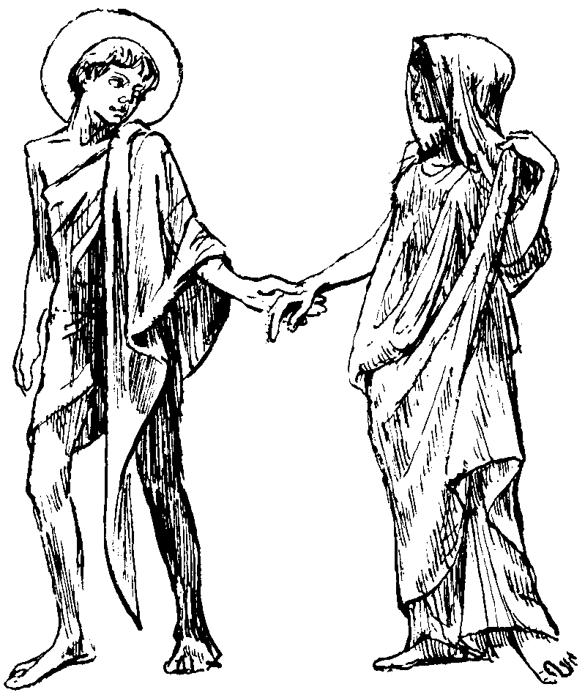

Vicar : Rev. Hugh Lervy

Tel. / Fax. : (01792) 771329

Mobile : 07976 725644

e-mail : thevicar@fsmail.net

Curate:
Rev. Edwin Phillips
(01639) 886784

Would you please let the Vicar know of people who
need visiting at home or in hospital. Thankyou
The Church is open Monday to Friday from 10 a.m. to 12 midday for quiet prayer. Please feel free to come in at any time.

28th June 2009

Today is the third Sunday after Trinity

Hymns at Eucharist : 467 , 167 , 249 , ( 625 , 315 , 368 ) , 683

TODAY 9.30 am Parish Eucharist with Sunday School

11.15 am Cymun Bendigaid

5.00 pm Youth Service and Youth Club

6.00 pm Evensong

MONDAY 9.45 am Clergy Chapter Meeting at Ystalyfera
10.00 am Parent and Toddler group

TUESDAY 2.00 pm Mother’s Union

WEDNESDAY 7.00 pm Bible Study Group at 2 Mynydd Garnlwyd Rd.
- every fortnight – please ask for details

THURSDAY 10.30 am Holy Eucharist
Followed by refreshments in the crypt
1.30 pm Graig School Church visit
6.00 pm Youth Club for school years 4,5,6 ( Crypt )
6.00 pm Clergy Surgery for booking of baptisms, banns and
weddings etc. No appointments necessary.
7.00 pm Holy Eucharist

FRIDAY 7.00 pm Diocesan Conference ( Brecon Cathedral)

SATURDAY 3.00 pm Friends of the Cathedral AGM ( Brecon )

NEXT SUNDAY Readings : Ez. 2:1-5 , 2 Cor. 12 :2-10 , Mk. 6:1-13 9.30 am Family Eucharist with Sunday School
Presentation. Followed by refreshments.
4.30 pm PCC Meeting
6.00 pm Holy Eucharist

PARISH NOTES

RIP : it was with great sadness we learnt last week that Rae Evans had passed away so suddenly. We commend Rae’s soul to God’s keeping and offer our condolences and prayers for Rae’s family at this time.

Thankyou : to all who have joined the Friends of Brecon Cathedral for the coming year. £606 has been sent from the Parish. Thankyou to Meuryl who co-ordinated this collection.

Folly Farm Trip : for our Parent and Toddler Group and for our Sunday School members of Monday 3rd August. Please speak to Lawrence or Sunday School teachers with numbers attending as soon as possible. If there are places left on the bus they will be available for other church members and their families who wish to join us.

Royal Welsh Show Trip : on Wednesday 22nd July. Prices for entrance tickets and coach are as follows Adult £28 Child £9. This is a lovely day out and has been enjoyed by many in the past. Please could you give your names and £5 deposit to Diane Richardson(Tel. 517606) as soon as possible. WE NEED MORE NAMES TO BE ABLE TO RUN THIS TRIP !!

CONCERT : PLEASE GIVE YOUR FULL SUPPORT : on SUNDAY 6th September at 7.30 p.m. a concert will be given by Richard, James and Jonathan Mainwaring, the Belmont Singers and the guest compere for the evening will be Jamie Owen ( BBC Wales Today ). This is in aid of the Wales Air Ambulance. Tickets are £5. PLEASE SELL TICKETS AS WIDELY AS YOU CAN AND DO MAKE EVERY EFFORT TO JOIN US FOR THIS CONCERT. THANKYOU.

Open House Coffee Mornings : over the last few years members have kindly opened their homes to us for a coffee morning to enable us to come together in fellowship. If you would be prepared to host one of these mornings in July or August we would be pleased to hear from you. Please speak to Meuryl Lewis ( 775895 ) who is co-ordinating the dates.

Social Coffee Mornings : The first will take place at Nan Morris’ home on Saturday 11th July – tickets now available.

