Parish of Morriston
St. David’s Church
Weekly Bulletin
www.churchinwales.org.uk
www.stdavidsmorriston.co.uk
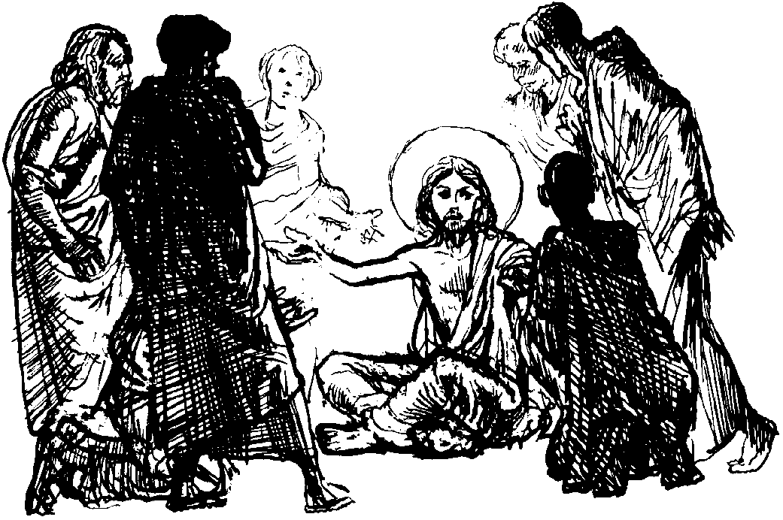

Vicar : Rev. Hugh Lervy

Tel. / Fax. : (01792) 771329

Mobile : 07976 725644

email : thevicar@fsmail.net

Curate:
Rev. Edwin Phillips
(01639) 886784

Would you please let the Vicar know of people who
need visiting at home or in hospital. Thankyou
The Church is open Monday to Friday from 10 a.m. to 12 midday for quiet prayer. Please feel free to come in at any time.

26th April 2009

Today is the third Sunday of Easter

Hymns at Eucharist : 19 , 67 , 716 , ( 241 , 72 , 365 ) , 358

TODAY 9.30 am Parish Eucharist with Sunday School

Followed by our annual Parish Meeting

11.15 am Cymun Bendigaid

6.00 pm Evening Worship

MONDAY 9.45 am Clergy Chapter Meeting ( Llangyfelach )
10.00 am Parent and Toddler group

TUESDAY 2.00 pm Mother’s Union talk on Lliw Valley Women’s Aid
7.30 pm Council of Churches meeting ( Aenon )

WEDNESDAY 7.00 pm Bible Study Group at 2 Mynydd Garnlwyd Rd.
- every fortnight – please ask for details

THURSDAY 10.30 am Holy Eucharist
Followed by refreshments in the crypt
6.00 pm Youth Club for school years 4,5,6 ( Crypt )
6.00 pm Clergy Surgery for booking of baptisms, banns and
weddings etc. No appointments necessary.

FRIDAY 12.00 pm Wedding

NEXT SUNDAY Readings : Acts 4:5-12 , 1 Jn. 3:16-24, Jn. 10:11-18
9.30 am Parish Eucharist with Sunday School
Followed by refreshments
11.15 am Baptism
6.00 pm Holy Eucharist

PCC and Churchwardens nomination : forms for those wishing to stand for the coming year are at the back of the church. If you wish to stand or to know more about what is involved please ask. The nomination forms will remain open until the start of our morning service today. The Annual Parish meeting will follow our service this morning and we hope as many as possible will be able to stay.

Thankyou : Dorothy Coombes would like to thank everyone for their cards and good wishes received for her “special” birthday.

Thankyou : June Stoker would like to thank everyone for their prayers and good wishes following her recent operation.

Thankyou : Susan and Heath Davies ( and family ) would like to thank everyone for the cards and presents given for the baptism of Owen.

Men’s Society : Tuesday 5th May in the welcome Inn – see John Richardson to book your meal – all men are welcome. The speaker will be Rev. Basil Jenkyns.

Meet the Bishop : a family day has been organised ( particularly for our young members ) at Brecon Cathedral on Saturday 9th May from 10 a.m. – all are welcome to attend. Please see Diane Richardson for details.

Christian Aid Week : begins on Sunday 10th May. Helpers are needed for street collections. Please see Harry if you are able to assist.

Ascension Day : Thursday 21st May. Holy Eucharist will be celebrated at 10.30 am ( please note that due to the Diocesan Meeting there will be no evening Eucharist ).

Legislation and the Church : a meeting will be held here on Thursday 21st May at 7 p.m. All who are interested are welcome but especially PCC members.

Water Aid : the Bishop is collecting money to be sent to Water Aid from the Diocese. If you would like to make a donation please place contributions in the Disaster box today.

New Purchase : Pete and Gladys were looking at a new living room suite in the furniture store. Pete said to the salesman, "We really like it, but I don't think we can afford it." The salesman said, "You just pay a small deposit, and then you don't make another payment for six months." Gladys wheeled around with her hands on her hips and said, "Who told you about us?"

