Parish of Morriston
St. David’s Church
Weekly Bulletin
www.churchinwales.org.uk
www.stdavidsmorriston.co.uk

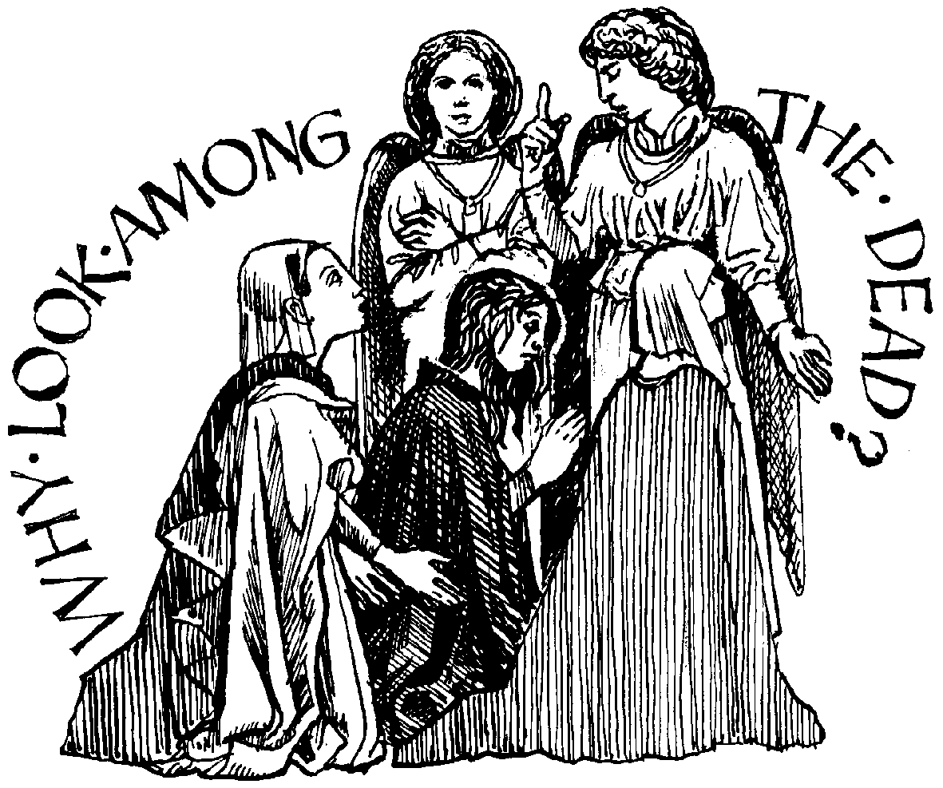

Vicar : Rev. Hugh Lervy

Tel. / Fax. : (01792) 771329

Mobile : 07976 725644

e-mail : thevicar@fsmail.net

Curate:
Rev. Edwin Phillips
(01639) 886784

Would you please let the Vicar know of people who
need visiting at home or in hospital. Thankyou
The Church is open Monday to Friday from 10 a.m. to 12 midday for quiet prayer. Please feel free to come in at any time.

19th April 2009

Today is the Second Sunday of Easter

Hymns at Eucharist : 435 , 74 , 718 , ( 367 , 34 , 587 ) , 666
Psalm 133 : BCP p. 633

TODAY 9.30 am Parish Eucharist with Sunday School
11.15 am Baptism
2.00 pm Baptism
4.30 pm RD Conference in St. Michael’s Church , Trebanos
followed by Deanery Evensong at 6 p.m. The
Speaker and preacher is Archdeacon Robert
Williams.
6.00 pm Parish Evensong

MONDAY 10.00 am Parent and Toddler group
7.30 pm Evening M.U. Speaker : Kari Lucas on
Swansea Community Farm

WEDNESDAY 7.00 pm Bible Study Group at 2 Mynydd Garnlwyd Rd.
- every fortnight – please ask for details

THURSDAY 10.30 am Holy Eucharist
Followed by refreshments in the crypt
6.00 pm Youth Club for school years 4,5,6 ( Crypt )
6.00 pm Clergy Surgery for booking of baptisms, banns and
weddings etc. No appointments necessary.

FRIDAY 10.00 am Prayer Fellowship Group – all welcome

SATURDAY 11.00 am Sunday School and Youth leader’s meet the
Bishop event at Brecon Cathedral
NEXT SUNDAY Readings : Acts 3:12-19 , 1 Jn. 3:1-7 , Lk. 24:36-48
9.30 am Parish Eucharist with Sunday School
A shortened morning service followed by our
ANNUAL PARISH MEETING – DO TRY AND COME
TO THIS MEETING
11.15 am Cymun Bendigaid
5.00 pm Youth Service and Club
6.00 pm Evensong

Men’s Society : Tuesday 5th May in the welcome Inn – see John Richardson to book your meal – all men are welcome. The speaker will be Rev. Basil Jenkyns.

Meet the Bishop : a family day has been organised ( particularly for our young members ) at Brecon Cathedral on Saturday 9th May from 10 a.m. – all are welcome to attend. Please see Diane Richardson for more details.

Christian Aid Week : begins on Sunday 10th May. Helpers are needed for street collections. Please see Harry if you are able to assist.

PCC and Churchwardens nomination : forms for those wishing to stand for the coming year are now available. If you wish to stand or to know more about what is involved please ask. The nomination forms will remain open until the start of our morning service next Sunday.

Legislation and the Church : a meeting will be held here on Thursday 21st May at 7 p.m. All who are interested are welcome but especially PCC members. Would you please sign the list if you will be attending so I can let the Diocese know.

Diocesan Conference : a special additional conference has been called for Friday 3rd July at 7 p.m. in Brecon Cathedral to discuss proposals to make Llandaff the permanent home of the Archbishop of Wales. Feedback from each Diocese is required for changes to be implemented.

Water Aid : the Bishop is collecting money to be sent to Water Aid from the Diocese. If you would like to make a donation please place contributions in the Disaster box at the back of church by next Sunday.
The old ones are the best : A man was stranded on the proverbial deserted Pacific island for years. Finally one day a boat comes sailing into view, and the man frantically waves and draws the skipper's attention. The boat comes near the island and the sailor gets out and greets the stranded man. After awhile the sailor asks, "What are those three huts you have here?" "Well, that's my house there." "What's that next hut?" asks the sailor. "I built that hut to be my church." "What about the other hut?" "Oh, that's where I used to go to church."

