Parish of Morriston
St. David’s Church
Weekly Bulletin
www.churchinwales.org.uk
www.stdavidsmorriston.co.uk
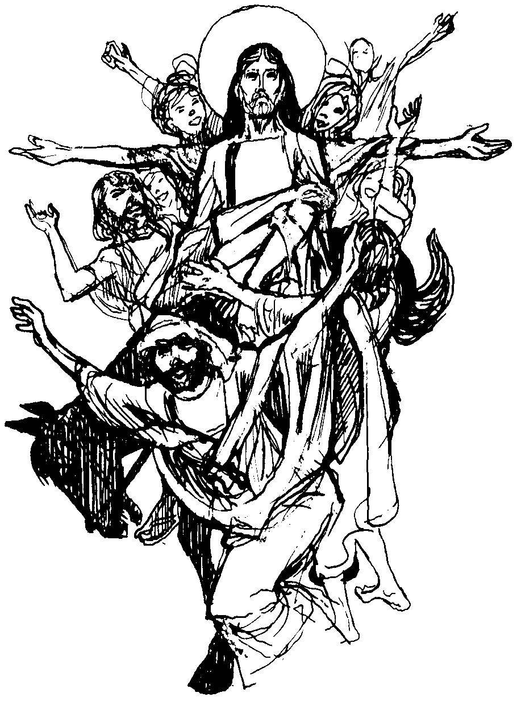

Vicar : Rev. Hugh Lervy

Tel. / Fax. : (01792) 771329

Mobile : 07976 725644

e-mail : thevicar@fsmail.net

Curate:
Rev. Edwin Phillips
(01639) 886784

Would you please let the Vicar know of people who
need visiting at home or in hospital. Thankyou
The Church is open Monday to Friday from 10 a.m. to 12 midday for quiet prayer. Please feel free to come in at any time.

5th April 2009 HOLY WEEK : Today is Palm Sunday

Hymns at Eucharist : 583 , 819 , 14 , ( 38 , 35 , 564 ) , 97

TODAY 9.30 am Parish Eucharist with Sunday School –

followed by refreshments and then a short

meeting of the PCC

6.00 pm Lent Talk “What is the resurrection?”

MONDAY 10.00 am Parent and Toddler group
7.00 pm Stations of the Cross

TUESDAY 12.00 pm Chrism Eucharist at Brecon Cathedral
2.00 pm Mother’s Union : talk by John Stoker on “What is
the resurrection?”
7.00 pm Devotional service
7.30 pm Easter Meditation in music at the Salvation Army

WEDNESDAY 7.00 pm Devotional Service

MAUNDY 10.30 am Holy Eucharist
THURSDAY Followed by refreshments in the crypt
6.00 pm Clergy Surgery for booking of baptisms, banns and
weddings etc. No appointments necessary.
7.00 pm Holy Eucharist and stripping of the altar

GOOD 9.30 pm Council of Churches March of Witness
FRIDAY ( beginning at Sacred Heart )
10.00 am Craft morning – all children welcome
2.00 pm Holy Hour Devotional Service
7.00 pm Devotional service
7.30 pm Stainer’s Crucifixion and St. Michael’s Church,
Manselton

SATURDAY 10 .00 am Church Cleaning and preparation for Easter
– all help would be very welcome !!
7.00 pm Easter Vigil and Holy Eucharist

NEXT SUNDAY EASTER SUNDAY
Readings : Acts 10:34-43 , 1 Cor. 15:1-11, Mk. 16:1-8
9.30 am Parish Eucharist
11.15 am Cymun Bendigaid
3.30 pm Baptism
5.00 pm Songs of Praise at the Salvation Army – note the start time !!

Welcome : to all who join us for our service today and especially those who are joining us for the Baptism.

Thankyou : could I sincerely thank all who have led our series of Sunday Evening Lent talks giving us a great deal to think about regarding different aspects of our faith. Thankyou to all who have joined us for these talks.

Camera Club Exhibition : in the crypt from Tuesday 14th April – all are welcome and admission is free.

R.D. Conference : Sunday 19th April at 4.30 pm in St. Michael’s Church, Trebanos followed by Deanery Evensong to which all are invited. The speaker and preacher will be Archdeacon Robert Williams.

Annual Parish Meeting : Sunday 26th April following the morning service. We are hoping that by holding the meeting in the morning more of our members will be able to join us for this important meeting.

PCC and Churchwardens nomination : forms for those wishing to stand for the coming year are now available. If you wish to stand or to know more about what is involved please ask. The nomination forms will remain open until the morning of the 26th April.

Thankyou : Diane Gambold would like to thank everyone who supported the coffee morning in aid of Chernobyl Children’s Lifeline raising over £730.

Thankyou : to George the owner of Wall to Wall Carpet who has given and Easter Egg for each of our Sunday School children.

Holy week services :
DO TRY AND JOIN US THIS WEEK FOR OR SERVICES THROUGHOUT THE WEEK. ESPECIALLY TRY AND JOIN US ON GOOD FRIDAY AND FOR EASTER SUNDAY.

