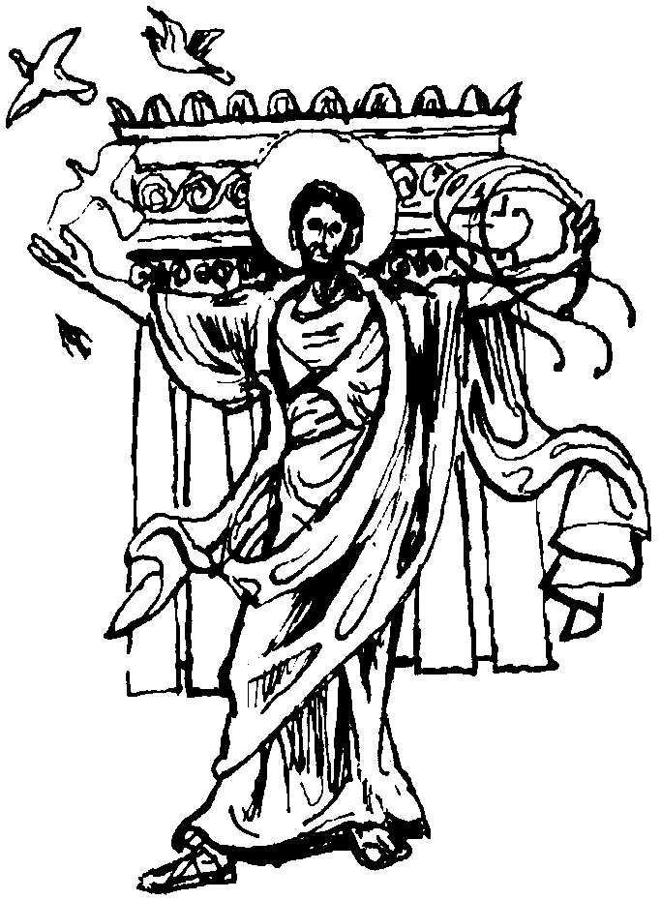
Parish of Morriston
St. David’s Church
Weekly Bulletin
www.churchinwales.org.uk
www.stdavidsmorriston.co.uk

Vicar : Rev. Hugh Lervy

Tel. / Fax. : (01792) 771329

Mobile : 07976 725644

e-mail : thevicar@fsmail.net

Curate:
Rev. Edwin Phillips
(01639) 886784

Would you please let the Vicar know of people who
need visiting at home or in hospital. Thankyou
The Church is open Monday to Friday from 10 a.m. to 12 midday for quiet prayer. Please feel free to come in at any time.

15th March 2009

Today is the third Sunday of Lent

Hymns at Eucharist : 225 , 682 , 70 , ( 420 , 659 , 327 ) , 413

Psalm 19 BCP p. 465

TODAY 9.30 am Parish Eucharist with Sunday School

11.15 am Baptism

6.00 pm Lent talk “What is the Eucharist?”

MONDAY 10.00 am Parent and Toddler group

TUESDAY 2.00 pm Mother’s Union Lent Talk by Rev. Edwin Phillips

WEDNESDAY 7.00 pm Bible Study Group at 2 Mynydd Garnlwyd Rd.
- every fortnight – please ask for details

THURSDAY 10.30 am Holy Eucharist
Followed by refreshments in the crypt
6.00 pm Youth Club for school years 4,5,6 ( Crypt )
6.00 pm Clergy Surgery for booking of baptisms, banns and
weddings etc. No appointments necessary.

NEXT SUNDAY MOTHERING SUNDAY
Readings : Ex. 2:1-10, Col. 3:12-17, Lk. 2:33-35
9.30 am Parish Eucharist with Sunday School
11.15 am Cymun Bendigaid
4.00 pm Cream Tea and Songs of Praise – all are welcome – please let us know how many are joining us by returning the slip on the invitation.
Mothering Sunday Cream Tea : NEXT SUNDAY at 4 p.m. : you are all welcome ( and your family / friends ) to join us. There is no charge. Please complete and return a slip letting us know how many will be coming today if possible. Our morning service will be led by our Sunday School members and we hope as many as possible will try and join us.

Lent Talk : thankyou to Ken who continued our Lent series last Sunday with a talk on What is Baptism ? Do try an join us this evening as we continue our talks with What is the Eucharist ?

Men’ Society : the next meeting will be on the 31st March.

October Trip : we are hoping to run a trip to the Park Hotel in Bruges October half term ( 3 nights from Monday 26th October to Thursday 29th October ). Due to the state of the pound at the moment the prices are more than usual. If 30 wish to travel the cost will be £245 40 wish to travel it will be £215. there is a supplement for single room occupancy if required. If you would like to come ( or family and friends ) please let us know as soon as possible ( £50 deposit ) so we can decide if this trip will be viable.

Thankyou : to all who supported our coffee morning on Thursday in aid of the MS treatment centre in Swansea.

RIP : it was with great sadness we learnt that Len Huzzey had passed away last week. We offer Margaret, Claire and all the family our prayers and condolences at this time. Margaret would like to thank everyone for their cards, flowers and kind thoughts at this time. May the souls of the departed through the love and mercy of God rest in peace.

50th anniversary Concert of the Swansea Philharmonic Choir. The will be performing The Messiah on Saturday 4th April at 7 p.m. in St. Mary’s Church, Swansea. Tickets are £12 or £10 and can be obtained from the Grand Theatre tel. 475715 or speak to Eira.

Chernobyl Children's Lifeline are holding a "Coffee Morning" in the crypt on Saturday 28th March from 10 a.m. in aid of funds to bring 12 children to Swansea in July for respite. Tickets are on sale at the back of church. If unable to attend donations are welcome.

The Barber : Ronnie goes down to the barber shop. He gets his hair cut and then he is getting a shave. After being nicked by the barber several times Ronnie says "Have you got an extra razor?"
The barber replies "Well yes sir I do, would you prefer shaving yourself?" Ronnie said, "Well not exactly but I thought I might could defend myself."

