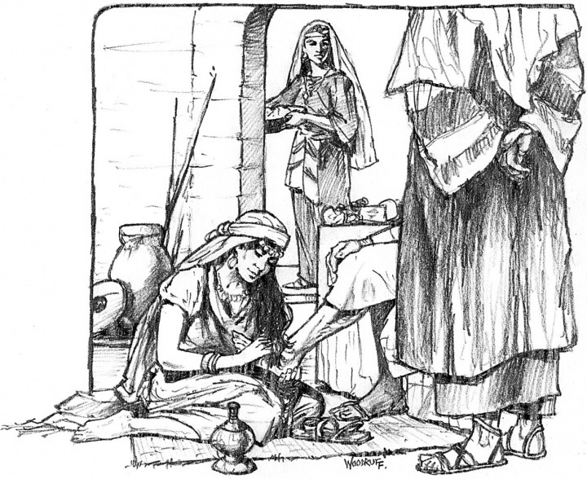
17th July 2016
Assistant Curate : Rev. Anthony Porter
07989572837

Today is the eighth Sunday after Trinity

Hymns at Eucharist : 573 , 694 , 457 , ( 70 , 67 , 590 ) , 449

Psalm 15 BCP p. 458

TODAY 10.00 am Parish Eucharist with Sunday School

11.30 am Baptism

4.30 pm Confirmation Class

6.00 pm Evensong

MONDAY 9.30 am Parent and Toddler group

TUESDAY 1.00 pm Funeral of Alwyn Williams (Church) followed by
committal at Swansea Crematorium at 2 p.m.

THURSDAY 10.30 am Holy Eucharist followed by tea /coffee
6.00 pm Clergy Surgery for booking of baptisms, banns and
weddings etc. No appointments necessary.

NEXT SUNDAY Gen. 18:20-32 , Col. 2:6-19 , Lk. 11:1-13
10.00 am Parish Eucharist

6.00 pm Evensong

Don’t forget the church is open from 10 am. to 12 Midday.
All are welcome to come in for quietness,
prayer or a cup of tea/ coffee.

PARISH NOTES

Thankyou : to Jane who organised the shopping trip yesterday. I hope you all had a good day.

Sunday School : from today our Sunday school will be taking a break for the Summer holidays. Thankyou to all the teachers who have worked so hard this year - it has been lovely to see new members joining this year. Sunday School will resume when the schools go back in September.

Church Collection : Firstly can we thank all who give regularly to our church collections. Although currently about £1000 down on where we should be at this point in the year we are grateful to all who give so generously to help with the financial obligations of our Parish. With HSBC soon to close in Morriston the Treasurer has asked me to say that if anyone would prefer to give collection via Direct Debit this can be set up for you. Please speak to Gwyn Lewis for details.
Parish of Morriston
Weekly Bulletin
St. David’s Church
www.churchinwales.org.uk
www.stdavidsmorriston.co.uk
Registered Charity : 1131686

Vicar : Canon Hugh Lervy
Area Dean of Afon Tawe (Swansea)

Tel. : (01792) 771329

Mobile : 07976 725644

e-mail : thevicar@lervy.net

Painting : during the Summer while many groups that use the crypt take a break, we are hoping to paint the walls in the main room ( and replace the carpet ). If you would be able to help with the painting we would be very pleased to hear from you. Please let Keith Lewis know. Dates for painting can be decided around those able to help.

Parish Treasure Hunt : on Sunday 28th August we are going to hold a Treasure Hunt ( starting at 2.30 p.m. ) followed by a meal at our destination. The cost will be £10 per car and food can be ordered and paid for where we end up. Please let the wardens know if you would like to take part. If you have a spare place in your car or would like to be given a lift let us know and we will try to ensure everyone who wants to take part can be found a place.

Home Communions : if you or someone you now would like to receive communion at home because they cannot attend church through health or infirmity please me know and the Eucharistic Team will ensure they are visited.

Evening Service : Don’t forget we have evensong on Sundays at 6 p.m. ( Holy Eucharist on the first Sunday each month ). Why not make this service part of your worshipping pattern ? It is a lovely way to end the day.

Please let the clergy or pastoral team know of those in need of visits. Please also help by keeping in touch with those who are missing from our worship.

