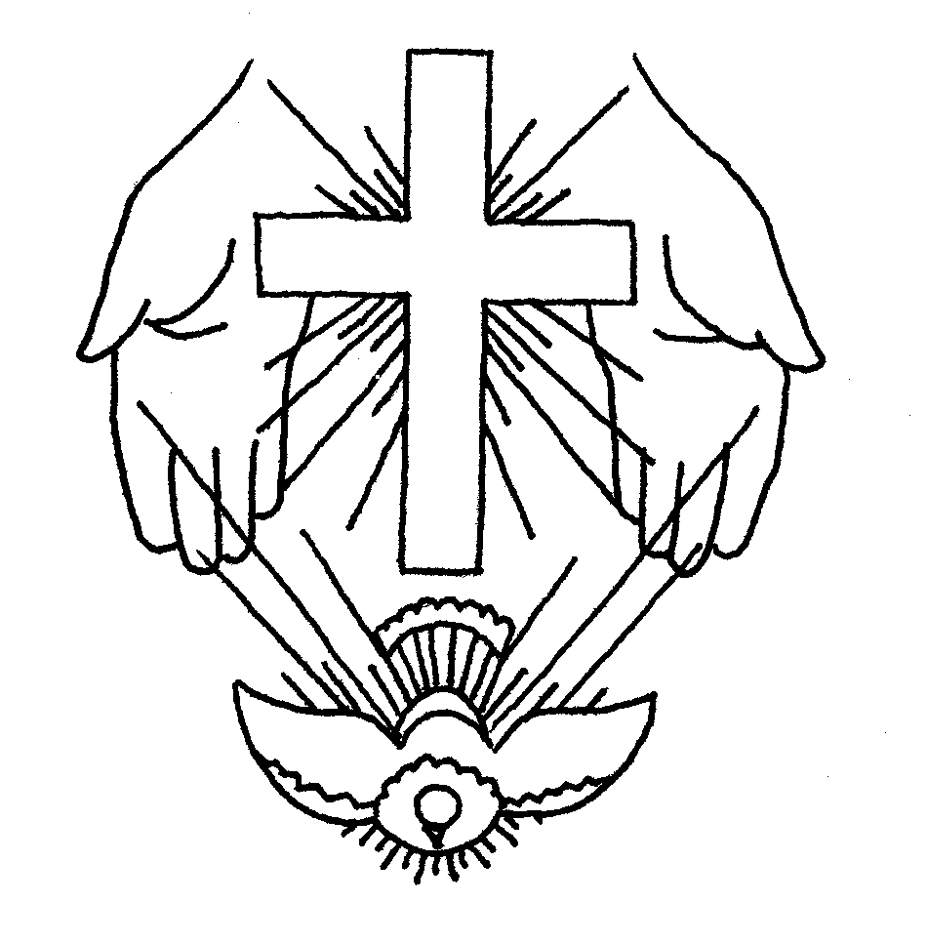
22nd May 2016 Today is Trinity Sunday

Hymns at Eucharist : 286 , 436 , 413 , ( 82 , 165 , 285 ) , 97

TODAY 10.00 am Parish Eucharist with Sunday School

6.00 pm Evensong

MONDAY 9.30 am Parent and Toddler group
7.30 pm Evening M.U. Speaker : Polly Davies on
‘The Grand Canyon’

TUESDAY 2.00 pm Mother’s Union : Speaker : Rev. Kay Warrington

THURSDAY 10.30 am Holy Eucharist followed by tea /coffee
6.00 pm Youth Club for school years 4,5,6 ( Crypt )
6.00 pm Clergy Surgery for booking of baptisms, banns and
weddings etc. No appointments necessary.

FRIDAY 2.00 pm Funeral of Marian Williams (Crematorium)

NEXT SUNDAY 1 Kings 8:22-43 , Gal. 1:1-12 , Luke 7:1-10
10.00 am MORNING PRAYER with Sunday School

6.00 pm Evensong
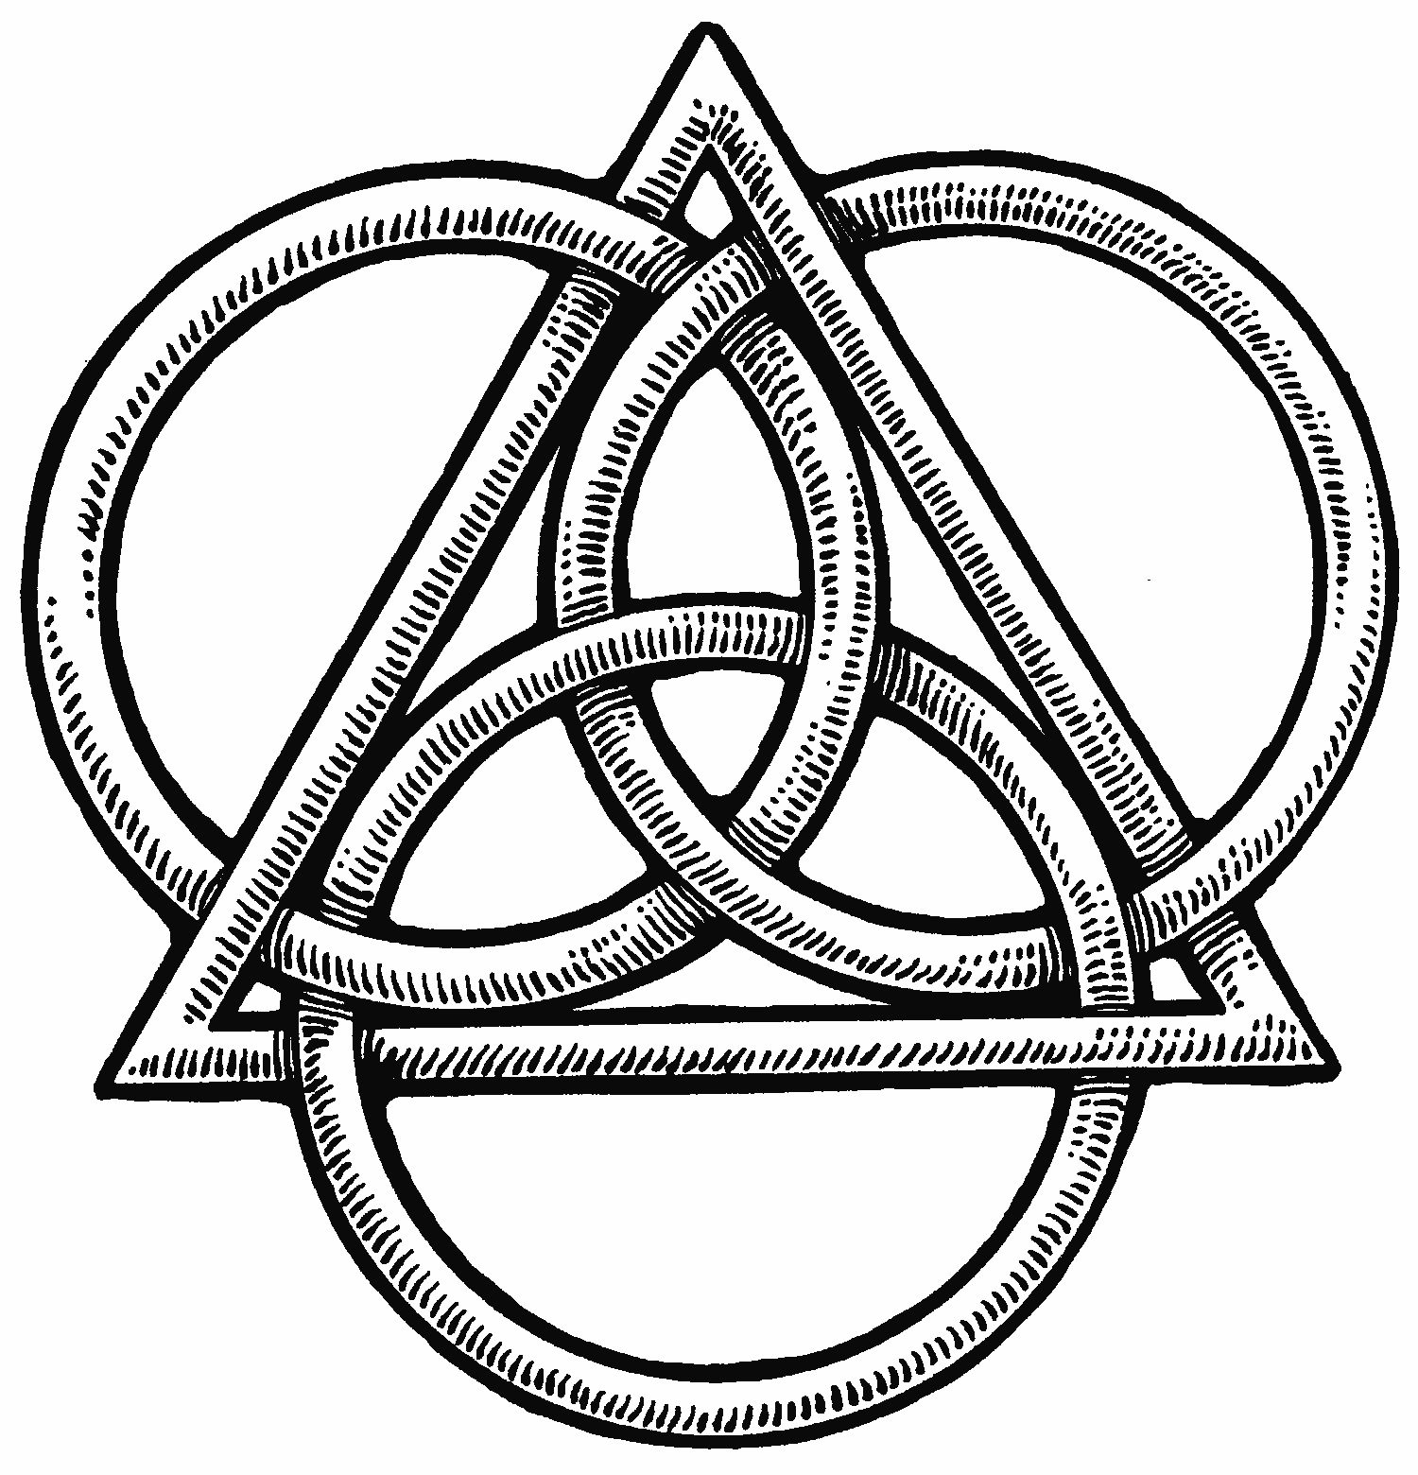

PARISH NOTES

Friends of Brecon Cathedral : if anyone would like to join for this coming year please speak to Marilyn Lewis if you would like to join or for more details.

Thankyou : Alan Penhaligan and family would like to thank everyone for their prayers and support following the passing away of Christine.

Thankyou : Anne Lewis would like to thank everyone for their cards , gifts and good wishes following her recent ‘special’ birthday.

Visiting : please do let the Vicar or a member of our Pastoral Visiting team know of those requiring home or hospital visits. Your help with keeping in touch with those missing from worship or our Parish groups is always appreciated.

RIP : we extend our love and prayers to the family of Marian Williams (Fagwr Place ) who passed away this week. May the souls of the departed through God’s love and mercy rest in peace.
Parish of Morriston
Weekly Bulletin
St. David’s Church
www.churchinwales.org.uk
www.stdavidsmorriston.co.uk
Registered Charity : 1131686

Vicar : Canon Hugh Lervy
Area Dean of Afon Tawe (Swansea)

Tel. : (01792) 771329

Mobile : 07976 725644

e-mail : thevicar@lervy.net

Greetings : Iris Jones ( now resident in Llys Y Tywysog ) would like to be remembered to everyone in church and thanks those who have been able to visit and keep in touch.

Ordination : the ordination of Anthony Porter as a deacon will take place in Brecon Cathedral on Sunday 26th June at 2 p.m. If you would be interested in coming on a bus to this service please add your name to the list at the back of church TODAY

Area Deanery Conference : Sunday 19th June at 4.30 p.m. in Llansamlet Church followed by Deanery worship. The speaker at the meeting will be Peter Doyle the new safeguarding officer for the Diocese and anyone interested is welcome to come along in addition to those appointed at the Vestry Meeting.

Recipe Book : if you have a favourite recipe you would be able to share can you please let Marilyn Lewis know. thankyou.

Mugs : if you would like to order a Church mug ( if they are produced) would you please indicate it on the sheet at the back of church, so we know if enough wish to place orders.

Coffee Morning : Nan Morris has kindly invited us to her home for a coffee morning on Saturday 25th June from 10 a.m. All are welcome.

THE CHURCH IS OPEN MONDAY TO FRIDAY 10 a.m. to MIDDAY FOR PRIVATE PRAYER & QUIETNESS OR POP IN FOR A CUP OF TEA / COFFEE. ALL VERY WELCOME.

