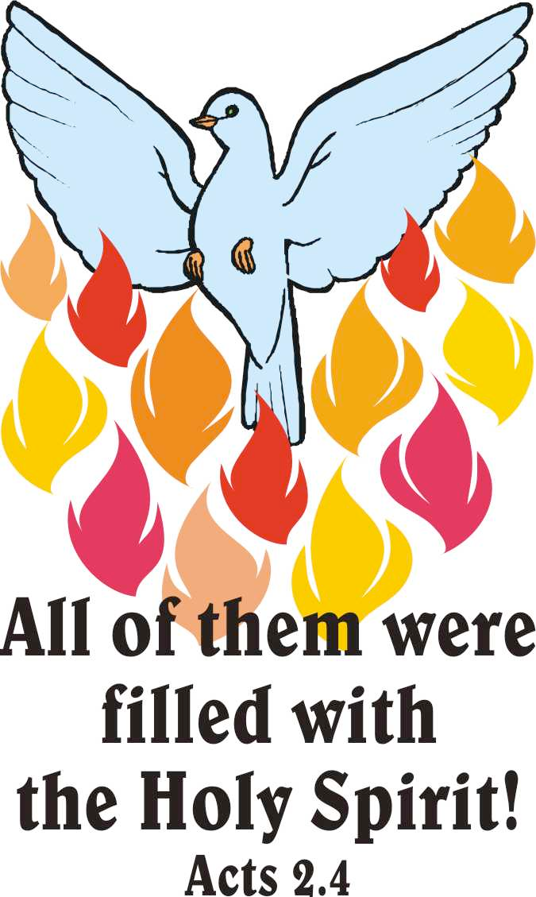

15th May 2016 Today is Pentecost Sunday

Hymns at Eucharist : 20 , 96 , 662 , ( 116 , 118 , 117 ) , 666

Psalm 104 :25-35 BCP p. 587

TODAY 10.00 am Parish Eucharist with Sunday School

11.30 am Baptism

6.00 pm Pentecost Songs of Praise

MONDAY 9.30 am Parent and Toddler group

TUESDAY 2.00 pm Mother’s Union

WEDNESDAY Diocesan Clergy Training Day ( Carmarthen )

THURSDAY 10.30 am Holy Eucharist followed by tea /coffee
6.00 pm Youth Club for school years 4,5,6 ( Crypt )
6.00 pm Clergy Surgery for booking of baptisms, banns and
weddings etc. No appointments necessary.

FRIDAY 12.00 pm Funeral of Irene Yeoman ( Crematorium )

NEXT SUNDAY Trinity Sunday
Prov. 8:1-31 , Rom. 5:1-5 , John 16:12-15
10.00 am Parish Eucharist with Sunday School

6.00 pm Evensong


Friends of Brecon Cathedral : if anyone would like to join for this coming year please speak to Marilyn Lewis if you would like to join or for more details.

Social Committee : Thankyou to those who were able to join us and for all the ideas shared. One of the ideas is to produce a recipe book later this year. If you have any favourite recipes you would be able to share can you please write them down and give to Marilyn Lewis. Another plan is to produce Mugs with the church picture on. We would like to judge if this is an idea that people would like so please indicate if you would purchase a mug on the form at the back of church.

Ordination : the ordination of Anthony Porter as a deacon will take place in Brecon Cathedral on Sunday 26th June at 2 p.m. If you would be interested in coming on a bus to this service please add your name to the list at the back of church as soon as you can.
Parish of Morriston
Weekly Bulletin
St. David’s Church
www.churchinwales.org.uk
www.stdavidsmorriston.co.uk
Registered Charity : 1131686

Vicar : Canon Hugh Lervy
Area Dean of Afon Tawe (Swansea)

Tel. : (01792) 771329

Mobile : 07976 725644

e-mail : thevicar@lervy.net

RIP : we offer our prayers to the family of Irene Yeoman who was a faithful member of our congregation prior to illness. May the souls of the departed through God’s love and mercy rest in peace.

Morning Prayer : the 29th May will be a 5th Sunday of the month so the 10 a.m. service will be Sung Morning Prayer in place of the Parish Eucharist.

Visiting : please do let the Vicar or a member of our Pastoral Visiting team know of those requiring home or hospital visits. Your help with keeping in touch with those missing from worship or our Parish groups is always appreciated.

Hospital Eucharist : a reminder that every Tuesday at 11.30 a.m. a Service of Holy Eucharist is held in Morriston Hospital Chapel. This is open to any wishing to attend and is led by the Chaplaincy Team.

Area Deanery Conference : Sunday 19th June at 4.30 p.m. in Llansamlet Church followed by Deanery worship. The speaker at the meeting will be Peter Doyle the new safeguarding officer for the Diocese and anyone interested is welcome to come along in addition to those appointed at the Vestry Meeting.

Coffee Morning : Nan Morris has kindly invited us to her home for a coffee morning on Saturday 25th June from 10 a.m. All are welcome.

THE CHURCH IS OPEN MONDAY TO FRIDAY 10 a.m. to MIDDAY FOR PRIVATE PRAYER & QUIETNESS OR POP IN FOR A CUP OF TEA / COFFEE. ALL VERY WELCOME.

