Parish of Morriston
St. David’s Church
Weekly Bulletin
www.churchinwales.org.uk
www.stdavidsmorriston.co.uk
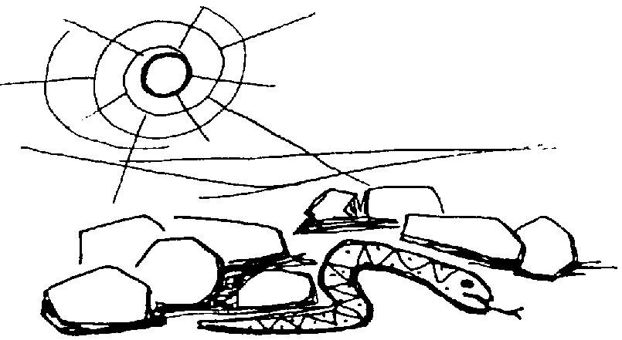

Vicar : Rev. Hugh Lervy

Tel. / Fax. : (01792) 771329

Mobile : 07976 725644

e-mail : thevicar@fsmail.net

Curate:
Rev. Edwin Phillips
(01639) 886784

Would you please let the Vicar know of people who
need visiting at home or in hospital. Thankyou
The Church is open Monday to Friday from 10 a.m. to 12 midday for quiet prayer. Please feel free to come in at any time.

1st March 2009 Today is the first Sunday of Lent ( St. David’s Day )

Hymns at Eucharist : 428 , 212 , 190 , ( 374 , 517 , 379 ) , 252

TODAY 9.30 am Parish Eucharist with Sunday School

6.00 pm Lent talk and worship “What is faith?” - do

try and join us for a Sunday evening series

of Lent talks.

MONDAY 10.00 am Parent and Toddler group
2.00 pm Clergy Chapter Meeting ( Ystradgynlais )

TUESDAY 2.00 pm Mother’s Union lent talk by Roy Gambold
6.30 pm Men’s Society meeting ( Welcome Inn )

WEDNESDAY 7.00 pm Bible Study Group at 2 Mynydd Garnlwyd Rd.
- every fortnight – please ask for details

THURSDAY 10.30 am Holy Eucharist
Followed by refreshments in the crypt
6.00 pm Youth Club for school years 4,5,6 ( Crypt )
6.00 pm Clergy Surgery for booking of baptisms, banns and
weddings etc. No appointments necessary.
7.00 pm Holy Eucharist

FRIDAY 11.30 am Mother’s Union Eucharist ( St. Mary’s )
2.30 pm Women’s world day of prayer service at the
Salvation Army ( Morfydd Street )

NEXT SUNDAY Readings : Gen.17:1-16, Rom. 4:13-25 , Mk. 8:31-38
9.30 am Parish Eucharist with Sunday School
11.15 am Cymun Bendigaid
6.00 pm Lent talk and worship “What is baptism?”
Open church : thankyou to all who have agreed to help on the rota to open our church each morning. Do call into the church for quietness and prayer. If anyone else would be able to help with the rota please let John Richardson know. Thankyou.

Sunday School teachers : The Bishop would like to meet all those interested in Children's Work i.e. Sunday School Teachers, Youth Workers, P&T helpers, at the Diocesan Centre in Brecon on Saturday 25th April between 11a.m. and 1 p.m. If you are able to come please let Diane Richardson know by 8th March so that numbers may be given.
Children’s day in Brecon : The Bishop would like to meet all Sunday School children and their parents at a Fun Day at Brecon Cathedral on Sat. 9th May from 11 a.m. to 3.30 p.m. If we have a good number of people going we will be able to hire a coach. Please ask Diane Richardson for a form to be returned by 8th March so that places may be booked.

Thankyou : Meg Hill ( and family ) would like to thank everyone for their cards, flowers and prayers following their recent bereavement.

Charity Coffee Morning : in aid of the M.S. Treatment centre on Thursday 12th March. Tickets are £1 and are now available. Help to sell them would be appreciated.

Mothering Sunday Cream Tea : 22nd March at 4 p.m. : you are all welcome ( and your family / friends ) to join us. There is no charge. Please complete and return a slip letting us know how many will be coming. Our morning service will be lad by our Sunday School members and we hope as many as possible will try and join us.

Fairtrade Fortnight : 23rd Feb – 4th March : Please support the farmers by buying Fairtrade products. A large selection are available at the back of church. Proverbs 31:8-9 "Speak up for those who cannot speak for themselves, for the rights of all who are destitute. Speak up and judge fairly; defend the rights of the poor and needy."

Thankyou : to those who helped our Shrove Tuesday social evening go so well – esp. those who prepared our meal and Alan for the quiz!!
October church Trip : we are waiting for prices and options on destinations – further details as soon as we can .
Talking dog : I have a dog that talks in its sleep. One day a visitor was astonished to hear the dog bellow, "My name is Christopher Columbus! I am seven hundred years old! I own America! I married Marilyn Monroe!" When the visitor asked what was going on, I replied, "Don't worry about it. It's better to just let sleeping dogs lie."

