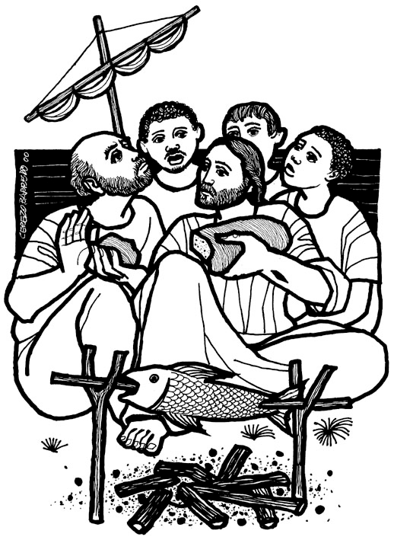

10th April 2016 Today is the third Sunday of Easter

Hymns at Eucharist : 552 , 120 , 162 , ( 411 , 285 , 379 ) , 756

TODAY 10.00 am Parish Eucharist with Sunday School - the

affirmation vows for the wardens and PCC

members will take place during our service

today.

11.30 am Baptism

6.00 pm Evensong

MONDAY 9.30 am Parent and Toddler group
12.00 pm Funeral of Vera Lewis (Crematorium)
7.30 pm Evening M.U. : Speaker : Anita Pugh on Italian
Communities in Wales

TUESDAY 2.00 pm Mother’s Union : Speaker : Ivor Williams on the
History of Llangyfelach Church

WEDNESDAY 2.00 pm MU Diocesan Festival (Brecon Cathedral)

THURSDAY 10.30 am Holy Eucharist followed by tea /coffee
6.00 pm Youth Club for school years 4,5,6 ( Crypt )
6.00 pm Clergy Surgery for booking of baptisms, banns and
weddings etc. No appointments necessary.
7.00 pm Induction of Rev. Andrew Holmes as
Vicar of Manselton


NEXT SUNDAY Acts 9:36-43, Rev. 7:9-17 , John 10:22-30
THE CHURCH IS OPEN MONDAY TO FRIDAY FROM 10 a.m. to 12 Midday..
ALL ARE WELCOME TO COME IN FOR QUIETNESS / PRAYER
OR A CUP OF TEA / COFFEE
10.00 am Parish Eucharist with Sunday School
3.30 pm Installation of Canons at Brecon Cathedral

5.00 pm Concert in Aid of Chernobyl Children’s

Lifeline - tickets now available.

PARISH NOTES

Parish Meal : FRIDAY 29th APRIL at 7 pm. in Morriston Golf Club. We will be sharing this with our friends from Llangyfelach and LLansamlet Parishes. A quiz will be held raising money for the Bishop’s Lent Appeal. The cost of the meal is £14 ( 3 Course ) - please see sheet at back of church for details and to book your places.
Parish of Morriston
Weekly Bulletin
St. David’s Church
www.churchinwales.org.uk
www.stdavidsmorriston.co.uk
Registered Charity : 1131686

Vicar : Canon Hugh Lervy
Area Dean of Afon Tawe (Swansea)

Tel. : (01792) 771329

Mobile : 07976 725644

e-mail : thevicar@lervy.net

Social Committee : thankyou to those who have said they will help with this new committee - if you would like to be part of this group we would be VERY pleased - please let the Wardens know. A meeting will be held soon.

Elections : thankyou to those who were able to join us for our Parish meeting last week. The following were appointed : Vicar’s Warden - Bob Lloyd , People’s Warden - Keith Lewis. PCC Members - Anne Lewis , Trevor Barrow , Nicola Morris , Grey Phillips , Gaynor Demery , Craig Oldham , Myra James , Anne Evans , Janet Cooze. Please hold all our officers in your prayers and offer full support in their roles. THE PCC WILL MEET ON SUNDAY 24th APRIL AT 4.30 p.m

Confirmation : a reminder that those wishing to be confirmed this year should please complete and return an application form. A meeting will be held soon to talk about the best time to hold classes.

Ordination : the ordination of Anthony Porter as a deacon will take place in Brecon Cathedral on Sunday 26th June at 2 p.m. Anthony will begin his curacy with us here in Morriston. If you would be interested in coming on a bus to this service please add your name to the list at the back of church as soon as you can so we can judge what size coach to book

So this bloke says to me,
"Can I come in your house and talk about your carpets?" I thought "That's all I need, a Je-hoover's witness".

