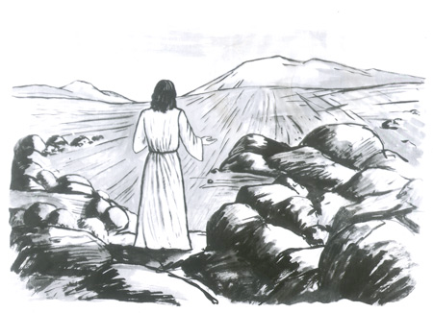

14th February 2016

Today is the first Sunday of Lent

Hymns at Eucharist : 503 , 532 , 379 , ( 165 , 590 , 249 ) , 428

TODAY 10.00 am Parish Eucharist with Sunday School

6.00 pm Lent Course : The Arrival

MONDAY 9.30 am Parent and Toddler group

TUESDAY 2.00 pm Mother’s Union : Lent Course

THURSDAY 10.30 am Holy Eucharist followed by tea /coffee
6.00 pm Youth Club for school years 4,5,6 ( Crypt )
6.00 pm Clergy Surgery for booking of baptisms, banns and
weddings etc. No appointments necessary.

FRIDAY 4.45 pm Mother’s Union Wave of Prayer - all welcome

NEXT SUNDAY Gen. 15:1-18, Phil. 3:17 - 4:1 , Lk. 13:31-35
10.00 am Parish Eucharist with Sunday School

2.30 pm A service to commemorate the 75th anniversary

of the Swansea Blitz ( St. Mary’s , Swansea )

6.00 pm Lent Course : Conspiracy

PARISH NOTES

Lent Course : this year we will using a DVD produced by the BBC on the Passion Narrative. The first episode will be tonight at 6 p.m. in the Crypt. The evenings will be between between 60 - 90 minutes depending on the film extract for each week. Do try and join us for what should be a thought provoking series.

Lent Collection : throughout Lent a collection plate will be placed at the back of church for donations to the Bishop’s Lent Appeal for charity. Details of the charities to be supported will be given soon.

Mothering Sunday Cream Tea : Sunday 6th March at 4 p.m. All are welcome. The list for numbers attending is now available. Please put names down as soon as possible if you are able to join us. Family and friends are welcome.
Parish of Morriston
Weekly Bulletin
St. David’s Church
www.churchinwales.org.uk
www.stdavidsmorriston.co.uk
Registered Charity : 1131686

Vicar : Canon Hugh Lervy
Area Dean of Swansea

Tel. : (01792) 771329

Mobile : 07976 725644

e-mail : thevicar@lervy.net

PCC Meeting : Sunday 13th March at 4.30 p.m.

Youth Club : our Thursday night club has grown over the last few months to about 40 young people attending. This is a very important part of our mission and outreach. However, if we are to keep this group going we will need more volunteers to help with the supervision and activities. If you can help out on a Thursday we would be very pleased to hear from you. Please let the wardens know. A meeting for our Youth Leaders will take place at 7.30 p.m. on Thursday 26th February.

Family service coffee : if you can help with the serving of tea and coffee following the daily services on the First Sunday each month would you please let the wardens know. More names are needed to ensure this does not fall on a small group of volunteers.

Charity Coffee Morning : for the Charity MIND on Thursday 10th March following our mid week Eucharist.

Hospital Eucharist : A service of Holy Eucharist will be led by the Chaplaincy Team on Tuesday every week at 11.30 a.m. in Morriston Hospital Chapel. Please let people know this service is taking place.

Open Church : we are hoping to be able to open the church again this year daily from 10 a.m. to 12 midday from the Monday of Holy Week to October. If you can help on the rota opening the church and welcoming visitors can you please let John Richardson know Thankyou.

