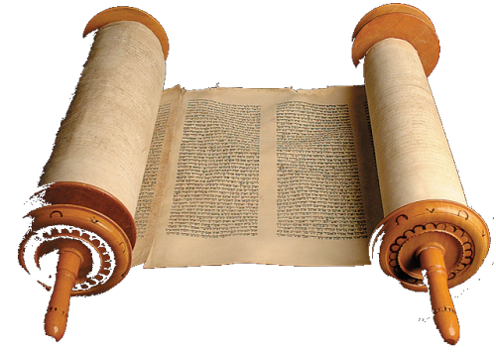

24th January 2016

Today is the third Sunday of Epiphany

Hymns at Eucharist : 225 , 590 , 303 , ( 264 , 752 , 17 ) , 646

TODAY 10.00 am Parish Eucharist with Sunday School

6.00 pm Evensong

MONDAY 9.30 am Parent and Toddler group
7.30 pm Evening M.U. : Speaker : Colin Weldon James on
“Joseph Parry - A welshman of note”

TUESDAY 2.00 pm Mother’s Union

THURSDAY 10.30 am Holy Eucharist followed by tea /coffee
6.00 pm Youth Club for school years 4,5,6 ( Crypt )
6.00 pm Clergy Surgery for booking of baptisms, banns and
weddings etc. No appointments necessary.
7.00 pm Induction of Rev. Phil Gwyn as Vicar or Killay ( St.
Hilary’s) in addition to being Vicar of Tycoch)

NEXT SUNDAY Fourth Sunday of Epiphany / Presentation of
Christ in the Temple
10.00 am Morning Prayer with Sunday School

11.30 am Baptism

6.00 pm Evensong

I went to a restaurant that serves 'breakfast at any time'.
So I ordered French Toast during the Renaissance.

PARISH NOTES

Congratulations : to Eileen Thomas who celebrated a ‘special’ birthday on Wednesday this week.

Church Flowers : the new Flower List is now up in the porch. If you would like to pay for the flowers on a particular Sunday please add your name to the list on the date you would like Thankyou.

Annual Report : I would be grateful if those who run our various Parish groups and organisations could please submit articles for the Annual report by the end of January. Thankyou.

Hospital Eucharist : A service of Holy Eucharist will be led by the Chaplaincy Team on Tuesday every week at 11.30 a.m. in Morriston Hospital Chapel. This service is open for all : patients , staff and visitors. Please let people know this service is taking place.
Parish of Morriston
Weekly Bulletin
St. David’s Church
www.churchinwales.org.uk
www.stdavidsmorriston.co.uk
Registered Charity : 1131686

Vicar : Canon Hugh Lervy
Area Dean of Swansea

Tel. : (01792) 771329

Mobile : 07976 725644

e-mail : thevicar@lervy.net

Visiting : with the weather we have had the last few weeks and cases of illness, numbers attending our worship have been lower than usual. With such a number missing it is difficult to keep track of everyone. Please let the Vicar or members of our Pastoral visiting team know of those in need of visits at home or in hospital. For those unable to attend our services ( short or long term ) our Eucharistic team would be happy to take the sacrament to people’s homes if requested.

Shrove Tuesday Social : Tuesday 9th February. We will be holding a fish and chip supper at 7 p.m. All are welcome. The list for food orders is now available. ALL ARE WELCOME TO JOIN US. Please complete your name and food order as soon as you can.

Ash Wednesday Service : 10th February at 10.30 a.m.

Lent Course : this year we will using a DVD produced by the BBC on the Passion Narrative. The first episode will be on Sunday 14th February at 6 p.m. in the Crypt. The evenings will be between between 60 - 90 minutes depending on the film extract for each week. Do try and join us for what should be a thought provoking series.

Mother’s Union Wave of Prayer : Friday 19th February 4.45 - 5.25 p.m. All are welcome to join this time of prayer.

Food Box : a quick reminder that we have plastic box at the back of church into which donations of tinned or dried food can be placed for local charities working with the homeless. There is also a request for hats, scarves and gloves at this time of year.

