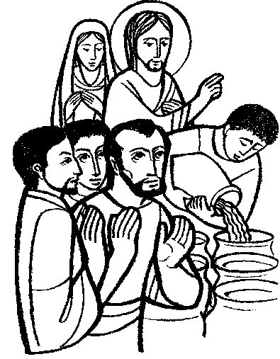
17th January 2016 Today is the second Sunday of Epiphany

Hymns at Eucharist : 314 , 288 , 245 , ( 625 , 506 , 621 ) , 721

Psalm 36 : 5-10 BCP p. 489

TODAY 10.00 am Parish Eucharist with Sunday School

6.00 pm Evensong

MONDAY 9.30 am Parent and Toddler group

TUESDAY 12.30 pm Mother’s Union Dinner ( Golf Club )

THURSDAY 10.30 am Holy Eucharist followed by tea /coffee
6.00 pm Youth Club for school years 4,5,6 ( Crypt )
6.00 pm Clergy Surgery for booking of baptisms, banns and
weddings etc. No appointments necessary.

NEXT SUNDAY Neh. 8:1-10, 1 Cor. 12:12-31 , Lk. 4:14-21
10.00 am Parish Eucharist with Sunday School

6.00 pm Evensong

PARISH NOTES

Church Flowers : the new Flower List is now up in the porch. If you would like to pay for the flowers on a particular Sunday please add your name to the list on the date you would like Thankyou.

Morning Prayer : at the PCC meeting last Sunday we have agreed that when there is a fifth Sunday in the month ( about 4 a year ) we would have sung Morning Prayer ( Matins ) in ok ace of the Morning Eucharist. The first of these will take place on the morning of Sunday 31st January.

Annual Report : I would be grateful if those who run our various Parish groups and organisations could please submit articles for the Annual report by the end of January. Thankyou.

Thankyou : Rita and Claerwyn Randall have asked to pass on their sincere thanks to everyone for their cards and good wishes on the occasion of their Diamond Anniversary.

Visiting : with the weather we have had the last few weeks and cases of illness, numbers attending our worship have been lower than usual. With such a number missing it is difficult to keep track of everyone. Please let the Vicar or members of our Pastoral visiting team know of those in need of visits at home or in hospital. For those unable to attend our services ( short or long term ) our Eucharistic team would be happy to take the sacrament to people’s homes if requested.
Parish of Morriston
Weekly Bulletin
St. David’s Church
www.churchinwales.org.uk
www.stdavidsmorriston.co.uk
Registered Charity : 1131686

Vicar : Canon Hugh Lervy
Area Dean of Swansea

Tel. : (01792) 771329

Mobile : 07976 725644

e-mail : thevicar@lervy.net

Collection Envelopes : a big thankyou to everyone who gives to our church fund so regularly through the envelope scheme. If you haven’t yet picked them up this years envelopes are now available. If you would like to receive envelopes for your giving please ask the treasurer or the wardens. If you are a tax payer have you signed a GIFT AID form so the church can reclaim the tax on your giving at no extra cost to yourself. We do not need to know any details of your income or savings but the tax received makes a BIG difference to our church income and balancing our books.

Smarties : Thankyou to all who have been returning your Smarties tubes. If any others are to be returned we would be grateful to receive them by the end of January.

Shrove Tuesday Social : Tuesday 9th February. We will be holding a fish and chip supper at 7 p.m. All are welcome. The list for food orders is now available. ALL ARE WELCOME TO JOIN US. Please complete your name and food order as soon as you can..

Ash Wednesday Service : 10th February at 10.30 a.m.

Lent Course : this year we will using a DVD produced by the BBC on the Passion Narrative. The first episode will be on Sunday 14th February at 6 p.m. in the Crypt. The evenings will be between between 60 - 90 minutes depending on the film extract for each week. Do try and join us for what should be a thought provoking series.

Food Box : a quick reminder that we have plastic box at the back of church into which donations of tinned or dried food can be placed for local charities working with the homeless. There is also a request for hats, scarves and gloves at this time of year.

