

20th December 2015 Today is the fourth Sunday of advent.

Hymns at Eucharist : 759 , 152 , 740 , ( 182 , 655 , 364 ) , 631

TODAY 10.00 am Parish Eucharist with Sunday School

4.00 pm CHRISTINGLE AND NATIVITY SERVICE -

please try and join us - a lovely service for

all the family.

TUESDAY 11.00 am Funeral of Ada Blackmore ( crematorium)

THURSDAY CHRISTMAS EVE
NO MORNING SERVICE TODAY
5.00 pm FAMILY EUCHARIST
- led by the Sunday school.
10.00 pm SUNG EUCHARIST

FRIDAY CHRISTMAS DAY
10.00 am HOLY EUCHARIST ( said service with carols)

NEXT SUNDAY Christmas 1
1 Sam. 2:18-26 , Col. 3:12-17 , Lk. 2:41-52
10.00 am Parish Eucharist
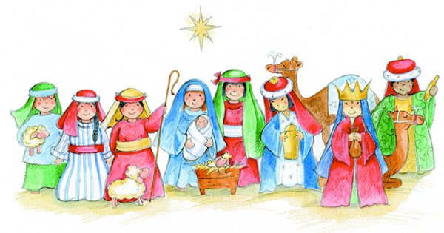
No evening service

PARISH NOTES

Welcome : to all who join us today for our services.

Smarties : the tubes with the 20p pieces can be returned at any of our Christmas Services. Thank you to all who have helped raise funds for local children's charities.

Congratulations : to Rita and Claerwyn Randell who are celebrating the Diamond Wedding anniversary next Sunday.

Thankyou : Alan Penhaligan would like to thank everyone for their cards and good wishes following Christine's recent fall and spell in hospital. We are pleased to hear Christine is now back in the nursing home and making good progress.
Parish of Morriston
Weekly Bulletin
St. David’s Church
www.churchinwales.org.uk
www.stdavidsmorriston.co.uk
Registered Charity : 1131686

Vicar : Canon Hugh Lervy

Tel. : (01792) 771329

Mobile : 07976 725644

e-mail : thevicar@lervy.net

RIP : we extend our love and prayers to the family of Ada Blackmore ( Jean Beddoe's mother ) who passed away last week. May the souls of the departed through the love and mercy of God rest in peace.

Thankyou : to our friends in the Salvation Army and the Bay choir and to all who were able to join us for the wonderful service of Christmas Praise last Sunday.

Thankyou : to all who worked so hard at the craft morning yesterday.

Thankyou : to all who helped put the Christingle Oranges together and all who decorated our church so beautifully for our Christmas services.

Happy Christmas : may I wish a Happy Christmas to all who will be going away this week. We look forward to seeing you in your return. We look forward to welcoming visitors into our congregation for our Christmas services. DO TRY AND ATTEND OUR SERVICES THIS WEEK AS WE GIVE THANKS FOR THE BIRTH OF JESUS AND WELCOME HIM AFRESH INTO OUR HEARTS.

Evening Service : please note there will be no evening service next Sunday or Sunday 3rd January.

PCC Meeting : Sunday 10th January at 4.30 p.m.

