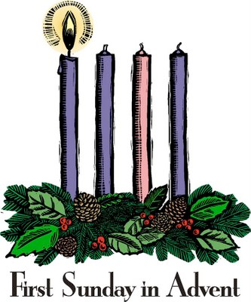
29th November 2015 Today is the first Sunday of Advent

Hymns at Eucharist : 405 , 615 , 128 , ( 303 , 655 , 633 ) , 480

TODAY 10.00 am Parish Eucharist with Sunday School

6.00 pm ADVENT SERVICE of hymns, readings and

prayers - do try and join us.

MONDAY 9.30 am Parent and Toddler group

TUESDAY 10.30 am Bereavement Support Group ( crypt )
2.00 pm Mother’s Union : Holy Eucharist
6.30 pm Men’s Society Christmas Dinner (The Eagle)

WEDNESDAY 9.30 am HELP NEEDED to put up the Christmas trees and
Santa’s Grotto - please come along if you can
give a hand.

THURSDAY 10.30 am Holy Eucharist followed by tea /coffee
6.00 pm Youth Club for school years 4,5,6 ( Crypt )
6.00 pm Clergy Surgery for booking of baptisms, banns and
weddings etc. No appointments necessary.

FRIDAY 10.00 am Crypt open to set up stalls.
4.30 pm TREE OF LIGHT CAROL SINGING & PRAYERS
5.00 pm CHRISTMAS FETE
- DO COME ALONG !

NEXT SUNDAY Bar. 5:1-9 , Phil. 1:3-11 , Lk. 3:1-6
10.00 am Parish Eucharist with Sunday School
Followed by tea/ coffee - ALL WELCOME
11.45 am Baptism
2.00 pm Baptism
6.00 pm Holy Eucharist

Smarties : once again this year we will be collecting 20p pieces in the Smarties tubes which are available today. Enjoy the sweets and then the tubes can be returned at our Christmas services ( with as many 20p pieces as you can collect ). Money raised will be for local children’s charities.

Thankyou : to everyone who helped in our Christmas present appeal for Samaritan’s purse. 240 boxes have been sent from our church family. Thankyou to Judith who co-ordinated this appeal for us and to all who worked so hard packing the gifts ready for sending.
Parish of Morriston
Weekly Bulletin
St. David’s Church
www.churchinwales.org.uk
www.stdavidsmorriston.co.uk
Registered Charity : 1131686

Vicar : Canon Hugh Lervy

Tel. : (01792) 771329

Mobile : 07976 725644

e-mail : thevicar@lervy.net

Christian Aid : thankyou to all who gave for our Harvest gifts for Christian Aid. A cheque for £600 has been sent for their work in the refugee crisis.

200 Club Winners November : 1st no. 149 Peter Davies , 2nd. no. 35 Marjorie Worner , 3rd no. 26 Anne Marie-Thomas. Congratulations to the winners.

Thankyou : Marilyn and Gwyn Lewis and family would like to thank everyone for their kind words and prayers following the recent passing away of Gaynor.

Thankyou : to all who supported our coffee morning for Air Ambulance on Thursday.

Leaflets with details of all our Advent and Christmas services are available. Please help to pass them out to family, neighbours and friends. It would be good to see as many as possible joining us over the Advent and Christmas period and we can all help by letting people now what is taking place.

Christmas Praise : with the Salvation Army and Bay Choir will take place here on Sunday 13th December at 5 p.m. ( please note the new start time this year ).

Bereavement Carol Service : organise by the Hospital Chaplaincy team. Wednesday 16th December at 7 pm. here in St. David’s. All are welcome come along to this quiet service of reflection.

Craft Morning for children : Saturday 19th December from 10 a.m. to 12 midday. Please let all children know. It would be good to see them doing us for this activity.

Christingle and Nativity Service : Sunday 20th December at 4 p.m. - a lovely service for all the family.

DON’T FORGET THE CHRISTMAS FETE ON FRIDAY

