Parish of Morriston
St. David’s Church
Weekly Bulletin
www.churchinwales.org.uk
www.stdavidsmorriston.co.uk
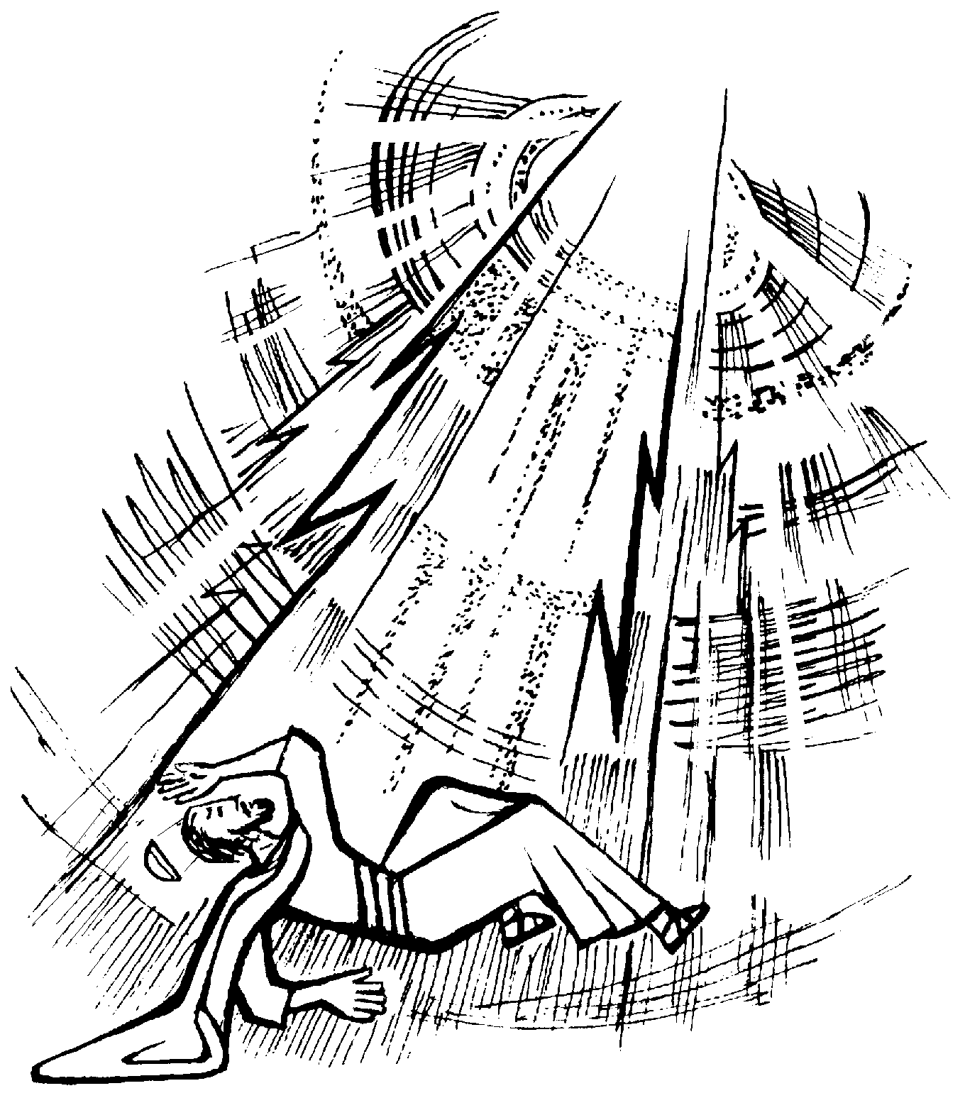

Vicar : Rev. Hugh Lervy

Tel. / Fax. : (01792) 771329

Mobile : 07976 725644

e-mail : thevicar@fsmail.net

Curate:
Rev. Edwin Phillips
(01639) 886784

Would you please let the Vicar know of people who
need visiting at home or in hospital. Thankyou

25th January 2009

Today is the Conversion of St. Paul

Hymns at Eucharist : 337 , 610 , 381 , ( 304 , 144 , 656 ), 187

TODAY 9.30 am Parish Eucharist with Sunday School

11.15 am Cymun Bendigaid

5.00 pm Youth Service followed by youth club

6.00 pm Evensong

MONDAY 10.00 am Parent and Toddler group
7.30 pm Evening M.U. : Reflections on Christmas by
Barbara Williams

TUESDAY 12.30 pm Mother’s Union Dinner at the Golf Club

WEDNESDAY 7.00 pm Bible Study Group at 2 Mynydd Garnlwyd Rd.
- every fortnight – please ask for details

THURSDAY 10.30 am Holy Eucharist
Followed by refreshments in the crypt
6.00 pm Youth Club for school years 4,5,6 ( Crypt )
6.00 pm Clergy Surgery for booking of baptisms, banns and
weddings etc. No appointments necessary.

FRIDAY 10.00 pm Prayer Fellowship Group – all welcome

NEXT SUNDAY Readings : Deut. 18:15-20, Rev. 12:1-5, Mk. 1:21-28
9.30 am Parish Eucharist with Sunday School
6.00 pm HEALING EUCHARIST

Annual Report : could articles for our annual report be submitted by the end of this week if at all possible.

Eucharistic Assistant licenses : could those licensed please bring your licenses to be sent to the Bishop for signing. Thankyou.
Men’s Society : our next meeting will take place on Tuesday 3rd Feb. (6.30 for 7 p.m.) All men are welcome. To book a meal please see John Richardson.
Wales Institute for Science, Education and Religion : are holding their first study day at Llangyfelach church hall on Saturday 7th February ( 9.30 am to 4 p.m. ). The cost is £10 ( £5 concessions ) which includes lunch. All are welcome. For more details or to book a place please phone Mrs. Jane Davies Hannen on 774120.
Shrove Tuesday Social Evening : 24th February from 7 p.m. Tickets are £2 and all are welcome.

Ash Wed. : 25th Feb. Holy Eucharist will be celebrated at 10.30 a.m. and 7 p.m.

From Daryl and Karen : I have been offered a job as a research fellow / PhD candidate at the Norwegian University of Science and Technology (NTNU) in Trondheim, Norway. We have booked flights for January 29th and therefore we will be leaving Swansea on Sunday 25th January. Our utmost thanks and gratitude go to everyone for making us feel so welcome and part of the St David's family. As a church family I am sure we thank Daryl and Karen for all they have brought into our church life and wish them well in this new venture.

Church Opening : we are hoping this year again to open the church each morning for people to come in for private prayer / quietness. If you are able to help on a rota from March to open the church 10 a.m. to Midday we would be very pleased to hear from you. Please let John Richardson know if and when you can help. Thankyou.

Hostage: Marvin found the following ransom note slipped under his front door. "Bring £50,000 to the 17th hole of your Golf club tomorrow at 10:00 a.m. if you ever want to see your wife alive again." But it was well after 1:00 p.m. by the time he arrived at the designated meeting spot. A masked man stepped from behind a bush and demanded, "You're three hours late. What took you so long?" "Give me a break!" said Marvin, pointing to his scorecard. "I'm a 27 handicap."

