
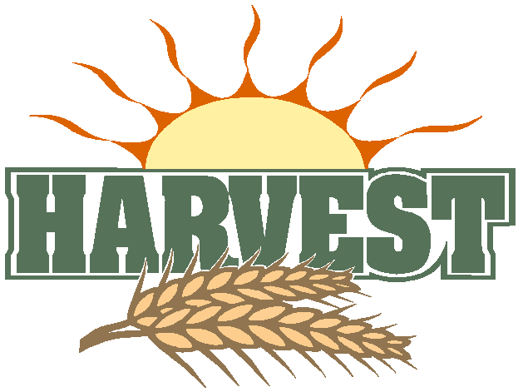
4th October 2015
The Church is Open Monday to Friday from 10 a.m. to Midday for quietness and private prayer. All are welcome.

Today is the Eighteenth Sunday after Trinity ( HARVEST FESTIVAL )

Hymns at Eucharist : 133 , 23 , 719 , ( 900 , 915 , 172 ) , 25

TODAY 10.00 am Family Harvest Eucharist led by our Sunday

School Sunday School. Followed by tea / coffee

and then a Bring and Share lunch in the Crypt -

all welcome

6.00 pm Harvest Songs of Praise

MONDAY 9.30 am Parent and Toddler group

TUESDAY 10.30 am Bereavement Support Group ( crypt ) - open to all
2.00 pm Mother’s Union : Speaker : Mrs. Dreena Morgan-
Harvey :”In Praise of Women”
6.30 pm Men’s Society AGM ( The Eagle )

THURSDAY 10.30 am Holy Eucharist followed by tea /coffee
6.00 pm Youth Club for school years 4,5,6 ( Crypt )
6.00 pm Clergy Surgery for booking of baptisms, banns and
weddings etc. No appointments necessary.
SATURDAY 10.00 am Diocesan Conference ( Brecon cathedral)

NEXT SUNDAY Amos 5:6-15 , Heb. 4:12-16 , Mk 10:17-31
10.00 am Parish Eucharist with Sunday School

11.30 am Baptism

6.00 pm Evensong

PARISH NOTES

Thankyou : to all who helped to decorate the church for our Harvest Services today. Harvest cash donations made today ( in the Harvest envelopes ) will be given to Christian Aid for their work in the refugee crisis. Gifts of tinned and dried food will be passed to local charities working with the homeless. Thankyou for your support.

Welcome : A warm welcome to all who are joining us for our services today.


Sunday School : November is a month of Remembrance. This year the Sunday School are going to remember important events at the end of WWII. If you have any photos of V.E. and V.J. day and would be prepared to bring them to church to be copied for a display ( originals will be returned ) then this would be appreciated. The November family service will be a commemoration of these events.
Parish of Morriston
Weekly Bulletin
St. David’s Church
www.churchinwales.org.uk
www.stdavidsmorriston.co.uk
Registered Charity : 1131686

Vicar : Canon Hugh Lervy

Tel. : (01792) 771329

Mobile : 07976 725644

e-mail : thevicar@lervy.net

Visiting : please help by keeping in touch with those missing from our worship. Please let the Vicar or Pastoral Visiting team of know of those in need of visits.

200 Club : A FINAL REMINDER If you would like to join for the coming year ( or would like more details ) please speak to the wardens. The membership is £20 for the year. Payments should be made TODAY PLEASE.

Shopping Trip : to the Victorian Christmas Markets in Gloucester. Saturday 21st November. Leaving church at 8.30 a.m. Cost is £17 per head and all are welcome. Please speak to Jane Gimblett to book places. (£10 deposit)

200 Club winners September : First. No. 64 Grace Godrich, Second. No. 70 Rosemary Parry , Third. No.102 Ruby Godrich. Congratulations to the winners.

Faith in Families : is a charity run by the Diocese and working with Children and young families in various communities in our Diocese. We had an excellent talk at Area Deanery Conference last week on their work and now have collection boxes available to support this vital outreach work in our Diocese. If you would like to take a box they can be returned as and when in an ongoing collection for us to play a part in supporting this work.

A cowboy walks in to a German car showroom and he says "Audi!"

