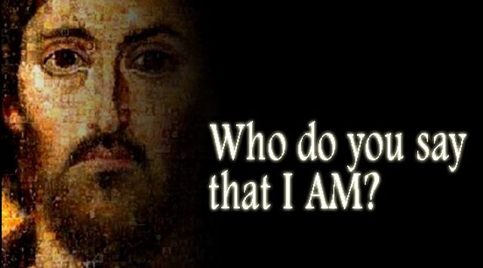

13th September 2015
The Church is Open Monday to Friday from 10 a.m. to Midday for quietness and private prayer. All are welcome.

Today is the fifteenth Sunday after Trinity

Hymns at Eucharist : 315 , 658 , 54 , ( 70 , 374 , 625 ) , 716

TODAY 10.00 am Parish Eucharist with Sunday School

1.30 pm Bus Leaves St. David’s for Cathedral

Evensong and Canon’s Licensing in Brecon.

The bus is working out at £10 per head. There will be no evening service here tonight.

MONDAY 9.30 am Parent and Toddler group
9.45 am Deanery Clergy Chapter Mtg. (Ystalyfera)
7.30 pm Evening M.U. Speaker : Hayley Ironside from
”Hope House” (Drug addiction in young people)

TUESDAY 2.00 pm Mother’s Union : Speaker : Gareth Harlow
“Your Local Pharmacist”

THURSDAY 10.30 am Holy Eucharist followed by tea /coffee
6.00 pm Youth Club for school years 4,5,6 ( Crypt )
6.00 pm Clergy Surgery for booking of baptisms, banns and
weddings etc. No appointments necessary.

SATURDAY 1.00 pm Wedding

NEXT SUNDAY Wis. 1:16-2:22, James 3:13-8 , Mk. 9:30-37
10.00 am Parish Eucharist with Sunday School

11.30 am Baptism

4.30 pm AD Conference and Deanery Evening

Worship in Llansamlet Church.

PARISH NOTES

Welcome Back : to our Sunday School. We hope you all had a enjoyable Summer holiday.

AD Conference : NEXT SUNDAY at 4.30 p.m. in Llansamlet Church. The talk will be on the Faith in Families Charity that works within the Diocese. All are welcome. Please note there will be no evening service in St. David’s tonight or next Sunday.


200 Club : If you would like to join for the coming year ( or would like more details ) please speak to the wardens. The membership is £20 for the year. Payments should be made by the end of September please.
Parish of Morriston
Weekly Bulletin
St. David’s Church
www.churchinwales.org.uk
www.stdavidsmorriston.co.uk
Registered Charity : 1131686

Vicar : Rev. Hugh Lervy

Tel. : (01792) 771329

Mobile : 07976 725644

e-mail : thevicar@lervy.net

Harvest Festival : Sunday 4th October. 10 am. Family service led by our Sunday School. This will be followed by a BRING AND SHARE LUNCH - do try and join us . Then a Service of Harvest songs of Praise will take place at 6 p.m. If you can help with offers of food for lunch please can you add your name and what you can offer to the list at the back of church. OUR HARVEST COLLECTION THIS YEAR WILL BE GIVEN TO CHARITIES WORKING WITH THE SYRIAN REFUGEES. Items of tinned and dried food will be given to local homeless shelters.

Diocesan Conference : Saturday 10th October at 10 am in Brecon.

Pastoral Team Meeting : Thursday 1st October at 7 p.m. in church.

Disaster Box : if anyone would like to make a donation to the Charities working with the Syrian Refugees please place donations in the box and they will be passed on this week and over the coming weeks.

Christian Aid 70th Anniversary Service : at Brecon Cathedral on Saturday 26th September at 2.30 p.m. The preacher will be Archbishop Rowan Williams. All are welcome to attend.

Visiting : please help by keeping in touch with those missing from our worship. Please let the Vicar or Pastoral Visiting team of know of those in need of visits.

I was mugged by a man on crutches, wearing camouflage.
Ha ha, I thought, you can hide but you can’t run.

