Parish of Morriston
St. David’s Church
Weekly Bulletin
www.churchinwales.org.uk
www.stdavidsmorriston.co.uk
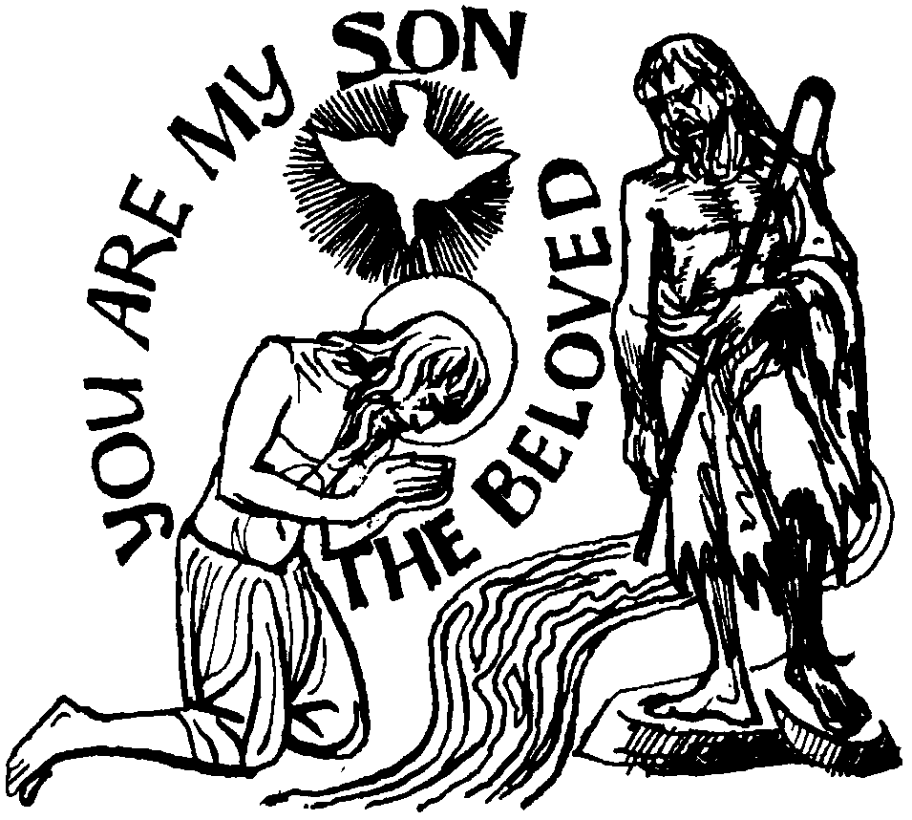

Vicar : Rev. Hugh Lervy

Tel. / Fax. : (01792) 771329

Mobile : 07976 725644

e-mail : thevicar@fsmail.net

Curate:
Rev. Edwin Phillips
(01639) 886784

Would you please let the Vicar know of people who
need visiting at home or in hospital. Thankyou

11th January 2009

Today is the Baptism of Christ

Hymns at Eucharist : 625 , 84 , 70 , ( 374 , 506 , 615 ) , 650

TODAY 9.30 am Parish Eucharist with Sunday School

11.15 am Cymun Bendigaid

2.00 pm Baptism

6.00 pm Evening Worship

MONDAY 10.00 am Parent and Toddler group

TUESDAY 2.00 pm Mother’s Union AGM

WEDNESDAY 7.00 pm Bible Study Group at 2 Mynydd Garnlwyd Rd.
- every fortnight – please ask for details

THURSDAY 10.30 am Holy Eucharist
Followed by refreshments in the crypt
6.00 pm Youth Club for school years 4,5,6 ( Crypt )
6.00 pm Clergy Surgery for booking of baptisms, banns and
weddings etc. No appointments necessary.

NEXT SUNDAY Readings : 1 Sam.3:1-20, Rev. 5:1-10, Jn. 1:43-51
9.30 am Parish Eucharist with Sunday School
2.00 pm Baptism
4.30 pm P.C.C. Meeting
6.00 pm Evensong
PARISH NOTES

Annual Report : I would be grateful if those who run our various groups and organisations would kindly submit an article for our annual report as soon as you can.

Charity Coffee mornings 2009 : at our meeting of the PCC next Sunday we will be fixing the dates for this year’s charity coffee mornings. If you have a charity you wish to nominate please put the name of the charity , a contact number or address and a brief description of their work on a piece of paper and hand to the wardens before next Sunday.

Thankyou : John Stoker ( and family ) would like to thank everyone for their prayers, cards and good wishes following his operation. We continue to hold John in our prayers during his time of recovery.

Thankyou : to Anne Lewis who organised our Parish Meal at the Treetops on Friday night and to Gordon and his band for providing the entertainment. We hope you all enjoyed the evening. Our thanks to the Treetops for helping us at short notice following a flood in the Barn.

Welcome Back : to all who have been away for Christmas and the New Year. We hope you all enjoyed your break and wish you a very Happy 2009.

Collections Envelopes : for 2009 are now available at the back of church. Could we thank all who contribute so generously to our church funds. If you would like to join the envelope please speak to the Wardens or the treasurer.

Visiting : I cannot remember a time when there has been so much illness! Almost everyone has had the various coughs and colds that are going around. This is having a huge impact on our church attendance. I am trying to cover as many visits as possible but would be grateful if you can help by letting me know of those in urgent needs of visiting so that I can prioritise those who are seen. I apologise for those who do not receive visits but wish you well and we look forward to seeing you on your recovery / return.

Diocesan Family Centre in Bonymaen : are looking for volunteers to support our High/Scope Play Groups on Tuesday and Thursday 12.45 to 2.45 and Fridays 9.15 to 11.30. We would also value volunteer support on Tuesday, Wednesday and Thursday from 3p.m. to 5.15 to support the primary children in the afterschool club. If you feel able to help or would like more details please speak to Barbara Williams on 700821 / or in church today.
Thought for the week : "When you are dissatisfied and would like to go back to youth, think of Algebra."

