
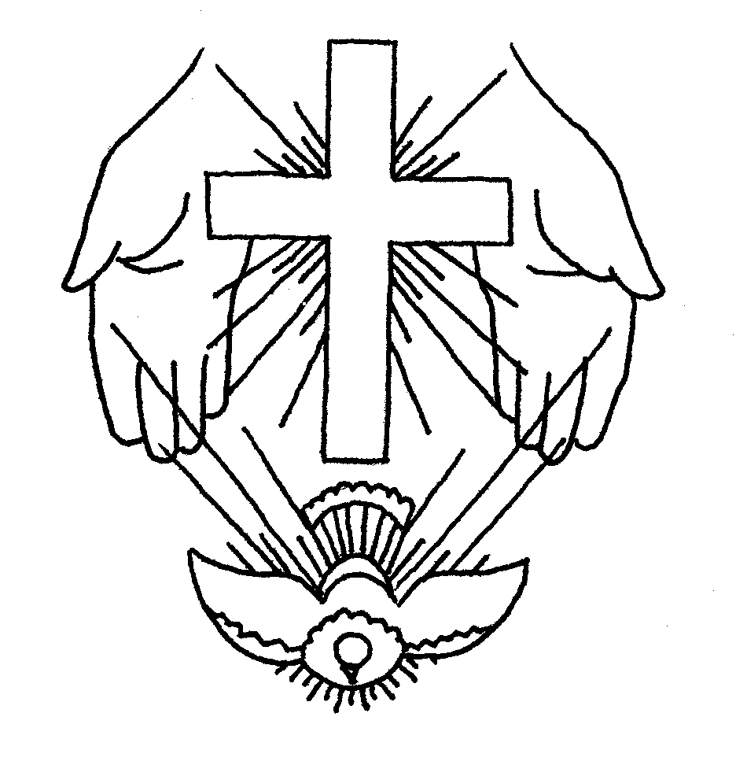
31st May 2015
The Church is Open Monday to Friday from 10 a.m. to Midday for quietness and private prayer. All are welcome.

Today is Trinity Sunday

Hymns at Eucharist : 286 , 166 , 163 , ( 285 , 167 , 165 ) , 684

TODAY 10.00 am Parish Eucharist with Sunday School

6.00 pm Evensong

MONDAY 9.30 am Parent and Toddler group
7.30 pm Evening M.U.: Speaker : Tony Paultyn on
“The History of the Cinema”.

TUESDAY 10.30 am Bereavement Support Group - open to all
1.00 pm Council of Churches meeting ( Aenon )
2.00 pm Mother’s Union : Holy Eucharist

THURSDAY 10.30 am Holy Eucharist followed by tea /coffee
6.00 pm Youth Club for school years 4,5,6 ( Crypt )
6.00 pm Clergy Surgery for booking of baptisms, banns and
weddings etc. No appointments necessary.

FRIDAY 11.00 am Deanery Mother’s Union Eucharist
( St. Mary’s, Swansea )

NEXT SUNDAY Gen. 3:8-15, 2 Cor. 4:13-5:1 , Mk. 3:20-35
10.00 am Family Eucharist led by the Sunday School
Followed by tea / coffee
4.30 pm PCC Meeting

6.00 pm Holy Eucharist

PARISH NOTES

Warden Appointment : the voting on our new warden will take place during our service this morning.

Shopping Trip : to Hereford on Saturday 27th June. The cost is £15 per person. The bus will leave the Church at 8.30 am. All are welcome. Please book your place ( £5 deposit required ) as soon as you can so we know if there is enough interest. Please see Jane Gimblett for details - PLEASE TRY AND BOOK YOUR PLACES TODAY,


Charity Coffee Morning : in aid of “Water Aid” will be held following the mid-week Eucharist on Thursday 11th June. Tickets are now available. Please help to sell them. Thankyou.
Parish of Morriston
Weekly Bulletin
St. David’s Church
www.churchinwales.org.uk
www.stdavidsmorriston.co.uk
Registered Charity : 1131686

Vicar : Rev. Hugh Lervy

Tel. : (01792) 771329

Mobile : 07976 725644

e-mail : thevicar@lervy.net

PCC and Warden affirmation prayers : will take place during our 10 a.m. service on Sunday 14th June.

Swansea Philharmonic Choir : Summer Charity Concert on Saturday 13th June at 7 p.m. in All Saint’s Church, Oystermouth. For details and tickets please speak to Eira

Social Coffee Morning : Nan Morris has kindly invited us to her home for coffee from 10.30 a.m. on Saturday 13th June. Tickets are £1 ( in aid of church funds ). All are welcome. If you need directions to Nan’s house please ask.

Ordination Service : at Brecon Cathedral on Saturday 27th June at 2 p.m. If anyone would like a lift to this service let me know. Dorothy Lewis ( from Clydach Parish in our Deanery ) will be ordained as Deacon.

Services : a quick reminder that if you are unable to join our Parish Eucharist on Sunday mornings there also a service at 6 p.m. every week ( Eucharist on the first Sunday each month ) , and we also have a mid-week service every Thursday at 10.30 a.m. Do try and join us for these services if you can. For those requiring Home communion ( due to illness or other reason preventing you coming to Church ) please let me know and this will be arranged. Do keep in touch with those missing from our services and let me know of those in need of visits which will be arranged as soon as possible.

I took part in the sun-tanning Olympics. I got bronze.

