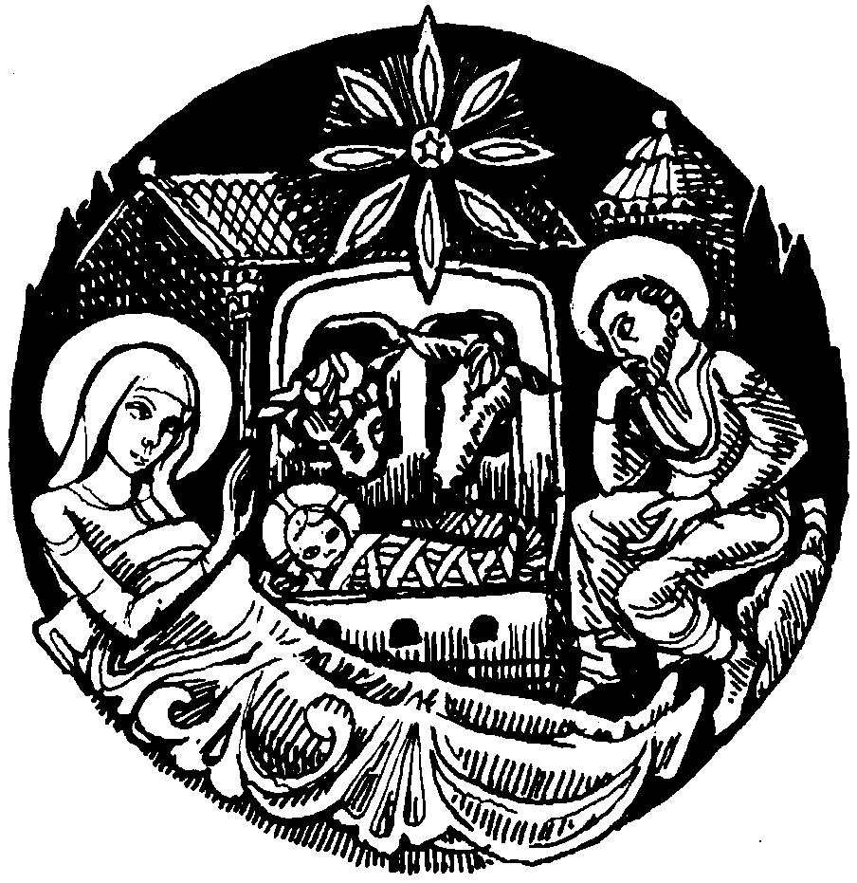
Parish of Morriston
St. David’s Church
Weekly Bulletin
www.churchinwales.org.uk
www.stdavidsmorriston.co.uk

Vicar : Rev. Hugh Lervy

Tel. / Fax. : (01792) 771329

Mobile : 07976 725644

e-mail : thevicar@fsmail.net

Curate:
Rev. Edwin Phillips
(01639) 886784

Would you please let the Vicar know of people who
need visiting at home or in hospital. Thankyou

28th December 2008

Today is the first Sunday of Christmas

Carols : 1 , 18 , 11 , ( 20 , 7 , 25 ) , 12

TODAY 9.30 am Parish Eucharist

There will be no evening service today

WEDNESDAY New Year’s Eve

THURSDAY New Year’s Day : There will be no services
or Clergy Surgery taking place today

FRIDAY No Prayer Group meeting today

NEXT SUNDAY Epiphany Sunday
Readings : Is. 60:1-6 , Eph. 3:1-12 , Mt. 2:1-12
9.30 am Parish Eucharist followed by refreshments
11.15 am Baptism
6.00 pm Holy Eucharist

HAPPY NEW YEAR : to you all and your families from the clergy and warden’s of St. David’s

Congratulations : to John and Margarete Wilkinson who are celebrating their Golden wedding Anniversary and will be renewing their vows during our morning service today. A warm welcome to their family and friends who join our worship today.

Thankyou : to all who worked so hard last weekend. The craft morning was excellent with 45 children attending. Thanks also to all who prepared the Christingle and to the Sunday teachers and members who presented the Nativity story last Sunday afternoon. It was a very special service and we thank you all for your hard work.

Collections Envelopes : the envelopes for 2009 are now available at the back of church. Could we thank all who contribute so regularly and generously to our church funds helping us to meet all our financial commitments as a Parish. We are very grateful for this continuous support. This year we have to rise again to new challenges with the Parish Share rising to £48000 (a 10% increase). If you would like to join the envelope scheme we would be pleased to here from you – please speak to the Wardens or the treasurer.

Bible Study Notes : the books are now available to purchase for the next quarter from John Richardson. If you would like to subscribe to these notes for the coming year John will give you the details.

Spirit Of Gower : a new book is for sale on the table near the door written by a local author and priced at £4.99. The money raised from these sales will be used to help a local group supporting those with Leukaemia.

Thankyou : could we sincerely thank you all for your cards, presents and good wishes received at the Vicarage. We are very grateful for all your kindness.

PCC Meeting : Sunday 18th January at 4.30 p.m.

One for today ... At his grandparents 50th wedding anniversary, the grandson was looking through a photo album of their marriage ceremony. "Grandma, so many of these styles have come back over the years," he commented. Grandma never hesitated. "That's why I've kept Grandpa all this time," she said. "I know he'll be back in style again one of these days."

