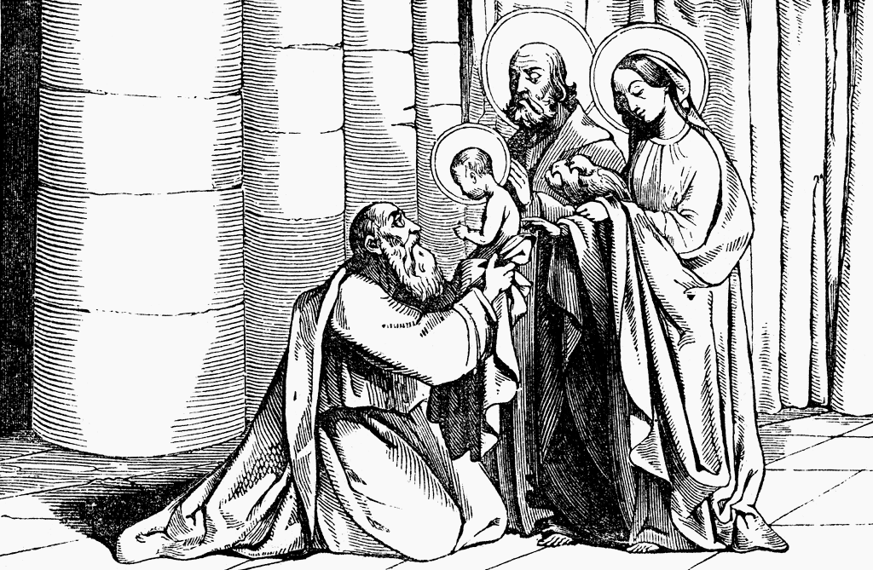

1st February 2015

Today is the Presentation of Christ in the Temple

Hymns at Eucharist : 375 , 67 , 297 , ( 202 , 658 , 349 ) , 174

TODAY 10.00 am Family Eucharist led by the Sunday School

Followed by tea / coffee - all welcome

4.30 pm PCC Meeting

6.00 pm Holy Eucharist

MONDAY 9.30 am Parent and Toddler group

TUESDAY 10.30 am Bereavement Support Group - open for all
2.00 pm Mother’s Union : Speaker : Mike Godrich on
“Funny times in the Police Force”
6.30 pm Men’s Society ( The Eagle ) : Speaker Tony Pain
on Crime Prevention.

THURSDAY 10.30 am Holy Eucharist followed by tea /coffee
6.00 pm Youth Club for school years 4,5,6 ( Crypt )
6.00 pm Clergy Surgery for booking of baptisms, banns and
weddings etc. No appointments necessary.
6.30 pm Pastoral Visiting team meeting ( vestry)

NEXT SUNDAY Hos. 2:14-20, 2 Cor. 3:1-6, Mk. 2:13-22
10.00 am Parish Eucharist with Sunday School

11.30 am Baptism

6.00 pm Evensong

PARISH NOTES

Visiting : as those attending services will know there are many people missing at the moment through ill health ( and some being away ). Please help by keeping in touch with those missing and letting the Vicar ( and Pastoral visiting team ) know of those who require home visits. As many as possible will be seen but at the moment we have a visiting list with over 80 names on it ! Your help is appreciated in keeping in touch !

Shrove Tuesday ( 17th Feb. ) Social Evening : we will be holding a fish and chip supper ( with a quiz ). All are welcome to come and join us . A list is at the back of church for your food order. FINAL ORDERS WILL BE TAKEN NEXT SUNDAY. Please pay Anne Lewis on booking.
Parish of Morriston
Weekly Bulletin
St. David’s Church
www.churchinwales.org.uk
www.stdavidsmorriston.co.uk
Registered Charity : 1131686

Vicar : Rev. Hugh Lervy

Tel. : (01792) 771329

Mobile : 07976 725644

e-mail : thevicar@lervy.net

200 Club winners Jan 15 : 1st no. 20 Anne Lewis , 2nd no. 125 John Richardson , 3rd no. 21 Caitlyn Oats. Congratulations to the winners.

Annual report : Could those who run the various groups and organisations please let me have your reports as soon as you can. Thankyou.

Electoral Roll : every five years our Parish Electoral Roll ( membership list ) needs to be completely renewed under Church in Wales rules. The renewal is due this year. Please take, complete and return your form as soon as you can. All persons over 18 who are communicants and either living in the Parish ( or regular worshippers in St. David’s ) are entitled to have their names on this list.

Ash Wednesday : 18th February. Holy Eucharist with ashing will be at 10.30 a.m. Details of this years Lent and Easter Services are on the form now available. This year’s Lent course will be looking at the four Gospels ( dates are on the forms ). On Sunday 22nd March the Clydach Catholic Church will be performing the PASSION PLAY here in St. David’s at 7 p.m. Please put this date in your diary. Tickets will be available soon at £5 ( for Charity ).

Church Lifts : if you can help give lifts to and from church on Sundays can you please let the churchwardens know. It will be on a rota so you will not be tied to this every week.

Mother’s Union Way of Prayer : Friday 20th February 4.45 - 5.20 p.m. All are welcome to join Mother’s Union members for these prayers.

“I’m learning the hokey cokey. Not all of it.
But I’ve got the ins and outs.”

