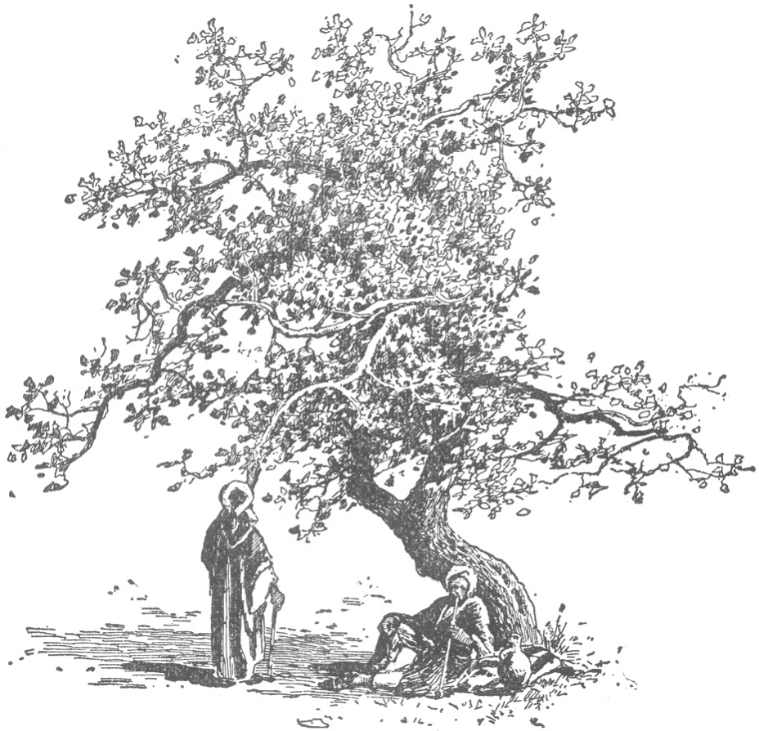

18th January 2015

Today is the second Sunday of Epiphany

Hymns at Eucharist : 12 , 66 , 551 , ( 374 , 752 , 332 ) , 188

Psalm 139 : 1-5 , 12-17 BCP p. 639

TODAY 10.00 am Parish Eucharist with Sunday School

6.00 pm Evensong

MONDAY 9.30 am Parent and Toddler group

TUESDAY 12.30 pm Mother’s Union meal at the Golf Club
7.15 pm Council of Churches Unity service at the Hospital
Chapel. ALL WELCOME

THURSDAY 10.30 am Holy Eucharist followed by tea /coffee
6.00 pm Youth Club for school years 4,5,6 ( Crypt )
6.00 pm Clergy Surgery for booking of baptisms, banns and
weddings etc. No appointments necessary.

FRIDAY 2.00 pm Diocesan Clergy Meeting ( Brecon )

NEXT SUNDAY Conversion of Paul
Mal. 3:1-5, Heb. 2:14-18 , Lk. 2:22-40
10.00 am Parish Eucharist with Sunday School

6.00 pm Deanery Tenebrae Service ( service of

Light ) - all welcome - followed by

refreshments

PARISH NOTES

Shrove Tuesday ( 17th Feb. ) Social Evening : we will be holing a fish and chip supper ( with a quiz ). All are welcome to come and join us . A list is at the back of church for your food order : Fish and Chips £5 , Chicken and chips £5 , Rissole and Chips £3.50 , Sausage and Chips £3.50. Please pay Anne Lewis on booking.

Annual report : we are starting to collect items for this year’s Parish Annual Report. Could those who run the various groups and organisations please let me have your reports as soon as you can. Thankyou.
Parish of Morriston
Weekly Bulletin
St. David’s Church
www.churchinwales.org.uk
www.stdavidsmorriston.co.uk
Registered Charity : 1131686

Vicar : Rev. Hugh Lervy

Tel. : (01792) 771329

Mobile : 07976 725644

e-mail : thevicar@lervy.net

Electoral Roll : every five years our Parish Electoral Roll ( membership list ) needs to be completely renewed under Church in Wales rules. The renewal is due this year. Please take, complete and return your form as soon as you can. All persons over 18 who are communicants and either living in the Parish ( or regular worshippers in St. David’s ) are entitled to have their names on this list.

PCC Meeting : Sunday 1st February at 4.30 p.m.

Envelopes : thankyou to all who contribute through the envelope scheme. If you have not yet had yours for this year they are available at the back of church. If you wish to gift aid your contributions please speak to Gwyn Lewis who can give you the relevant form to complete.

Church flowers : the available dates for Church flowers are now in the porch. The cost remains the same at £10. If you wish to chose a specific week for flowers please add your name to the list. Thankyou.

Shoeboxes : Judith Scott has kindly agreed to organise the shoebox collection next Christmas and throughout the year is happy to receive knitted items and gifts for this cause.

Q: How do you make an Octopus laugh? A: With ten-tickles

Q: Why are pirates called pirates? A: Cause they arrrrr.

