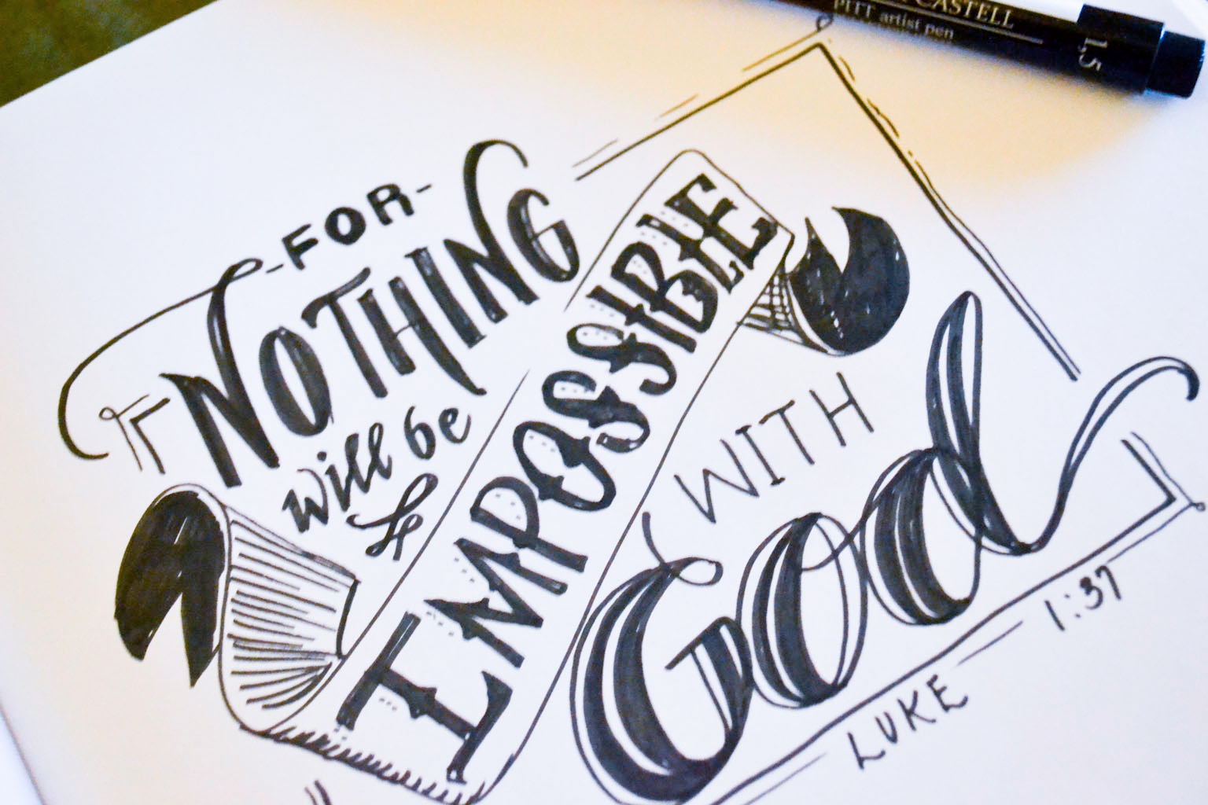

21st December 2014

Today is the fourth Sunday of Advent

Hymns at Eucharist : 54 , 634 , 486 , ( 759 , 381 ) , 631

Psalm 89 :1-4, 19-26 BCP p. 566

TODAY 10.00 am Parish Eucharist with Sunday School

4.00 pm CHRISTINGLE AND NATIVITY SERVICE - DO

TRY AND JOIN US - all children are welcome

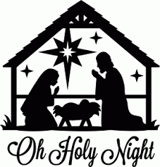
to dress in Nativity costume and join in !!

WEDNESDAY - CHRISTMAS EVE

5.00 pm FAMILY EUCHARIST
LED BY OUR SUNDAY SCHOOL

10.00 pm CHRISTMAS EUCHARIST

THURSDAY - CHRISTMAS DAY

10.00 am Holy Eucharist and Carols

NEXT SUNDAY Holy Innocents
Jer. 31:15-17 , 1 Cor. 1:26-29 , Mt. 2:13-18
10.00 am Parish Eucharist with Sunday School

11.30 am Baptism

NO EVENING SERVCE TODAY

PARISH NOTES

HAPPY CHRISTMAS
We warmly welcome to St. David’s all who will join us for our Christmas Services this week. On behalf of the officers and myself may I wish you all a very happy and blessed Christmas Celebration. DO TRY AND JOIN US FOR OUR SERVICES THIS WEEK.

Please note : that next Sunday and Sunday 4th January there will be no evening service. Also on Thursday 1st January there will be no mid-week service.

Smarties Tubes : if you have been collecting your 20p pieces through Advent could we please ask they be brought to Church in the next 2 weeks so that the money can be passed to the Children’s Charities. Thankyou.

Visiting : there are many people unable to join us in worship at the moment through illness and holidays. Please will you help the Vicar and the pastoral visiting team by keeping in touch with those who are missing and please let us know of those who need visiting - we can then ensure they are seen. Thankyou for your help.
Parish of Morriston
Weekly Bulletin
St. David’s Church
www.churchinwales.org.uk
www.stdavidsmorriston.co.uk
Registered Charity : 1131686

Vicar : Rev. Hugh Lervy

Tel. : (01792) 771329

Mobile : 07976 725644

e-mail : thevicar@lervy.net

Thankyou : to our friends in the Salvation and the Bay choir for sharing with us last Sunday in our service of Christmas Praise.

Thankyou : to all who worked so hard for the Children’s Craft morning and helping to put the Christingles together.

Thankyou : Philip and Jane Barnard and family would like to thank the Bishop and all who have given prayers and support for Sophie’s recent Confirmation.

Thankyou : Eileen Thomas and family would like to thank everyone for their cards, prayers and support during their bereavement.

Collection Envelopes : thankyou to all who give so generously through the church collection envelopes ( esp. those who make up their collection even if they are unable to join us on a particular Sunday or Thursday ). This really helps us with the budgeting and meeting our Financial commitments. There will be a rise in Parish Share next year of 2% which we must meet as a Parish. Any increase you feel able to make in your regular giving is much appreciated.

What’s a mathematician’s favourite Christmas snack?
A mince pi.

