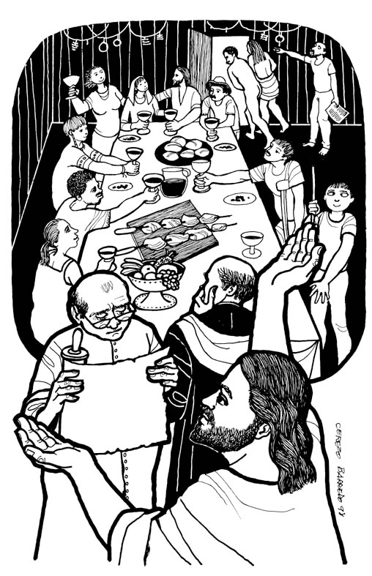
12th October 2014

Today is seventeenth Sunday after Trinity

Hymns at Eucharist : 304 , 82 , 727 ( 576 , 456 , 202 ) , 534

TODAY 10.00 am Parish Eucharist with the Baptism

of Grace Leigh

6.00 pm Evensong

MONDAY 9.30 am Parent and Toddler group
7.30 pm Evening M.U. : speaker : Canon Keith Evans on
the Bells of Santiago

TUESDAY 10.00 am Funeral of Harry Foreman (church) followed
by committal at 11 a.m. in Swansea
Crematorium
2.00 pm Mother’s Union : Holy Eucharist for St. Luke’s Day

THURSDAY 10.30 am Holy Eucharist followed by tea /coffee
6.00 pm Youth Club for school years 4,5,6 ( Crypt )
6.00 pm Clergy Surgery for booking of baptisms, banns and
weddings etc. No appointments necessary.

FRIDAY Diocesan Clergy Synod Day @ Penllegaer
2.00 pm Pentre’rgraig Harvest Service ( church )

SATURDAY 12.00 pm Wedding

NEXT SUNDAY Is. 45:1-7 , 1 Thes. 1:1-10 , Mt. 22:15-22
10.00 am Parish Eucharist with Sunday School

11.30 am Baptism

4.30 pm Confirmation Class

6.00 pm Evensong

RIP : with great sadness we learnt last week of the passing away of our dear friend and verger Harry (Henry ) Foreman. It is impossible to put into words how much Harry has meant to our church family and how many lives he touched with his faith and character. We pray that Harry is now safely re-united with his beloved soulmate Kath. May the souls of the faithful departed through the love and mercy of God rest in peace and rise in Glory.

Harvest: If there are further donations for the Food bank charity we would appreciate receiving them this week so we can send the money.

Shopping Trip : to Worcester on Saturday 29th November. Leaving church at 8.30 and then leaving Worcester at 5.30 p..m. The cost is £15.50 per head - all welcome ( inc. family and friends ). Please speak to Jane Gimblett to book your place ( tel. 07964566652 ). Deposit of £10 by 19th October please.
Parish of Morriston
Weekly Bulletin
St. David’s Church
www.churchinwales.org.uk
www.stdavidsmorriston.co.uk
Registered Charity : 1131686

Vicar : Rev. Hugh Lervy

Tel. : (01792) 771329

Mobile : 07976 725644

e-mail : thevicar@lervy.net

Shoeboxes : if anyone would like to contribute items to place in the shoeboxes for our contribution to the Samaritan’s Purse Charity could you please bring them to church by the end of October. See leaflets or speak to Judith Scott for details of items required. Thankyou.

November Family Service : will be a commemoration by the Sunday School for the WW1 anniversary. If you have any memorabilia from WW1 they can use for a display they would be pleased to borrow them. Items will be photocopied for the display and originals will be returned. A box for items is at the back of the church

200 Club Membership : thankyou to all who have indicated they would like to join for the coming 12 months. We now have enough names to run it so would be grateful to receive the £20 membership as soon as possible.

All Souls Service : Sunday 2nd November at the 6 p.m. Eucharist we will be remembering the Departed. If you would like anyone remembered by name please add to the list at the back of church.

Christmas Fete : to the date this year will be Friday 5th December at 5 p.m. if you can help in preparing / collecting items for the stalls it would be appreciated. More details closed the time.

Remembrance Sunday : 9th November. An act of remembrance will take place during our 10 a.m. service.

Confirmation Service : Bishop John will be joining us in church on Sunday 23rd November to confirm 4 of our young members : Ryan , Grace, Sophie and Ben. Please hold those to be confirmed in your prayer and do try and join us for this important service in the life of our Parish.

