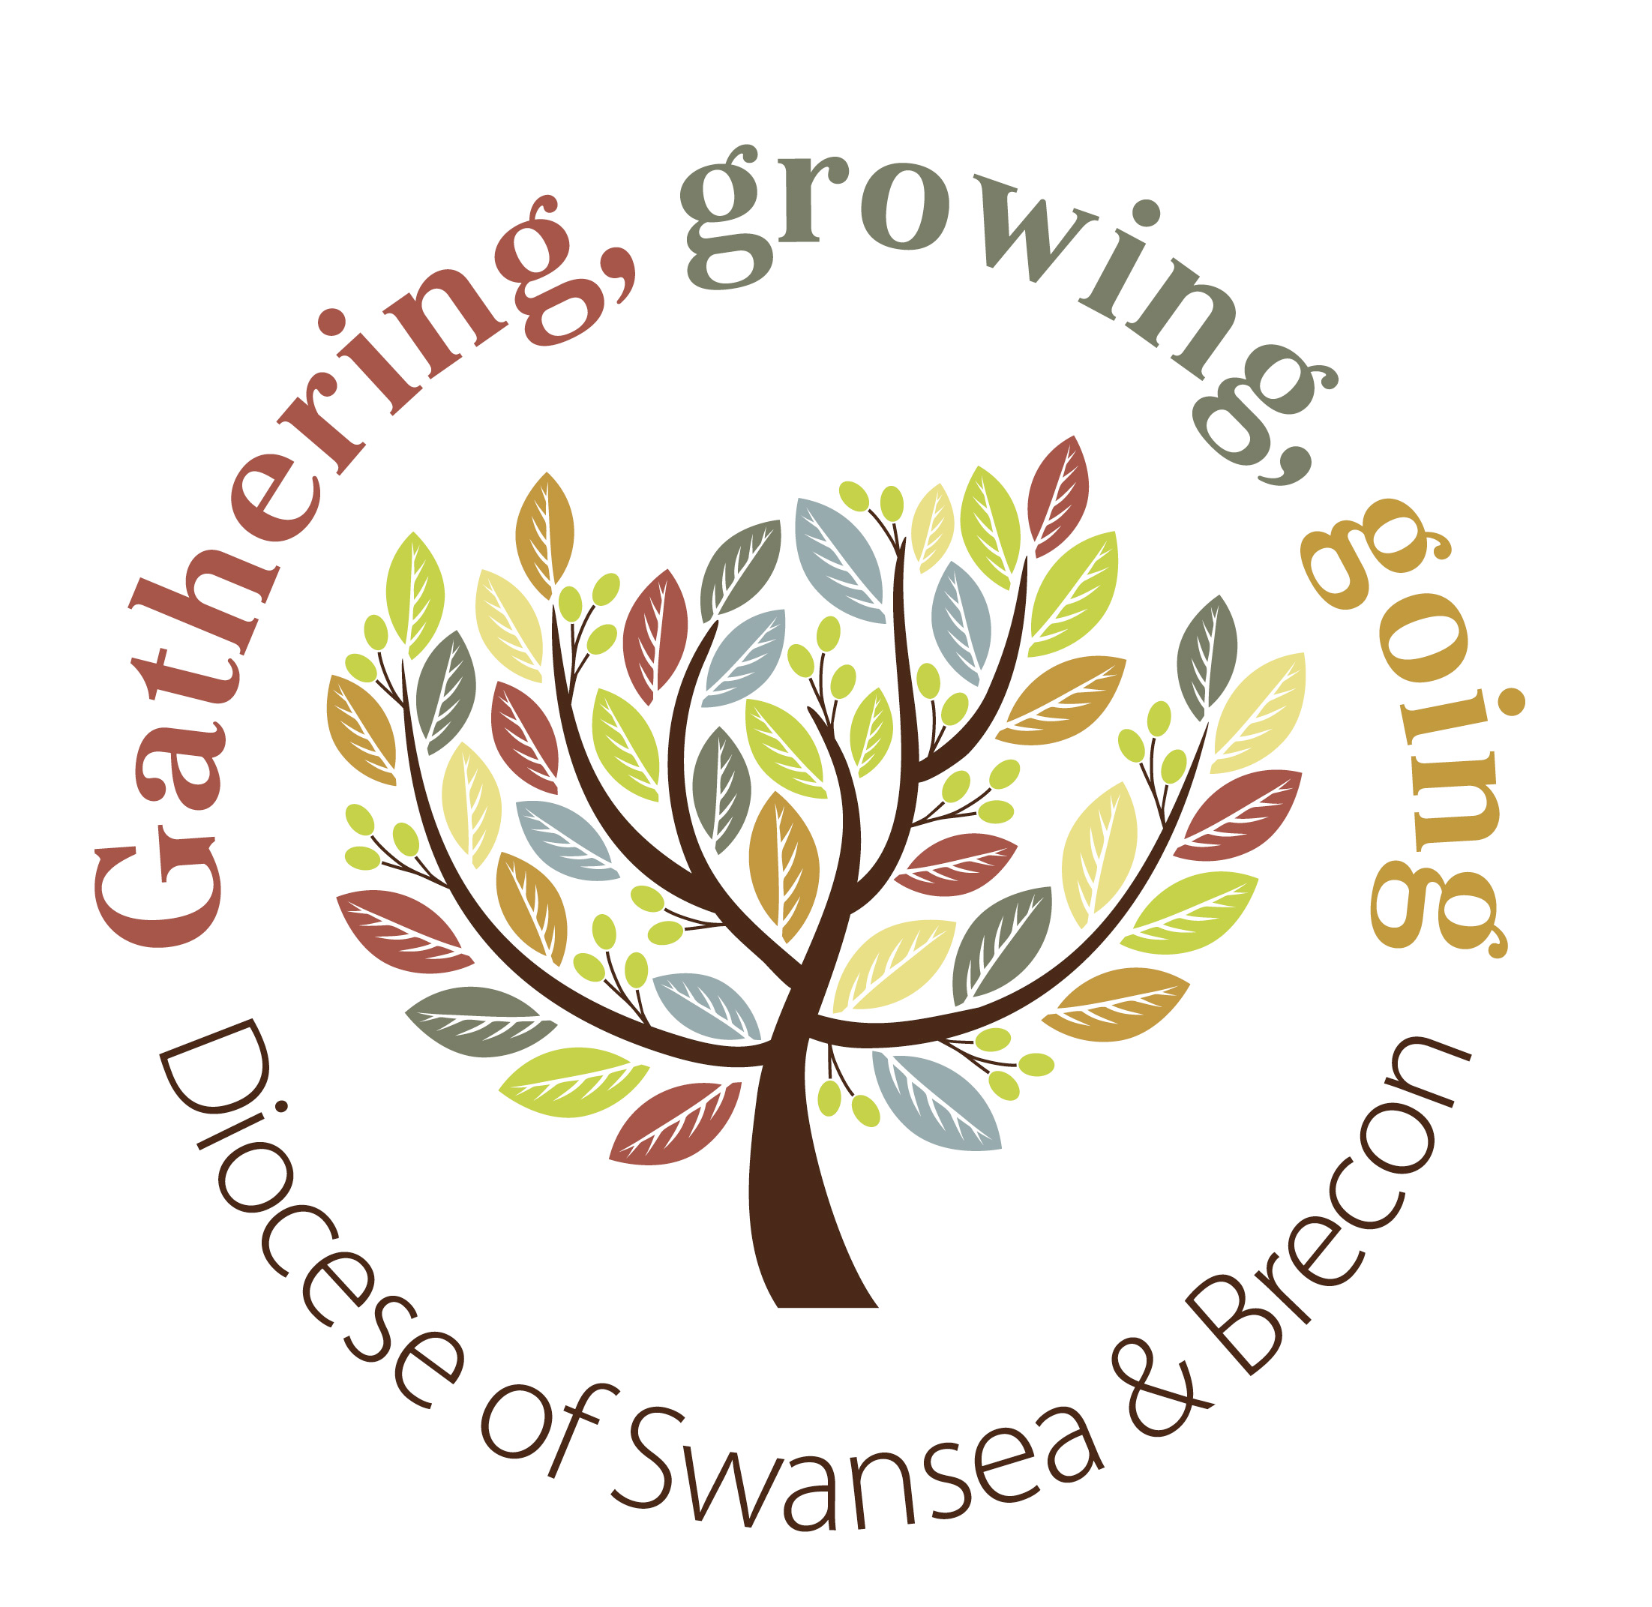
14th September 2014

Today is Holy Cross Day

Hymns at Eucharist : 644 , 658 , 195 , ( 620 , 723 , 517 ) , 54

TODAY 10.00 am Parish Eucharist with Sunday School Party

11.30 am Baptism

6.00 pm Evensong

MONDAY 9.30 am Parent and Toddler group

TUESDAY 2.00 pm Mother’s Union : Speaker: Mr. Howard Mortimer
on “Harry Parr Davies”

THURSDAY 10.30 am Holy Eucharist followed by Charity Coffee
Morning in aid of the Royal British Legion
6.00 pm Youth Club for school years 4,5,6 ( Crypt )
6.00 pm Clergy Surgery for booking of baptisms, banns and
weddings etc. No appointments necessary.

NEXT SUNDAY Prov. 3:13-18, 2 Cor. 4:1-6, Mt. 9:9-13
10.00 am Parish Eucharist with Sunday School

4.30 pm AD Conference at St. Michael’s Church,

Trebanos. Speaker Rev. Helen Rees on

“Working with schools”. Followed by Deanery

Worship.Please note : no Parish evening service

tonight.

PARISH NOTES

Welcome Back : to our Sunday School Members. We hope you have had a good Summer holidays and that you enjoy the Party Planned for you today.

200 Club Winners : 1st. no. 6 Bryan Evans , 2nd. no. 26 Anne Marie Thomas , 3rd. no 11 Nancy Newman . Congratulations to the winners. We are now starting to take names for those who would like to join the 200 Club for the coming year. Numbers who have joined have fallen in the last 12 months so we need to decide if it remain viable. Please invite family and friends to join and add names to the list as soon as you can. Membership is £20 for the year.

Harvest Services : Sunday 5th October. The 10 a.m. service will be a family service led by the Sunday School. We are then hoping to hold a bring and share lunch in the crypt ( please see separate handout ). Then at 6 p.m. our guest preacher will be Canon Padraig Gallagher talking about the work of Food Banks. Donations this year will be given to Food Banks ( tinned and dried food from our young members and cash donations from others ). We will be decorating the church for Harvest on Friday 3rd October.
Parish of Morriston
Weekly Bulletin
St. David’s Church
www.churchinwales.org.uk
www.stdavidsmorriston.co.uk
Registered Charity : 1131686

Vicar : Rev. Hugh Lervy

Tel. : (01792) 771329

Mobile : 07976 725644

e-mail : thevicar@lervy.net
The Church is open Monday to Friday 10 a.m. to Midday for quietness or prayer. Do come in. Please let people know the church is open for all.

November Family Service : will be a commemoration by the Sunday School for the WW1 anniversary. If you have any memorabilia from WW1 they can use for a display they would be pleased to borrow them. Items will be photocopied for the display and originals will be returned. A box for items will be placed at the back of the church

Joint Area Deanery Meeting : to talk about the new proposals for Ministry Areas and United Deaneries will take place here in St. David’s on Wednesday 1st October at 7 p.m. This is an important meeting.

Diocesan Conference : Saturday 11th October at 10 a.m. in Brecon Cathedral.

Welsh Bibles : a big thankyou to those who are helping with the reading of lessons in Welsh at our morning services. However, we currently have no Welsh Bibles left in church. If you have borrowed one to prepare for your readings and still have one at home would you be kind enough to return it to church until the next time you are reading. Thankyou.

Dear all, just to say I will be leaving my job in the genetic department of the RSPB. Sorry for the round robin.

