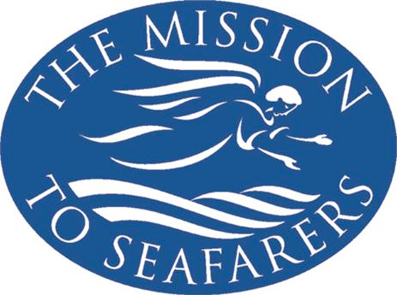
13th July 2014

Today is the fourth Sunday after Trinity ( Sea Sunday )

Hymns at Eucharist : 716 , 532 , 32 , ( 201 , 662 , 579 ) , 221

TODAY 10.00 am Family Eucharist led by the Sunday School -
we are joined by children from Chernobyl
Children’s Lifeline. WELCOME TO ALL WHO
JOIN US FROM THIS CHARITY.

6.00 pm Evensong

MONDAY 9.30 am Parent and Toddler group
9.45 am Deanery Clergy Chapter Meeting ( Ystalyfera )

TUESDAY 2.00 pm Funeral of Kath Foreman ( Church ) followed by
commit all at Swansea Crematorium at 3 p.m.

WEDNESDAY 2.00 pm Funeral of Jean Harrison ( Church ) followed by
committal at Swansea Crematorium at 3 p.m.

THURSDAY 10.30 am Holy Eucharist followed by tea /coffee
6.00 pm Youth Club for school years 4,5,6 ( Crypt )
4.00 pm Bus leaves St. David’s for licensing of Andrew
Perrin to the Ithon valley Parishes at 7 p.m.
6.00 pm Clergy Surgery for booking of baptisms, banns and
weddings etc. No appointments necessary.

SATURDAY 10.30 am Coffee morning at the home of Nan Morris.
ALL ARE WELCOME - please ask if you need
directions.
NEXT SUNDAY Wis. 12:13-19, Rom. 8:12-25, Mt. 13:24-43
10.00 am FAMILY Eucharist with Sunday School
Presentation - do let our young members
know. The Sunday School will then take a
break for the Summer.

6.00 pm Evensong

PARISH NOTES

RIP : with sadness we learnt of the passing away of Jean Harrison last week. We extend our love and prayer to Jean’s family. May the souls of the departed through God’s love and mercy rest in peace.

Worship Leaders Training : would you like to become involved in the leading of worship in St. David’s - especially at family services and evening services. If you would like to take part in a Diocesan Training scheme please let the Vicar know. If you want to know more about this please ask !!
Parish of Morriston
Weekly Bulletin
St. David’s Church
www.churchinwales.org.uk
www.stdavidsmorriston.co.uk
Registered Charity : 1131686

Vicar : Rev. Hugh Lervy

Tel. : (01792) 771329

Mobile : 07976 725644

e-mail : thevicar@lervy.net
The Church is open Monday to Friday 10 a.m. to Midday for quietness or prayer. Do come in. Please let people know the church is open for all.

Sea Sunday : Today. We hold in our prayers the work of the Mission to Seafarers. Prayers for seafarers: Lord God, Creator of land and sea, bless those who work at sea. Be with them in fair weather and foul, in danger or distress. Strengthen them when weary, lift them up when down and comfort them when far from their loved ones. In this life, bring them safely to shore and, in the life to come, welcome them to your kingdom. For Jesus Christ's sake.

Lifts to Church : due to changes in circumstances in some who were giving lifts we are looking for new volunteers to help transport people to church on Sunday mornings. If you have space in your car and can help out we would be Very Pleased to hear form you. Please let the Vicar or the Churchwardens know.

Thankyou very much : to all who helped provide such a wonderful spread for our buffet lunch last Sunday. Thankyou also to all who contributed to the leaving gift for Andrew.

Thankyou : to those who helped organise our Cheese and Wine evening last night - eps. to John and Diane.

Best wishes : many of our church members are now taking Summer holidays. may we wish you all a relaxing break if you are going away. We look forward to seeing you refreshed on your return. Please keep in touch with those missing from worship. Myself or a member of the Pastoral visiting team will gladly call and see those requiring home visits. Please let us know !!

I've just been on a once-in-a-lifetime holiday.
I'll tell you what, never again

