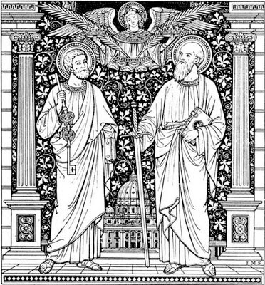

29th June 2014

Today is the feast of St. Peter and Paul, Apostles ( Trinity 2 )

Hymns at Eucharist : 19 , 169 , 626 , ( 318 , 367 , 636 ) , 695

TODAY 10.00 am Parish Eucharist with Sunday School

11.30 am Baptism

6.00 pm Evensong

MONDAY 9.30 am Parent and Toddler group
7.30 pm Evening M.U.

TUESDAY 6.30 pm Men’s Society ( The Eagle )

THURSDAY 10.30 am Holy Eucharist followed by tea /coffee
6.00 pm Youth Club for school years 4,5,6 ( Crypt )
6.00 pm Clergy Surgery for booking of baptisms, banns and
weddings etc. No appointments necessary.

SATURDAY 8.30 am Church Shopping Trip to Bath

NEXT SUNDAY Zech. 9:9-12, Rom. 7:15-25, Mt. 11:16- 30
10.00 am Parish Eucharist and Farewell to our Curate
Andrew - followed by a buffet Lunch

4.30 pm Deanery BBQ and Songs of Praise at

Trebanos Church to celebrate the 90th

Anniversary of the Diocese

PARISH NOTES

Happy Birthday ( in his absence) : to our curate Andrew for today.

Provincial Selection Committee : we hold Anthony Porter in our prayers this week. From Tuesday he will be away a few nights having his vocation to Ministry discerned by the selection Committee of the Church in Wales. We wish him well for this process.

Confirmation Service : Bishop John will be joining us later in the year for a service of Confirmation. If you would like to be confirmed this year please complete and return an application form.

Don’t forget : that Andrew’s last Service with us as curate of St. David’s will be NEXT SUNDAY at 10 a.m. I hope as many as possible will be able to join us as we thank Andrew for his ministry with us. FOLLOWING THIS SERVICE WE WOULD LIKE TO SHARE IN A BUFFET LUNCH IN THE CRYPT. IF YOU CAN HELP BY BRINGING A PLATE OF FOOD PLEASE LET THE WARDENS KNOW TODAY WHAT YOU CAN BRING. YOUR HELP WOULD BE APPRECIATED.
Parish of Morriston
Weekly Bulletin
St. David’s Church
www.churchinwales.org.uk
www.stdavidsmorriston.co.uk
Registered Charity : 1131686

Vicar : Rev. Hugh Lervy

Tel. : (01792) 771329

Mobile : 07976 725644

e-mail : thevicar@lervy.net
Assistant Curate:
Rev. Andrew Perrin
Tel. 428080
The Church is open Monday to Friday 10 a.m. to Midday for quietness or prayer. Do come in. Please let people know the church is open for all.

Andrew’s Licensing : to his new Parish will take place on Thursday 17th July at 7 p.m. in the Ithon Valley Parish. We are hoping to support Andrew at this and if enough are able to join us we will run a bus. Please note that with the distance and timing of the service we will probably be leaving about 4 p.m. and returning to Morriston about Midnight. A list is at the back of church if you would be interested in coming on a bus - please sign as soon as you can.

Cheese and Wine evening with entertainment : Saturday 12th July in the crypt. Tickets are £5 and are now available - do try and join us - family and friends are welcome to join us for what should be an enjoyable social evening.

Coffee Morning : Nan Morris is once again kindly opening her house and garden to us on Saturday 19th July from 10.30. Tickets are £1 - all are very welcome to come along.

Sunday School Presentation Service : 10 a.m. on 20th July.

Worship Leaders Training : would you like to become involved in the leading of worship in St. David’s - especially at family services and evening services. If you would like to take part in a Diocesan Training scheme please let the Vicar know. If you want to know more about this please ask !!

