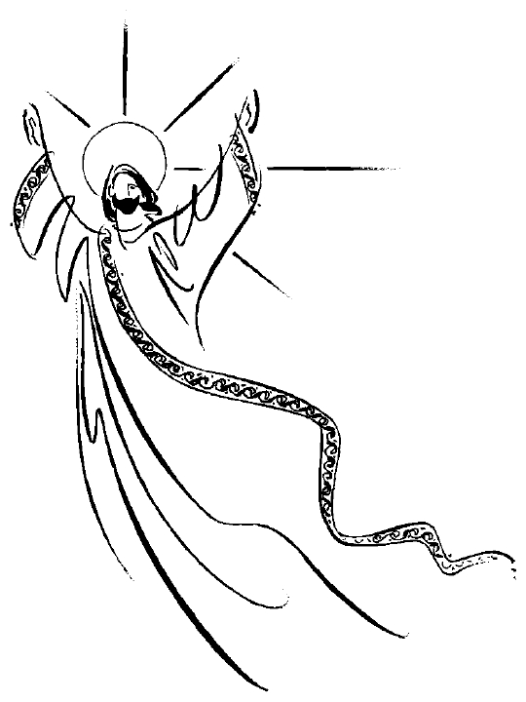
25th May 2014

Today is the sixth Sunday of Easter

Hymns at Eucharist : 352 , 35 , 12 , ( 386 , 34 , 620 ) , 314

TODAY 10.00 am Parish Eucharist with Sunday School

11.30 am Baptism

2.00 pm Baptism

6.00 pm Evensong

MONDAY Bank Holiday

THURSDAY ASCENSION DAY
10.30 am Holy Eucharist followed by tea /coffee
6.00 pm Youth Club for school years 4,5,6 ( Crypt )
6.00 pm Clergy Surgery for booking of baptisms, banns and
weddings etc. No appointments necessary.

FRIDAY 10.00 am Prayer Fellowship Group ( Crypt ) - ALL WELCOME

NEXT SUNDAY Acts 1:6-14 , 1 Pet. 4:12-5:11, Jn. 17:1-11
10.00 am Family Eucharist led by the Sunday School
- followed by tea / coffee

6.00 pm Holy Eucharist and Licensing of the Lay

Pastoral Visiting Team.

Preacher and Celebrant : Bishop John

DO TRY AND JOIN US

PARISH NOTES

Pastoral Lay Visiting Team : Bishop John will be joining us in the Parish on NEXT SUNDAY at 6 p.m. to licence our new team. I do hope as many of our church members as possible will be able to join us to support those being licensed. As you know the numbers attending our services has been affected by illness for many months. We are hoping this new team will add a valuable contribution to the pastoral support we are able to offer as a church family.

PCC Meeting : Sunday 15th June at 4.30 p.m.

Church Shopping Trip : to Bath on Saturday 5th July. Tickets are £15 and all are very welcome to join this trip. Please see Jane Gimlett to book your place. Do invite family and friends to come along.
Parish of Morriston
Weekly Bulletin
St. David’s Church
www.churchinwales.org.uk
www.stdavidsmorriston.co.uk
Registered Charity : 1131686

Vicar : Rev. Hugh Lervy

Tel. : (01792) 771329

Mobile : 07976 725644

e-mail : thevicar@lervy.net
Assistant Curate:
Rev. Andrew Perrin
Tel. 428080
The Church is open Monday to Friday 10 a.m. to Midday for quietness or prayer. Do come in. Please let people know the church is open for all.

Pentecost Sunday ( 8th June ) : the 6 p.m. will be service of Pentecost Songs of Praise. Do try and come along.

Wedding Blessing : on Thursday 12th June at our 10.30 a.m. Service two former members of St. David’s Daryl and Karen will be returning ( with family and friends ) to share in prayers of blessing and renewal of their marriage. Following the service they are inviting those present to join them in the crypt for a buffet lunch.

Coffee Morning : in aid of the Diocesan Widows, Orphans and Dependants Society will be held on Thursday 19th June following the 10.30 service. Tickets are now available.

Thankyou : Ven. Peter Hill would like to thank all in our church family for their prayers and good wishes following his recent appointment as a Bishop.

Thankyou : to all who came to the concert on 11th May. £865 was raised ( of which we have given £500 to the Velindre Cancer Centre).

Thankyou : Bishop John has asked to pass on his thanks to all who contributed so generously to his Lent Appeal. £500 has been sent from the Parish.

Services : if you can’t join us at your “usual” service on a particular week can I encourage you to come along to an alternative - esp. the Sunday evening service or the Mid-week service on a Thursday. It is always good to see new faces at our services !

Confirmation Service : Bishop John will be joint us later in the year for a service of Confirmation. If you would like to be confirmed this year please complete and return an application form. Classes will be arranged in the coming weeks.

