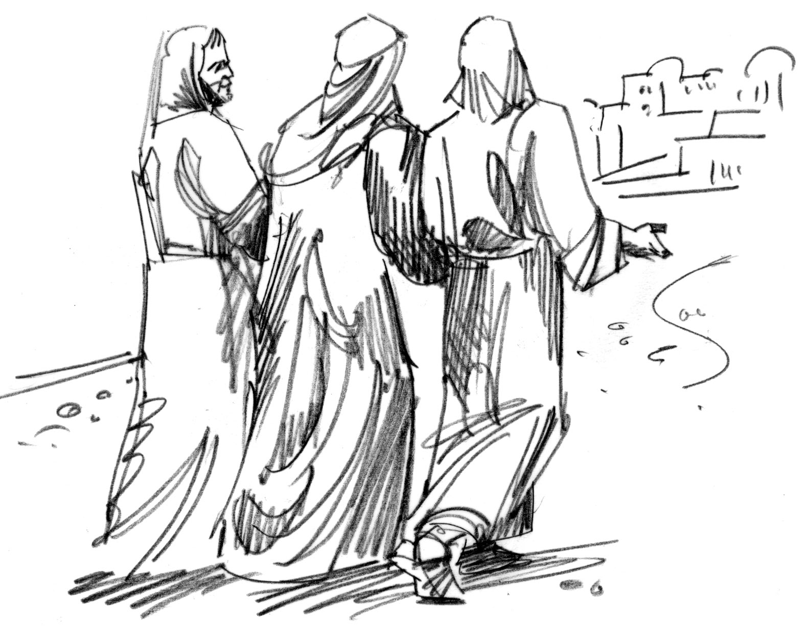
4th May 2014

Today is the third Sunday of Easter

Hymns at Eucharist : 580 , 532 , 299 , ( 228 , 381 , 77 ) , 716

TODAY 10.00 am Parish Eucharist followed by tea / coffee

2.00 pm Wedding

6.00 pm Holy Eucharist

MONDAY BANK HOLIDAY

TUESDAY 2.00 pm Mother’s Union
6.30 pm Men’s Society ( the Eagle )

WEDNESDAY 7.30 pm Bible Study Group at 2 Mynydd Garnlwydd Road
(2nd and 4th Wednesday each month)

THURSDAY 10.30 am Holy Eucharist followed by tea /coffee
6.00 pm Youth Club for school years 4,5,6 ( Crypt )
6.00 pm Clergy Surgery for booking of baptisms, banns and
weddings etc. No appointments necessary.

FRIDAY 10.00 am Church working party - all welcome

NEXT SUNDAY CHRISTIAN AID WEEK
Acts 2:42-47, 1 Pet. 2:19-25, Jn. 10:1-10
10.00 am Parish Eucharist with Sunday School

6.00 pm CONCERT - SEE NOTES

PARISH NOTES

CONCERT NEXT SUNDAY at 6 p.m.
given by Richard, Jonathan and James Mainwaring, the Belmont Male Choir and the choir of Bryn School , Llanelli. Tickets are £5 in aid of
The Velindre Cancer Centre and Church funds.
PLEASE HELP TO SELL TICKETS.
DO TRY AND GIVE YOUR FULL SUPPORT TO WHAT WILL BE A VERY ENJOYABLE EVENING.

Thankyou: Iris Thomas would like to thank everyone for their cards and phone calls following her recent fall. We are pleased to learn Iris is on the mend and hoping to be back with us soon.
Parish of Morriston
Weekly Bulletin
St. David’s Church
www.churchinwales.org.uk
www.stdavidsmorriston.co.uk
Registered Charity : 1131686

Vicar : Rev. Hugh Lervy

Tel. : (01792) 771329

Mobile : 07976 725644

e-mail : thevicar@lervy.net
Assistant Curate:
Rev. Andrew Perrin
Tel. 428080
The Church is open Monday to Friday 10 a.m. to Midday for quietness or prayer. Do come in. Please let people know the church is open for all.

Thankyou : Grey Phillips has asked me to thanks everyone who gave Evening Post tokens to him recently for the Cardiac Rehabilitation Unit. £426.13 was raised by the unit.

Council of Churches meeting : Tuesday 13th May at 7.15 p.m. in Aenon Chapel.

Cathedral Friends : if you wish to join the Friends of Brecon Cathedral for the coming year please let Marilyn Lewis have your donation by NEXT Sunday.

Thankyou : to Anne Lewis who organised our Parish Meal at the Golf Club on Friday Night. I hope you all enjoyed.

AD Conference : Sunday 18th May at 4.30 p.m. in Llansamlet Church. The speaker will be Rev. Ian Rees on “Lay Training opportunities”.

PCC Meeting : Sunday 15th June at 4.30 p.m.

Thankyou : to all who were able to join us for our Parish Meeting last Sunday. Please hold in your prayers those elected to serve as your representatives. Vicar’s Warden : Bob Lloyd, People’s Warden : Mike Godrich. PCC Members : Nicola Gimlett, Anne Lewis, Gaynor Demery, Myra James , Anthony Porter , Richard Leigh, Rita Randell, Grey Phillips. THE AFFIRMATION PRAYERS FOR THOSE ELECTED WILL TAKE PLACE DURING OUR SERVICE THIS MORNING.

Sunday School : following the Easter Break our Sunday School will resume at 10 a.m. Next Sunday morning.

