Parish of Morriston
St. David’s Church
Weekly Bulletin
www.churchinwales.org.uk
www.stdavidsmorriston.co.uk
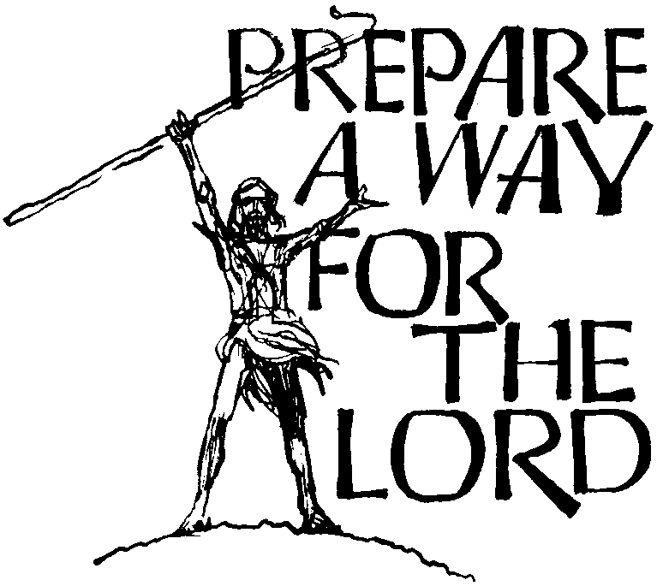

Vicar : Rev. Hugh Lervy

Tel. / Fax. : (01792) 771329

Mobile : 07976 725644

e-mail : thevicar@fsmail.net

Would you please let the Vicar know of people who
need visiting at home or in hospital. Thankyou

30th November 2008 Today is the first Sunday of Advent

Hymns at Eucharist : 259 , 92 , 367 , ( 691 , 459 , 381 ) , 405

TODAY 9.30 am Parish Eucharist with Sunday School

11.15 am Baptism

5.00 pm Youth Service and Youth Club

6.00 pm ADVENT SERVICE OF HYMNS, READINGS

AND PRAYER

MONDAY 10.00 am Parent and Toddler group
7.30 pm Evening M.U. : Speaker Margaret Miles on
Christmas Fayre

TUESDAY 2.00 pm Mother’s Union end of session Christmas
Symposium
6.30 pm Men’s Society Christmas Dinner at the
Welcome Inn

WEDNESDAY 10.30 am **** HELP NEEDED TO PUT UP CHRISTMAS
TREES AND CLEAR CHURCH GROUNDS OF
LEAVES ****
7.00 pm Bible Study Group at 2 Mynydd Garnlwyd Rd.
- every fortnight – please ask for details

THURSDAY 10.30 am Holy Eucharist
Followed by refreshments in the crypt
6.00 pm Youth Club for school years 4,5,6 ( Crypt )
6.00 pm Clergy Surgery for booking of baptisms, banns and
weddings etc. No appointments necessary.
7.00 pm Holy Eucharist

FRIDAY 4.30 pm A service to switch on Christmas Tree lights
5.00 pm Christmas Fete ( SEE NOTES )

NEXT SUNDAY Readings : Is. 40:1-11, 2 Pet. 3:8-15, Mk. 1:1-8
9.30 am Parish Eucharist with Sunday School
Followed by refreshments
12.30 pm Bus leaves St. David’s for trip to see Santa at the Gwilli Railway
6.00 pm Holy Eucharist

Smarties : we are holding our traditional collection of 20p pieces in your Smarties tubes. Please return the tube at the Christmas services with your offering. The money will be used to help children at Oakwood and Dyfed wards in Morriston hospital, the Welsh Dragon’s burns club and the Diocesan board for social responsibility.

Christmas Fete : THIS COMING FRIDAY at 5 p.m. : DO TRY AND JOIN US. The crypt will be open on Friday from 11 a.m. to 12.30 and then from 3 p.m. onwards. We would appreciate items for the stalls to be brought to church. Please give the fete your FULL support.

Gwilli Railway Trip : next Sunday. If you have put your name down but are unable to make it please let Diane know ( 517606 ) as soon as you can as we have a reserve list and it may be your place could be used. Please have lunch before the journey and wrap up warm !!

Carol service for the bereaved : organised by the ABM hospital trust on Tuesday 9th December at 7 pm here in St. David’s.

Carol Singing : in the ground of our church organised by the Council of Churches on Saturday 13th December from 11 a.m. – all are welcome.

Carol Service : with the Salvation Army on Sunday 14th December at 6 p.m.

Craft Morning : for all children on Saturday 20th December from 10 a.m. to 12 Midday. If you can help supervise this event please stay for a short meeting at the end of our service this morning.

Christingle and Nativity service : Sunday 21st December at 4 p.m.

Christmas Eve : 6.30 pm Family Eucharist and 11.30 pm Midnight Mass. Christmas Day 10 a.m. Holy Eucharist.

Parish Meal : 9th January in the Barn with entertainment provided by Gordon Morgan and his band ( A Christmas CD played by Gordon is currently on sale for church funds at the back of church ) : don’t forget to sign the list if you would like to join us. All are very welcome.

Christmas Cards : a board will be put up at the back of church from next Sunday if you wish you send Christmas greetings to your friends in church.

Thankyou : to all who supported our coffee morning for Diabetes UK on Thursday this week.

