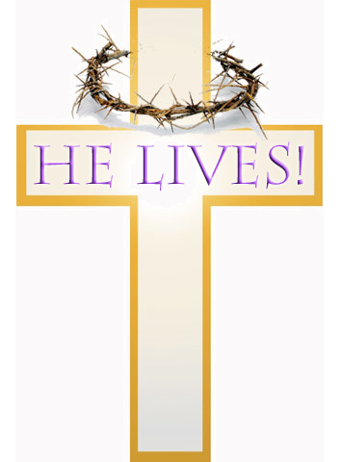
20th April 2014 Today is Easter Day

JESUS CHRIST IS RISEN TODAY ! ALLELUIA !

Hymns at Eucharist : 348 , 637 , 8 , ( 361 , 676 , 274 ) , 449

TODAY 10.00 am Parish Eucharist

5.00 pm Easter Praise with the Salvation Army on

Morfydd Street - do try and join us as we

share in Easter Worship.

MONDAY Bank Holiday Monday

WEDNESDAY 7.30 pm Bible Study Group at 2 Mynydd Garnlwydd Road
(2nd and 4th Wednesday each month)

THURSDAY 10.30 am Holy Eucharist followed by tea /coffee
6.00 pm Clergy Surgery for booking of baptisms, banns and
weddings etc. No appointments necessary.

FRIDAY 10.00 am Prayer Fellowship Group ( crypt )
- all welcome
10.00 am Church working party - all welcome

SATURDAY 12.00 pm Wedding

NEXT SUNDAY Acts 2:14-32, ! Pet. 1:3-9, Jn. 20:19-31
10.00 am Parish Eucharist
- followed by the Annual Parish Meeting

12.00 pm Baptism

6.00 pm Evensong

WELCOME TO ALL WHO JOIN US FOR OUR
EASTER SERVICES TODAY.
WISHING YOU ALL A VERY HAPPY EASTER FROM THE CLERGY AND OFFICERS OF ST. DAVID’S

Lent Collection : donations given on the plate near the door will be given to the Bishop’s Lent Appeal for Charities - TODAY will be the final chance for donations to be made. Thankyou.

Thankyou : to all who worked so hard to prepare the church for our services today. Thankyou to all who joined us for our lent talks through lent and our services through Holy week - a special thanks to the lay readers who have helped with leading our worship. Thankyou also to those who worked so hard at the Children’s Craft morning on Friday.

Parish of Morriston
Weekly Bulletin
St. David’s Church
www.churchinwales.org.uk
www.stdavidsmorriston.co.uk
Registered Charity : 1131686

Vicar : Rev. Hugh Lervy

Tel. : (01792) 771329

Mobile : 07976 725644

e-mail : thevicar@lervy.net
Assistant Curate:
Rev. Andrew Perrin
Tel. 428080
The Church is open Monday to Friday 10 a.m. to Midday for quietness or prayer. Do come in. Please let people know the church is open for all.

RIP : we offer our love and prayer to Margarette Wilkinson and family following the passing away on John this week. May the souls of the departed through the love and mercy of God rest in peace.

Parish Meal : on FRIDAY 2nd MAY ( 7 for 7.30 pm ) in Morriston Golf Club. The entertainment will be given by Rev. Eirian Wynn. Eirian will be giving a magic show. DO COME AND JOIN US AT THIS SOCIAL EVENT. Details of food etc are on the poster. Please sign up BY NEXT SUNDAY. Family and friends are very welcome.

Annual Parish Meeting : NEXT Sunday following the morning service - please bring your copies of the Annual Report with you. If you wish to stand for PCC or as warden for this coming year the nomination list is now at the back of church. Permission must be gained from those nominated before adding them to the list. The next meeting of the PCC will be on Sunday 15th June at 4.30 p.m. ( please note the change of date ). THE AFFIRMATION PRAYERS FOR THOSE ELECTED WILL TAKE PLACE DURING OUR MORNING SERVICE ON 4th MAY.

CONCERT SUNDAY 11th MAY at 6 p.m. : given by Richard, Jonathan and James Mainwaring, the Belmont Male Choir and the choir of Bryn School , Llanelli. Tickets are £5 in aid of The Velindre Cancer Centre and Church funds. PLEASE HELP TO SELL TICKETS.

Cathedral Friends : if you wish to join the Friends of Brecon Cathedral for the coming year please let Marilyn Lewis have your donation as soon as possible.

AD Conference : Sunday 18th May at 4.30 p.m. in Llansamlet Church. The speaker will be Rev. Ian Rees on “Lay Training opportunities".

