6th April 2014

Today is the fifth Sunday of Lent ( Passion Sunday )

Hymns at Eucharist : 32 , 84 , 723 , ( 165 , 658 , 87) , 195

TODAY 10.00 am Parish Eucharist with Sunday School -

followed by a short meeting for those able to

help with the Good Friday Craft morning.

6.00 pm Lent Talk : A simple guide to Christianity

MONDAY 9.30 am Parent and Toddler group

TUESDAY 2.00 pm Mother’s Union : Speaker : Roy Gambold
“A simple guide to Christianity”

WEDNESDAY 7.30 pm Bible Study Group at 2 Mynydd Garnlwydd Road
(2nd and 4th Wednesday each month)

THURSDAY 10.30 am Holy Eucharist followed by tea /coffee
6.00 pm Youth Club for school years 4,5,6 ( Crypt )
6.00 pm Clergy Surgery for booking of baptisms, banns and
weddings etc. No appointments necessary.

FRIDAY 10.00 am Church working party - all welcome

NEXT SUNDAY Palm Sunday
Is. 50:4-9, Phil. 2:5-11 , Mt. 2614 - 27:66
10.00 am Parish Eucharist with Sunday School

11.45 am Baptism

6.00 pm Lent Talk : A simple guide to Pilgrimage

Lent Collection : donations given on the plate near the door will be given the Bishop’s Lent Appeal for Charities.

Parish Meal : on FRIDAY 2nd MAY ( 7 for 7.30 pm ) in Morriston Golf Club. The entertainment will be given by Rev. Eirian Wynn. Eirian will be giving a magic show. DO COME AND JOIN US AT THIS SOCIAL EVENT. Details of food etc are on the poster. Please sign up as soon as you can. Family and friends are very welcome.

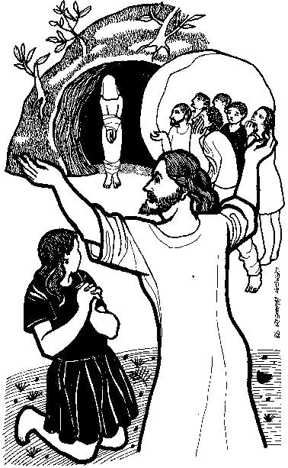
Church Cleaning and Flowers : if you can help on Saturday 19th April from 10 a.m. to prepare the church for Easter it would be much appreciated. Our “Flower Ladies” are asking for spring flowers ( esp. Yellow and white flowers / catkins / Pussy Willow ). I have also been asked to say there are a few gaps on the flower rota in the porch if anyone wishes to add their name.
Parish of Morriston
Weekly Bulletin
St. David’s Church
www.churchinwales.org.uk
www.stdavidsmorriston.co.uk
Registered Charity : 1131686

Vicar : Rev. Hugh Lervy

Tel. : (01792) 771329

Mobile : 07976 725644

e-mail : thevicar@lervy.net
Assistant Curate:
Rev. Andrew Perrin
Tel. 428080
The Church is open Monday to Friday 10 a.m. to Midday for quietness or prayer. Do come in. Please let people know the church is open for all.

Annual Parish Meeting : Sunday 27th April following the morning service.

Thankyou : to the Sunday School who led our service last week and to the ladies who prepared our cream tea in the afternoon. Although not many in the cream tea the fellowship was greatly enjoyed.

Thankyou : Glenys Jones and Bryan and their families would like to thank everyone for their cards, prayers , kind words etc following the recent passing away of Dilys.

HOLY WEEK AND EASTER SERVICES

NEXT SUNDAY : Palm Sunday
10 a.m. Parish Eucharist
6 p.m. Lent talk : A simple guide to Pilgrimage
Monday 14th April :
7 p.m. Stations of the Cross
Tuesday 15th April
12 Midday Chrism Eucharist ( Brecon Cathedral)
2 p.m. Mother’s Union : Holy Eucharist
7 p.m. Devotional Service
Wednesday 16th April
7 p.m. Devotional Service
Maundy Thursday : 17th April
10.30 a.m. Holy Eucharist
7 p.m. Sung Eucharist
Good Friday : 18th April
9.30 a.m. March of Witness
10 a.m. Craft Morning for children
2 p.m. Holy Hour Devotional Service
7 p.m. Devotional Service
Saturday : 19th April : Easter Eve
10 a.m. Church Cleaning and decorating
7 p.m. Devotional Service
EASTER DAY : 20th April
10 a.m. PARISH EUCHARIST
5 p.m. SONGS OF PRAISE IN THE SALVATION ARMY

