23rd March 2014

Today is the third
Sunday of Lent

Hymns at Eucharist : 205 , 44 , 683 , ( 297 , 382 , 686 ) , 343

TODAY 10.00 am Parish Eucharist with Sunday School

4.30 pm PCC Meeting

6.00 pm Lent Talk ( crypt ) : A simple guide to

Christian Discipleship

MONDAY 9.30 am Parent and Toddler group
7.30 pm Evening M.U.: Speaker : Dr. C Graves-Brown on
“The Egypt Centre”

TUESDAY 2.00 pm Mother’s Union : Holy Eucharist with Branch
Enrolment and talk on “A simple Guide to being a
Disciple”
7.00 pm Mother’s Union Deanery Lady Day Service
(Llansamlet Church)

WEDNESDAY 7.30 pm Bible Study Group at 2 Mynydd Garnlwydd Road
(2nd and 4th Wednesday each month)

THURSDAY 10.30 am Holy Eucharist followed by tea /coffee
6.00 pm Youth Club for school years 4,5,6 ( Crypt )
6.00 pm Clergy Surgery for booking of baptisms, banns and
weddings etc. No appointments necessary.

FRIDAY 10.00 am Prayer Fellowship Group ( Crypt ) - all are
welcome to come along.
10.00 am Church working party - all welcome

SATURDAY 11.30 am Wedding
2.30 pm Rev. Edwin Phillips will be making his vows to a
single consecrated life ( St. Theodore’s Church,
Port Talbot ) - all are welcome.

NEXT SUNDAY MOTHERING SUNDAY
10.00 am Family Eucharist led by our Sunday School

4.00 pm CREAM TEA AND SONGS OF PRAISE
Parish of Morriston
Weekly Bulletin
St. David’s Church
www.churchinwales.org.uk
www.stdavidsmorriston.co.uk
Registered Charity : 1131686

(Please note there is no 6 p.m. service)

PARISH NOTES

Prayers : we hold Anthony Porter in our prayers who tomorrow with be meeting with the Diocesan Selection Committee to have his vocation to Ministry discerned.

Thankyou : to all who supported our coffee morning for the Open the Book project on Thursday this week.

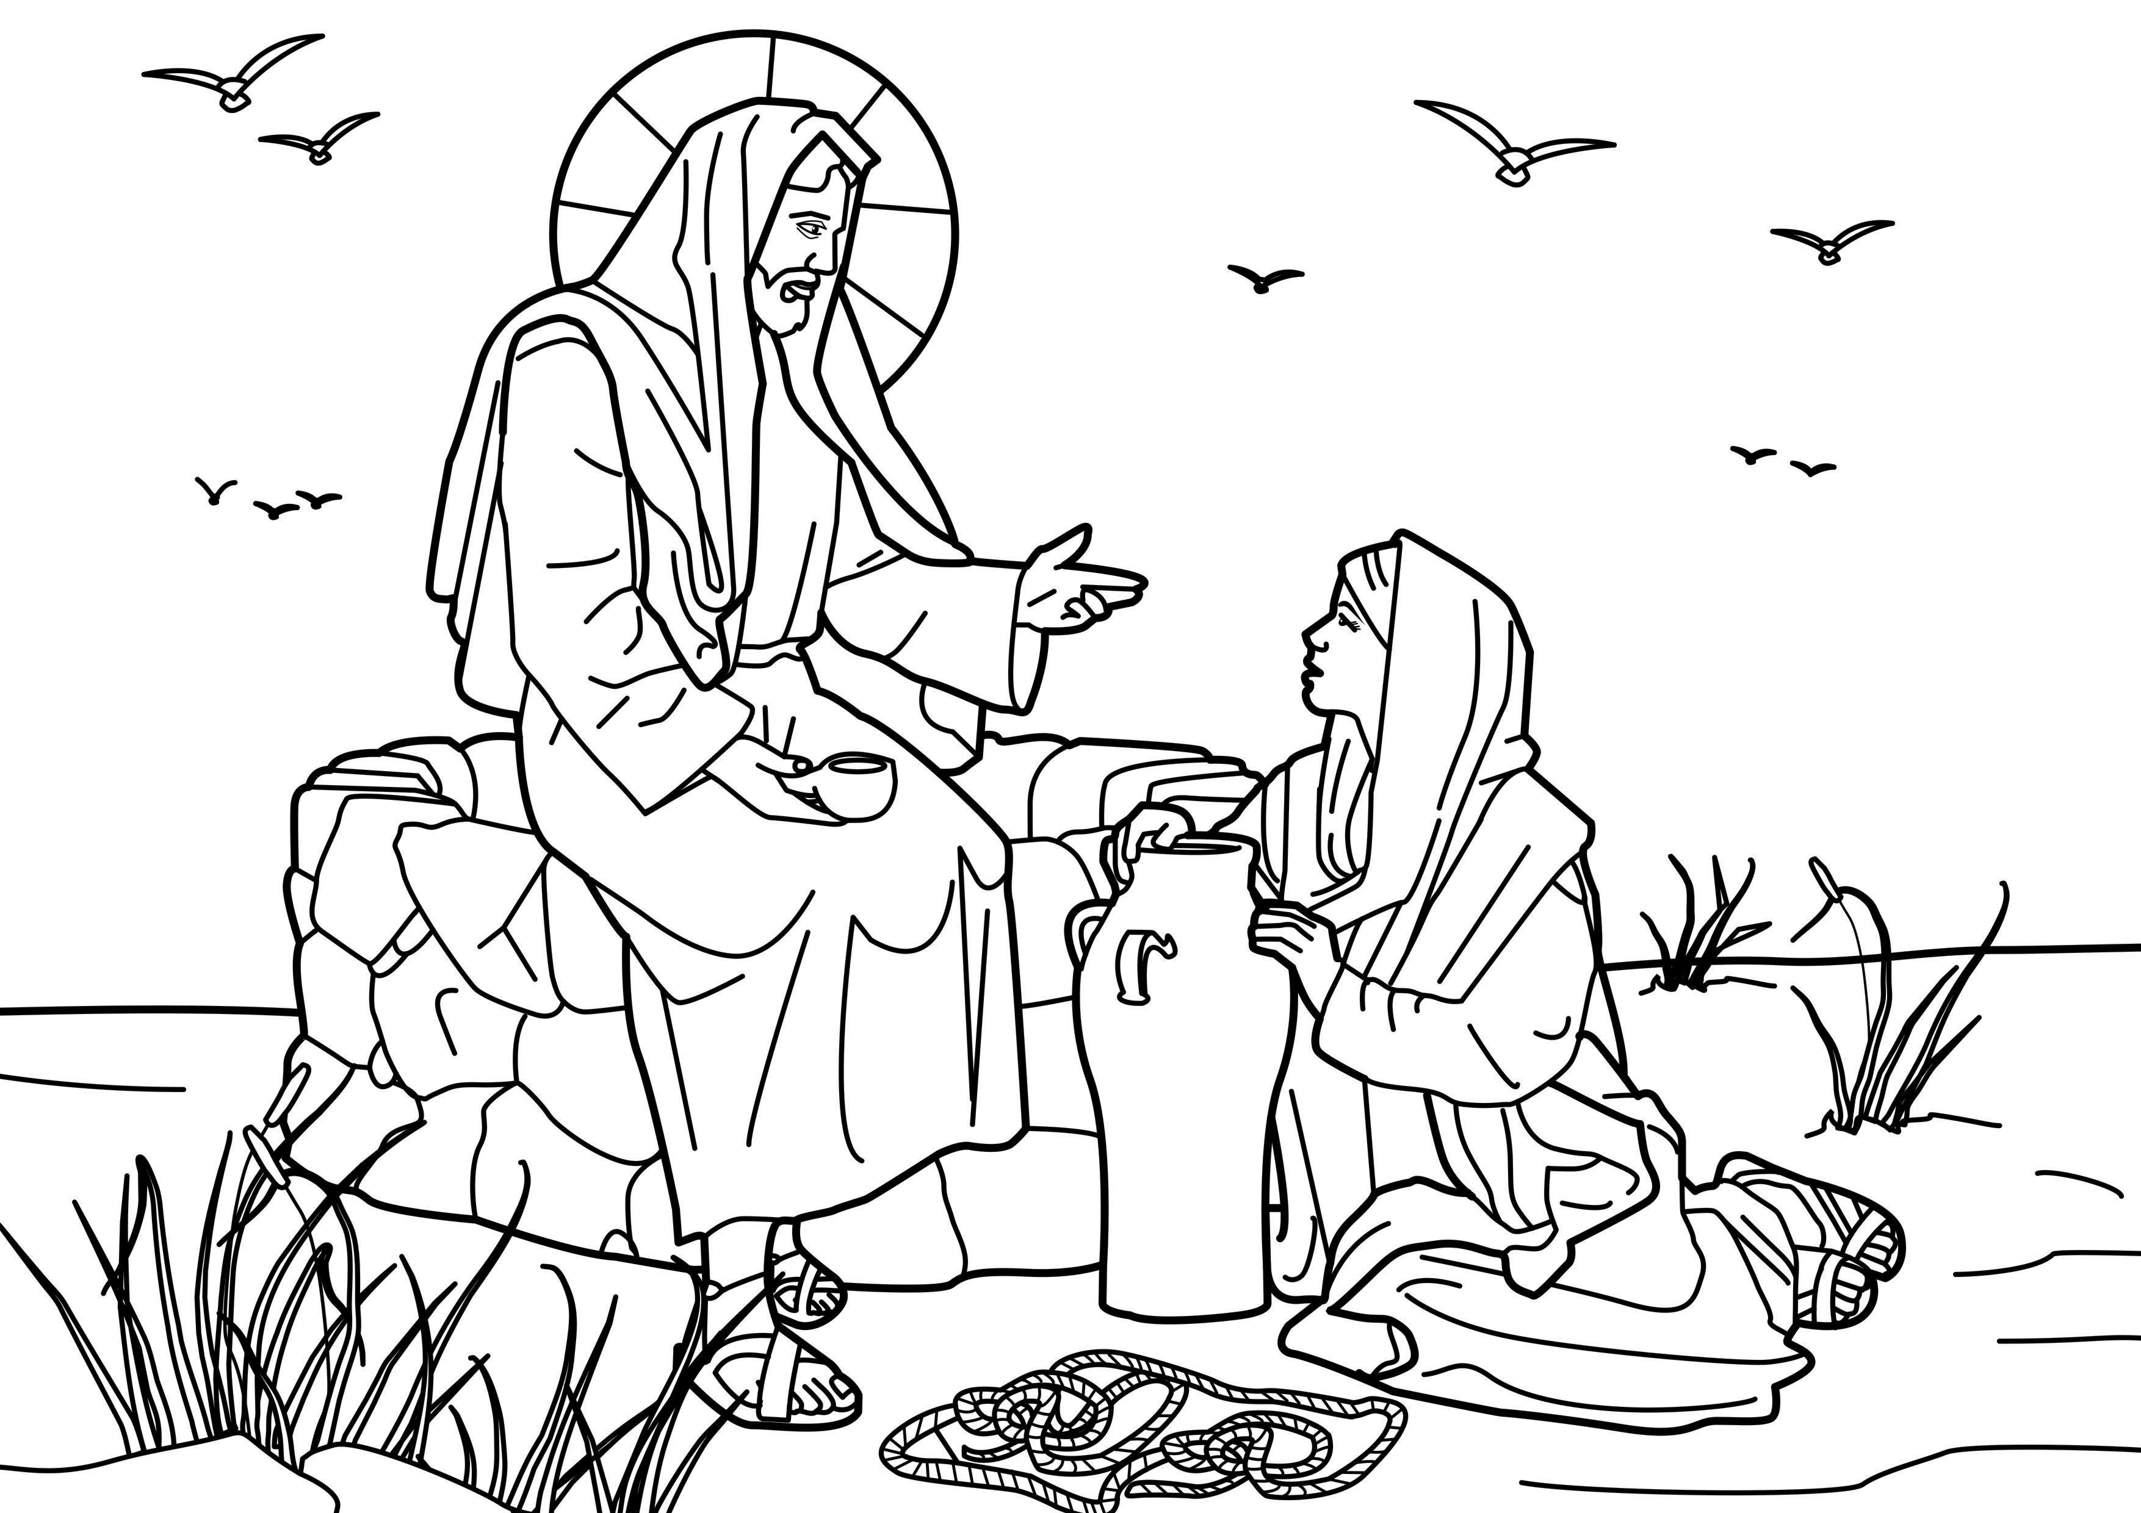
Mothering Sunday ( NEXT SUNDAY) : there will be a Cream Tea and Songs of Praise at 4 p.m. in the crypt. There are no tickets and no charge - all are welcome - including family and friends. Please sign the list at the back of church with the numbers who will be attending (please let us know TODAY ).

Vicar : Rev. Hugh Lervy

Tel. : (01792) 771329

Mobile : 07976 725644

e-mail : thevicar@lervy.net
Assistant Curate:
Rev. Andrew Perrin
Tel. 428080

Lent Collection : throughout Lent a collection plate will be placed on the table near the door. Donations given on this until Easter will be given the Bishop’s Lent Appeal for Charities.

Swansea Philharmonic Concert : Bach’s “St. John Passion” on Saturday 12th April in St. Mary’s Church. Swansea. Tickets are £12. Please speak to Eira for details or for tickets.

Parish Meal : on FRIDAY 2nd MAY ( 7 for 7.30 pm ) in Morriston Golf Club. All are welcome. The entertainment this year all be given by Rev. Eirian Wynn ( Minister of Seion Newydd and also a magician ). Eirian will be giving a magic show so the evening should also appeal to young members if you wish to bring them. Our Parish social events are a great time to get to know each other so if you haven’t been to one before why not come along. Details of food etc are on the poster. Please sign up as soon as you can if you wish to join us. Family and friends are also very welcome.

Annual Parish Meeting : Sunday 27th April following the morning service.

Fairtrade Easter Eggs : orders are now being taken. Please see Joan Lewis for details or to place orders. Don’t forget to take a look at the wide variety of Fairtrade goods available on the table at the back of church and help us keep our pledge to be a Fairtrade Church.

I love comfort food but the drink tastes like fabric softener!

