Parish of Morriston
St. David’s Church
Weekly Bulletin
www.churchinwales.org.uk
www.stdavidsmorriston.co.uk
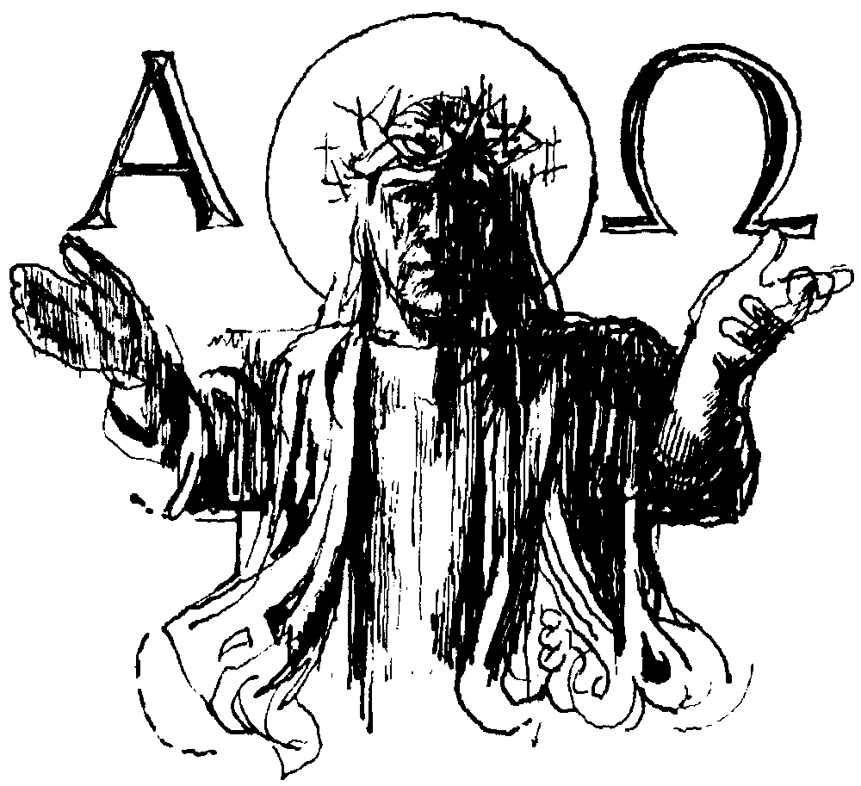

Vicar : Rev. Hugh Lervy

Tel. / Fax. : (01792) 771329

Mobile : 07976 725644

e-mail : thevicar@fsmail.net

Would you please let the Vicar know of people who
need visiting at home or in hospital. Thankyou

23rd November 2008 Today is the feast of Christ the King

Hymns at Eucharist : 375 , 362 , 54 , ( 736 , 608 , 244 ) , 252

TODAY 9.30 am Parish Eucharist with Sunday School

11.15 am Cymun Bendigaid

6.00 pm Evening Worship

MONDAY 10.00 am Parent and Toddler group
7.00 pm Core Skills training Course

TUESDAY 2.00 pm Mother’s Union. “My favourite things”

WEDNESDAY 7.00 pm Bible Study Group at 2 Mynydd Garnlwyd Rd.
- every fortnight – please ask for details

THURSDAY 10.30 am Holy Eucharist ( in the crypt )
Followed by a Charity coffee morning in aid
of Diabetes UK
6.00 pm Youth Club for school years 4,5,6 ( Crypt )
6.00 pm Clergy Surgery for booking of baptisms, banns and
weddings etc. No appointments necessary.

SATURDAY 8.30 am Bus leave church for Parish Shopping trip to
Cheltenham

FRIDAY 10.00 am Prayer fellowship Group

NEXT SUNDAY Advent Sunday
Readings : Is. 64:1-9 , 1 Cor. 1:3-9 , Mk. 13:24-37
9.30 am Parish Eucharist with Sunday School
11.15 am Baptism
5.00 pm Youth Service and Club
6.00 pm Advent service of Hymns, readings and prayers
Craft Morning : if you are able to assist with the craft morning for Children on 20th December we would be pleased to receive your help. There will be a short meeting at the end of the service next Sunday to discuss ideas.

Men's Society : will be holding a Christmas Dinner at The Welcome Inn on Tuesday, 2nd December . The cost of this 3 course meal is £14.00. Please see John Richardson(Tel 517606) for your choice of menu, which must be returned to him by 23rd November. All men are welcome.
The Link Christian Bookshop in Skewen has a sale on. Many books and gifts are half price. Lots of ideas for Christmas gifts.

Christmas Fete : Friday 5th December. If you have any items to donate they can be brought to the church. Thankyou. Raffle tickets are now available and help to sell them would be greatly appreciated. The Christmas Tree light will be switched on at 4.30 p.m. the same night during a short service. To sponsor a bulb in memory of a loved one forms are on the table near the door – raising funds for local children’s Charities.

Christmas Trip for Children : to see Santa at the Gwilli Railway on Sunday 7th December. The coach will leave St. David's at 12.30 p.m. and return by 4.30 p.m. Please see Diane Richardson( Tel. 517606). All children are welcome to join this trip.

Charity Coffee morning : in aid of Diabetes UK on Thursday 27th November from 11 a.m. Tickets are now available at £1.

Advent and Christmas Service Details : are now available. The Advent service of reflection will take place next Sunday at 6 p.m.

New Year Meal : Friday 9th January 2009 in THE BARN (behind Morriston Hospital ) at 7 p.m. for 7.30 p.m. A Three course meal is £11.50. All are welcome – please invite family and friends to come along - add your name to the list to book your places.

Morriston Rotary Club : have opened a charity shop ( near Phillips electrical ) for the Christmas period to raise funds for Charity and would appreciate any donations given to sell. They also have an open evening in Sherwood’s on 25th November at 6 p.m. if you would like to know more about their work or to become involved.

PDSA : shop in Morriston are very short of volunteers and have asked anyone who can spare some time to help out to let them know.

Thanks : David Morgans and his family would like to thank everyone who sent cards and good wishes through his recent ill health. We are all pleased to see David is now well on the road to recovery.

