26th January 2014

Today is the third
Sunday of Epiphany

Hymns at Eucharist : 625 , 436 , 259 , ( 738 , 144 , 304 ) , 646

TODAY 10.00 am Parish Eucharist with Sunday School

4.30 pm Baptism

6.00 pm Evensong

MONDAY 9.30 am Parent and Toddler group
7.30 pm Evening M.U. Speaker : Andre Scoville on
“Old Morriston”

TUESDAY 2.00 pm Mother’s Union

WEDNESDAY 7.30 pm Bible Study Group at 2 Mynydd Garnlwydd Road
(2nd and 4th Wednesday each month)

THURSDAY 10.30 am Holy Eucharist followed by tea / coffee
6.00 pm Youth Club for school years 4,5,6 ( Crypt )
6.00 pm Clergy Surgery for booking of baptisms, banns and
weddings etc. No appointments necessary.
7.30 pm Lay Visitor’s Training Course

FRIDAY 10.00 am Prayer Fellowship Group ( Crypt )
- all welcome
10.00 am Church working party - all welcome

NEXT SUNDAY Presentation of Christ in the Temple (Candlemas)
Mal. 3:1-5, Heb. 2:14-end, Lk. 2:22-40
10.00 am Family Eucharist led by the Sunday School
Followed by tea / coffee.

5.00 pm CONCERT for Chernobyl Children’s Lifeline

PARISH NOTES

Chernobyl Children’s Lifeline : a fundraising concert will be held here NEXT SUNDAY at 5 p.m. Details and Tickets available from Roy Gambold or committee members.

Area Deanery Conference : Sunday 9th February at 4.30 p.m. in St. David’s Church, Ystalyfera followed by Deanery Worship. the speaker will be Rev. Gary Green on “Practical Mission”. Please note there will be no Parish evening service on this Sunday as we hope you will be able to join us in Ystalyfera.

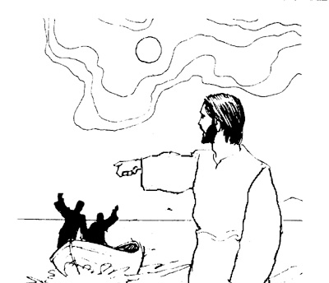
Evening Post Vouchers : are currently being printed for community Charities, The Patrons of Cardiac Rehab at Morriston Hospital are collecting these vouchers. If you wish can you please pass them to Grey Phillips who will pass them to the charity.
Parish of Morriston
Weekly Bulletin
St. David’s Church
www.churchinwales.org.uk
www.stdavidsmorriston.co.uk
Registered Charity : 1131686

Vicar : Rev. Hugh Lervy

Tel. : (01792) 771329

Mobile : 07976 725644

e-mail : thevicar@lervy.net
Assistant Curate:
Rev. Andrew Perrin
Tel. 428080

Annual Report : can I please ask those who run our various Parish groups if you can please submit articles for the Annual report by 16th February. Thankyou.

Smarties : thankyou to all who have returned Smarties Tubes and donations for the Children’s charities. If further donations are to be given could we please have them today.

Charity Coffee Mornings : the four charities chosen at PCC for us to support this year are : Open the Book Project , the Diocesan Widows Orphans and Dependents Society , the British Legion and The Pancreatic Cancer Research Fund. Details of these coffee mornings will be given as they are taking place.

Open Church : from March we are hoping to be able to open the church each morning again from 10 a.m. to 12 Midday. If anyone is able to help on a rota to open the church and welcome those who come in would you please let john Richardson know. Your help would be much appreciated.

Open the Book : if you would like to become involved in this project of sharing Bible stories with our local schools we need more volunteers. This is a wonderful project of Church outreach. Please speak to Diane Richardson or any of the current volunteers who will tell you how rewarding this project is ( it does not take large time commitment and full training and support is given).

A caller at the house said "Can I come in your house and talk about your carpets?" I thought "That's all I need, a Je-hoover's witness".

