19th January 2014

Today is the second
Sunday of Epiphany

WEEK OF PRAYER FOR CHRISTIAN UNITY

Hymns at Eucharist : 259 . 590 , 195 , ( 658 , 584 , 448 ) , 716

Psalm 40: 1 - 13 BCP p. 496

TODAY 10.00 am Parish Eucharist with Sunday School

4.30 pm PCC Meeting

6.00 pm Evensong

MONDAY 10.00 am Parent and Toddler group

TUESDAY 12.30 pm Mother’s Union Dinner ( Golf Club )
7.15 pm Council of Churches Christian Unity service in the
Chapel at Morriston hospital ( all welcome )

WEDNESDAY 7.30 pm Bible Study Group at 2 Mynydd Garnlwydd Road
(2nd and 4th Wednesday each month)

THURSDAY 10.30 am Holy Eucharist followed by tea /coffee
6.00 pm Youth Club for school years 4,5,6 ( Crypt )
6.00 pm Clergy Surgery for booking of baptisms, banns and
weddings etc. No appointments necessary.
7.30 pm Lay Visitors Training Course ( Crypt )

FRIDAY 10.00 am Church working party - all welcome

SATURDAY 7.00 pm Morriston Movie Night ( see notes )

NEXT SUNDAY Is. 9:1-4, 1 Cor. 1: 10-18 , Mt. 4:12-23
10.00 am Parish Eucharist with Sunday School

4.30 pm Baptism

6.00 pm Evensong

PARISH NOTES

Week of Prayer for Christian Unity ( 18th - 25th January) : the theme this year is “Is Christ Divided?”. During your prayers this week please pray for Unity amongst Christians.

PCC Meeting : today during this meeting we will be setting the dates and charities we will support at our coffee mornings this year. If you wish to nominate a charity please let the wardens.

Smarties : thankyou to all who have returned Smarties Tubes and donations for the Children’s charities. If further donations are to be given could we please have them by NEXT Sunday.

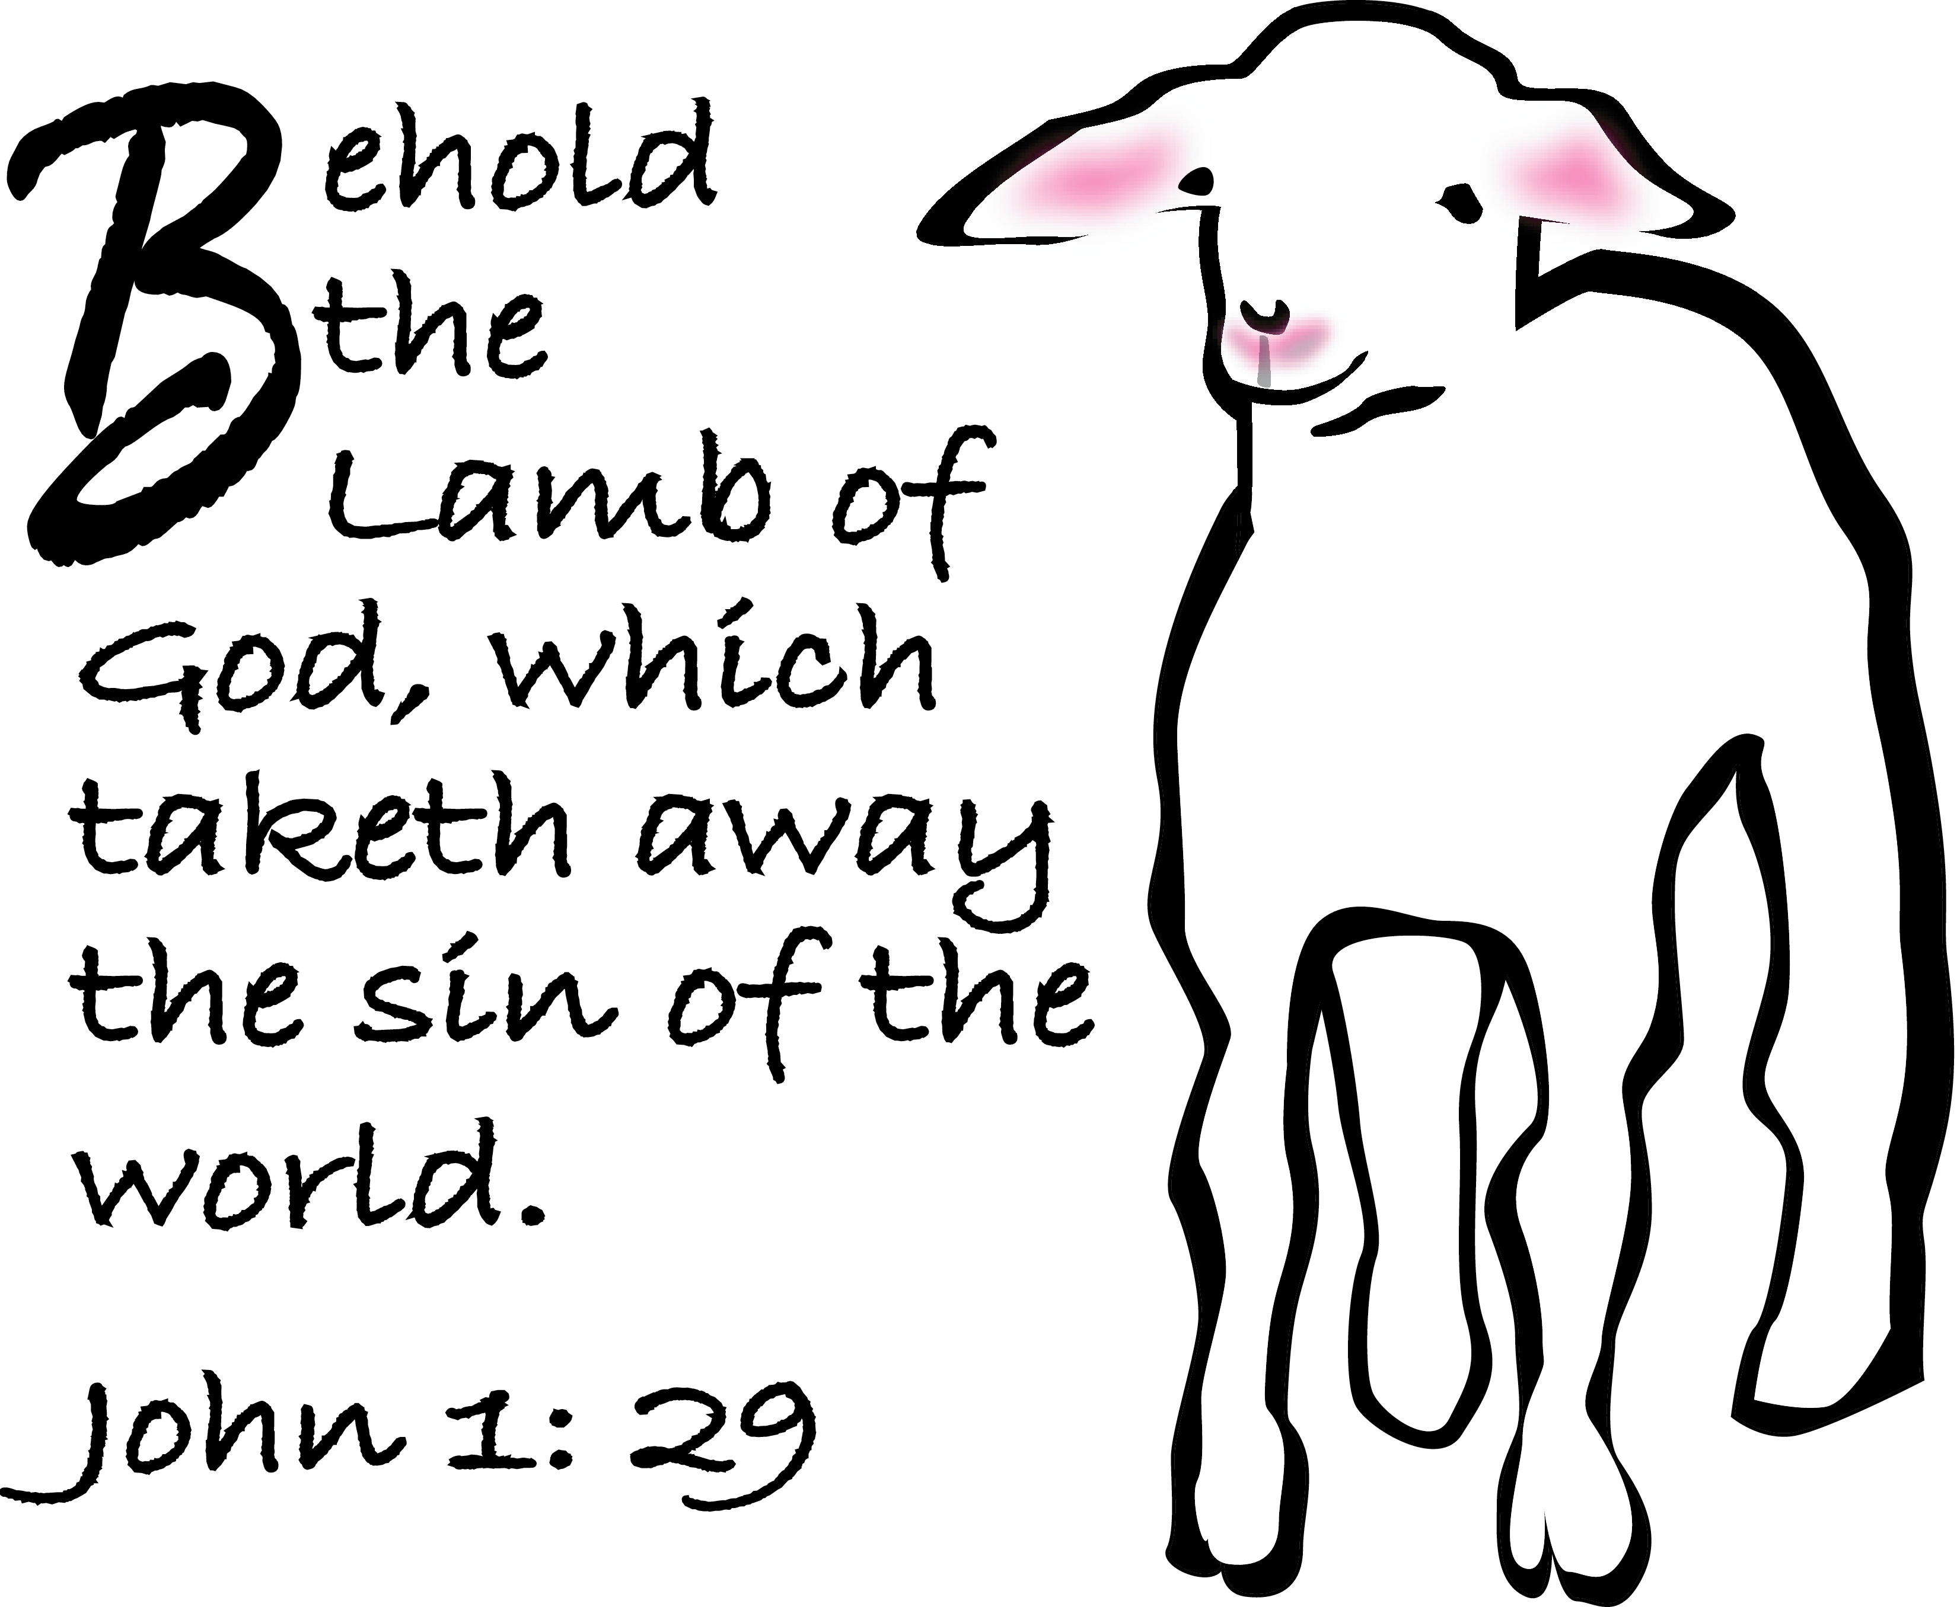
Ministry Area : proposals have been drawn up for the Ministry Area into which this Parish will fit in the future. There are two options : Option 1 would be Morriston, Llangyfelach and Llansamlet ( with Birchgrove and Glais ) Parishes becoming one ministry area. Option 2 would be Treboeth / Landore , Morriston, Llangyfelach and Penllegaer Parishes become one Ministry Area. Copies of the full proposals are available if you wish to receive a copy. If you wish to feedback YOUR thoughts on these proposals please do so ( preferably in writing ) to me by 9th February.
Parish of Morriston
Weekly Bulletin
St. David’s Church
www.churchinwales.org.uk
www.stdavidsmorriston.co.uk
Registered Charity : 1131686

Vicar : Rev. Hugh Lervy

Tel. : (01792) 771329

Mobile : 07976 725644

e-mail : thevicar@lervy.net
Assistant Curate:
Rev. Andrew Perrin
Tel. 428080

Morriston Movie Night : NEXT SATURDAY at 7 p.m. Andre Scoville will be repeating the very enjoyable and successful evening he held a few weeks ago. A DVD is shown with rare footage of memories of Morriston. Entry is just £1 and Andre is kindly donating all takings to our church funds.

Chernobyl Children’s Lifeline : a fundraising concert will be held here in St. David’s on Sunday 2nd February at 5 p.m. Details and Tickets available from Roy Gambold or committee members.

Area Deanery Conference : Sunday 9th February at 4.30 p.m. in St. David’s Church, Ystalyfera followed by Deanery Worship. the speaker will be Rev. Gary Green on “Practical Mission”. Please note there will be no Parish evening service on this Sunday as we hope you will be able to join us in Ystalyfera.

Evening Post Vouchers : are currently being printed for community Charities, The Patrons of Cardiac Rehab at Morriston Hospital are collecting these vouchers. If you wish can you please pass them to Grey Phillips who will pass them to the charity.

Annual Report : can I please ask those who run our various Parish groups if you can please submit articles for the Annual report by 16th February. Thankyou.

