22nd December 2013

Today is the fourth Sunday of Advent

Hymns at Eucharist : 128 , 45 , 406 , ( 411 , 690 , 297 ) , 405

TODAY 10.00 am Parish Eucharist with Sunday School

4.00 pm CHRISTINGLE AND NATIVITY SERVICE

LED BY OUR SUNDAY SCHOOL

- DO TRY AND JOIN US.

TUESDAY CHRISTMAS EVE

5.00 pm FAMILY EUCHARIST LED BY THE
SUNDAY SCHOOL

10.00 pm SUNG EUCHARIST

WEDNESDAY CHRISTMAS DAY

10.00 am HOLY EUCHARIST WITH CAROLS

THURSDAY 10.30 am NO MORNING SERVICE TODAY

NEXT SUNDAY Is. 63:7-9, Heb. 2:10-18, Mt. 2:13-23
10.00 am Parish Eucharist

No Evening service

PARISH NOTES

Thankyou : to all who were able to join us for our service of Christmas Praise last Sunday. It was a very meaningful and uplifting service.

Thankyou : to all who have helped prepare the Christingles and Church for our service today. DO TRY AND JOIN US AT 4 p.m.

200 Club Winners Christmas Draw: 1st. no. 36 John Stoker, 2nd no. 125 John Richardson, 3rd no. 68 Bruce Lervy. Congratulations to the winners.

Thankyou : Ael Y Bryn would like to thank all who have collected Evening Post Mini bus vouchers. If there are further vouched Alan Penhaligan would be pleased to take them to the home.

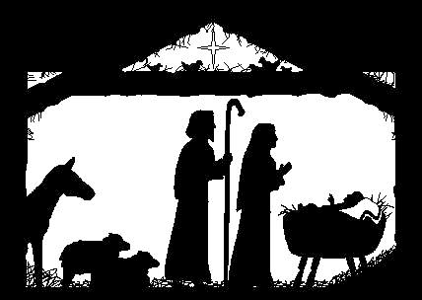

Sunday School : thankyou to all the teachers and Children who have worked so hard over Christmas. Sunday School will restart on the 12th January.
Parish of Morriston
Weekly Bulletin
St. David’s Church
www.churchinwales.org.uk
www.stdavidsmorriston.co.uk
Registered Charity : 1131686

Vicar : Rev. Hugh Lervy

Tel. : (01792) 771329

Mobile : 07976 725644

e-mail : thevicar@lervy.net
Assistant Curate:
Rev. Andrew Perrin
Tel. 428080

Collection Envelopes : for 2014 are now available. Thankyou to all who give regularly and so generously to our Church funds.

Flower Rota 2014 : the new list is now up in the porch. If anyone would like flowers for a particular date please fill in your name on the list. The donation is still £10. Please see one of our Flower arrangers for details. Thankyou very much to the ladies who prepare our flowers so well each week,

Advent Smarties Collection : thankyou to all who are collecting your 20p pieces in the Smarties tubes. These can be returned to church at any of our Christmas Services.

Lay Training Course : thankyou to those who wish to follow this course. The training will take place on Thursday evenings at 7.30 p.m. on the following dates : January 9th, 16th, 23rd and 30th and February 6th, 13th and March 6th.

PCC Meeting : Sunday 19th January at 4.30 p.m.

HAPPY CHRISTMAS :
to you and your families from the Clergy and Officers of St. David’s. Do try and join us for our Christmas Services this week. Thankyou for all the support you have
given the Parish throughout the year.

