8th December 2013

Today is the second
Sunday of Advent

Hymns at Eucharist : 480 , 265 , 221 , ( 323 , 359 , 582 ) , 646

TODAY 10.00 am Parish Eucharist with Sunday School

6.00 pm Evensong

MONDAY 9.30 am Parent and Toddler group
7.30 pm Evening M.U. Christmas Dinner

TUESDAY 6.30 pm Men’s Society Christmas Dinner ( The Eagle )

WEDNESDAY 7.00 pm Carol Service for the bereaved. All are
welcome to come to this service.
7.30 pm Bible Study Group at 2 Mynydd Garnlwydd Road
(2nd and 4th Wednesday each month)

THURSDAY 10.30 am Holy Eucharist followed by tea / coffee
12.30 pm Funeral of Gordon Grey ( Crematorium)
6.00 pm Youth Club for school years 4,5,6 ( Crypt )
6.00 pm Clergy Surgery for booking of baptisms, banns and
weddings etc. No appointments necessary.

FRIDAY 10.00 am Church working party - all welcome

SATURDAY 10.00 am Christmas Craft morning for children -All welcome
2.00 pm Sunday School trip to the Pantomime.

NEXT SUNDAY Is. 35:1-10, James. 5:7-10, Mt. 11:2-11
10.00 am Parish Eucharist with Sunday School

6.00 pm CHRISTMAS PRAISE SERVICE WITH THE

SALVATION ARMY AND THE BAY CHOIR .

DO COME ALONG !

Carol Service for the bereaved : organised by the Hospital Chaplaincy Department will take place here on WEDNESDAY this week at 7 p.m. All are welcome.

Thankyou : to all who worked so hard for and supported our Christmas fete on Friday. We will let you now how much was raised on next week’s bulletin.

Craft Morning for all children : NEXT Saturday from 10 am. to 12 midday. A short meeting will held at the end of our service today Sunday for those able to help out.

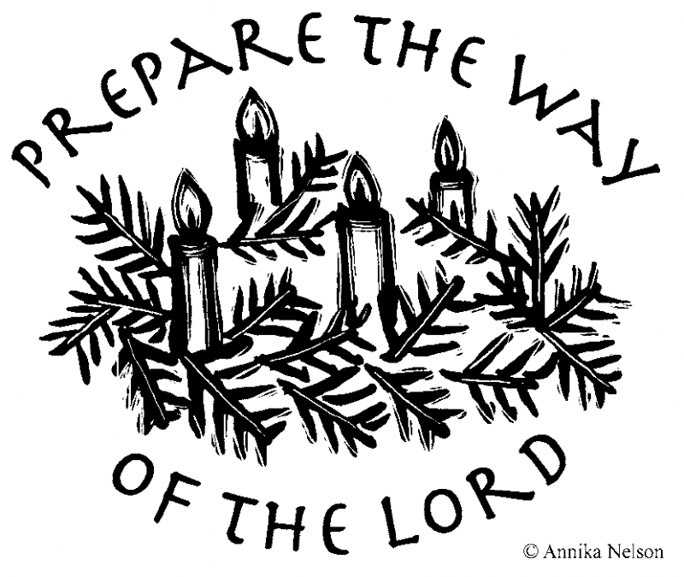
Christmas Praise : an uplifting service where we will be joined by the Salvation Army and the Swansea Bay Choir will take place NEXT Sunday at 6 p.m. - All Welcome.
Parish of Morriston
Weekly Bulletin
St. David’s Church
www.churchinwales.org.uk
www.stdavidsmorriston.co.uk
Registered Charity : 1131686

Vicar : Rev. Hugh Lervy

Tel. : (01792) 771329

Mobile : 07976 725644

e-mail : thevicar@lervy.net
Assistant Curate:
Rev. Andrew Perrin
Tel. 428080

Christingle and Nativity Service : Sunday 22nd December at 4 p.m. ( help to put the Christingle together on Saturday 21st December at 10 am. would be appreciated ).

Christmas Eve Services : 5 p.m. a Family Eucharist led by our Sunday School. 10 p.m. Holy Eucharist ( Midnight Mass ) Christmas Day Service : 10.00 a.m. Holy Eucharist with Carols. Please note there will be no midweek Eucharist on Boxing Day ( 26th December ) and no evening services on Sunday 29th December or Sunday 5th January - morning services take place as usual on these Sundays.

Christmas Cards : a board is now available at the back of church if you wish to place a card on it to your friends in church.

Advent Smarties Collection : once again we are asking through December if you would like to collect your 20p pieces in the Smarties tubes. These can then be returned to church at our Christmas Services and will be distributed amongst local Children’s Charities.

RIP : we extend our love and prayers to the family of Gordon Grey (one of our Thursday morning communicants ). May the souls of the departed through the love and mercy of God rest in peace.

Welsh Readers : if you are not yet on a rota of Welsh readers and would like to be please let Roy Gambold know as soon as you can.

Thankyou : to Andre Scoville who hosted an excellent evening of film of various aspects of Morriston’s past. Andrew kindly donated the taking from the evening to our church funds.

Lay Training Course : thankyou to those who wish to follow this course. The training will take place on Thursday evenings at 7.30 p.m. on the following dates : January 9th, 16th, 23rd and 30th and February 6th, 13th and March 6th.

