24th November 2013

Today is the feast of
Christ the King

Hymns at Eucharist : 408 , 436 , 580 , ( 644 , 67 , 137 ) , 438

TODAY 10.00 am Parish Eucharist with Sunday School

6.00 pm Evensong

MONDAY 10.00 am Parent and Toddler group
7.30 pm Evening M.U. Cookery Demonstration by
Margaret Miles

TUESDAY 2.00 pm Mother’s Union : “Baywood Belles”

WEDNESDAY 7.30 pm Bible Study Group at 2 Mynydd Garnlwydd Road
(2nd and 4th Wednesday each month)

THURSDAY 10.30 am Holy Eucharist ( crypt ) followed by a
Charity Coffee Morning in aid of the
Parkinson’s Society
6.00 pm Youth Club for school years 4,5,6 ( Crypt )
6.00 pm Clergy Surgery for booking of baptisms, banns and
weddings etc. No appointments necessary.

FRIDAY 10.00 am Prayer Fellowship Group - all welcome

SATURDAY 12.00 pm Diocesan Mission and Ministry Service
( Cathedral) - all welcome
7.00 pm An evening of slides and Video of Old Morriston
given by Andre Scoville ( see notes )

NEXT SUNDAY ADVENT SUNDAY
is. 2:1-5, Rom. 13:11-14, Mt. 24:36-44
10.00 am Family Eucharist followed by tea / coffee

6.00 pm Deanery Advent Service led by Canon

George Bennett/ “A reflection on Change”.

ALL WELCOME.

PARISH NOTES

Christmas Shopping trip : there are some spaces left on the bus to Cheltenham on 7th December leaving Church at 8.30 a.m. and return from Cheltenham at 5.30 p.m. The cost will be £13.50 per person. Please see Jane Gimlett to book your place. Family and friends are welcome. £5 deposit please.

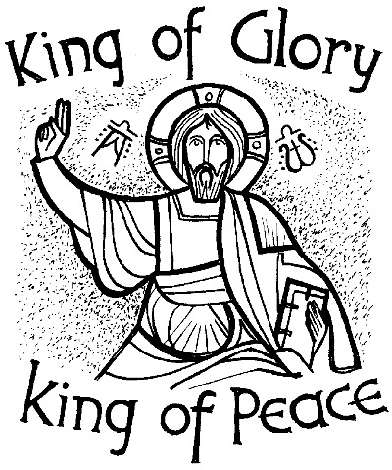
Remembering Morriston : an evening of photos / video and local knowledge will be led by Andre Scoville in our Crypt next Saturday evening from 7 p.m. Entry is £1 and Andre is kindly donating the proceeds to our church funds. Do try and come along.
Parish of Morriston
Weekly Bulletin
St. David’s Church
www.churchinwales.org.uk
www.stdavidsmorriston.co.uk
Registered Charity : 1131686

Vicar : Rev. Hugh Lervy

Tel. : (01792) 771329

Mobile : 07976 725644

e-mail : thevicar@lervy.net
Assistant Curate:
Rev. Andrew Perrin
Tel. 428080

Disaster Box: If you wish to make a donation for the people of the Philippines we will send a further donation in the coming weeks.

Charity Coffee Morning : in aid of the Parkinson’s Society -following the morning service on Thursday this week. Tickets are £1 and are now available - help to sell them would be much appreciated

Thankyou: to all who supported the “Samaritan’s Purse”. 127 shoeboxes filled with gifts have been sent from the church. Many thanks to Judith and all who worked so hard to make this happen.

Thankyou : to all who were able to support the coffee morning in aid of the Pancreatic Cancer Research fund on Friday.

Tree of Light : will be switched on with carol singing on Friday 6th December at 4.30 p.m. If you with to sponsor a bulb in memory of a loved one forms are now available. Please return the form to the address given on the leaflet ( not to church). Thankyou.

Christmas Fete : will take place on Friday 6th December at 5 p.m. Throughout November we are collecting items for the raffle and for the stalls. Items required include crafts / toiletries/ tins etc. If you have any new ideas for stalls or can help out we would be VERY pleased to hear from you ! RAFFLE TICKETS NOW AVAILABLE.

Advent and Christmas : leaflets are now available with details of services in the coming weeks. Please help to distribute them as widely as you can around the Parish.

Carol Service for the bereaved : organised by the Hospital Chaplaincy Department will take place here on Tuesday 10th December at 7 p.m. All are welcome.

Craft Morning for all children : Saturday 14th December form 10 am. to 12 midday. Please speak to Jill if you can help out.

