17th November 2013

Today is the Second Sunday before Advent ( Kingdom 3 )

Hymns at Eucharist : 741 , 105 , 108 , ( 437 , 150 , 315 ) , 684

Psalm 98 BCP p. 579

TODAY 10.00 am Parish Eucharist with Sunday School

11.30 am Baptisms

6.00 pm Evensong

MONDAY 9.30 am Parent and Toddler group
9.45 am Deanery Clergy Chapter Mtg. ( Pontardawe)

TUESDAY 2.00 pm Mother’s Union : Holy Eucharist

WEDNESDAY 2.15 pm Funeral of Robert Williams (Church)
7.30 pm Bible Study Group at 2 Mynydd Garnlwydd Road
(2nd and 4th Wednesday each month)

THURSDAY 10.30 am Holy Eucharist followed by tea / coffee
6.00 pm Youth Club for school years 4,5,6 ( Crypt )
6.00 pm Clergy Surgery for booking of baptisms, banns and
weddings etc. No appointments necessary.

FRIDAY 9.30 am Cwmrhydyceirw School Church Visit “Wedding”
10.00 am Church working party - all welcome
10.30 am Coffee Morning in aid of Pancreatic Cancer
Research Fund ( Crypt )

NEXT SUNDAY Christ the King
Jer. 23:1-6, Col. 1:11-20, Lk. 23:33-43
10.00 am Parish Eucharist with Sunday School

6.00 pm Evensong

Christmas Shopping trip : to Cheltenham on 7th December leaving Church at 8.30 a.m. and return from Cheltenham at 5.30 p.m. The cost will be £13.50 per person. Please see Jane Gimlett to book your place. Family and friends are welcome. £5 deposit please.

Disaster Box: thankyou to all who give regularly through the Disaster Box at the back of church. We have sent a donation to the Red Cross for their work with the people of the Philippines. If you wish to make a donation we will send a further donation in the coming weeks.


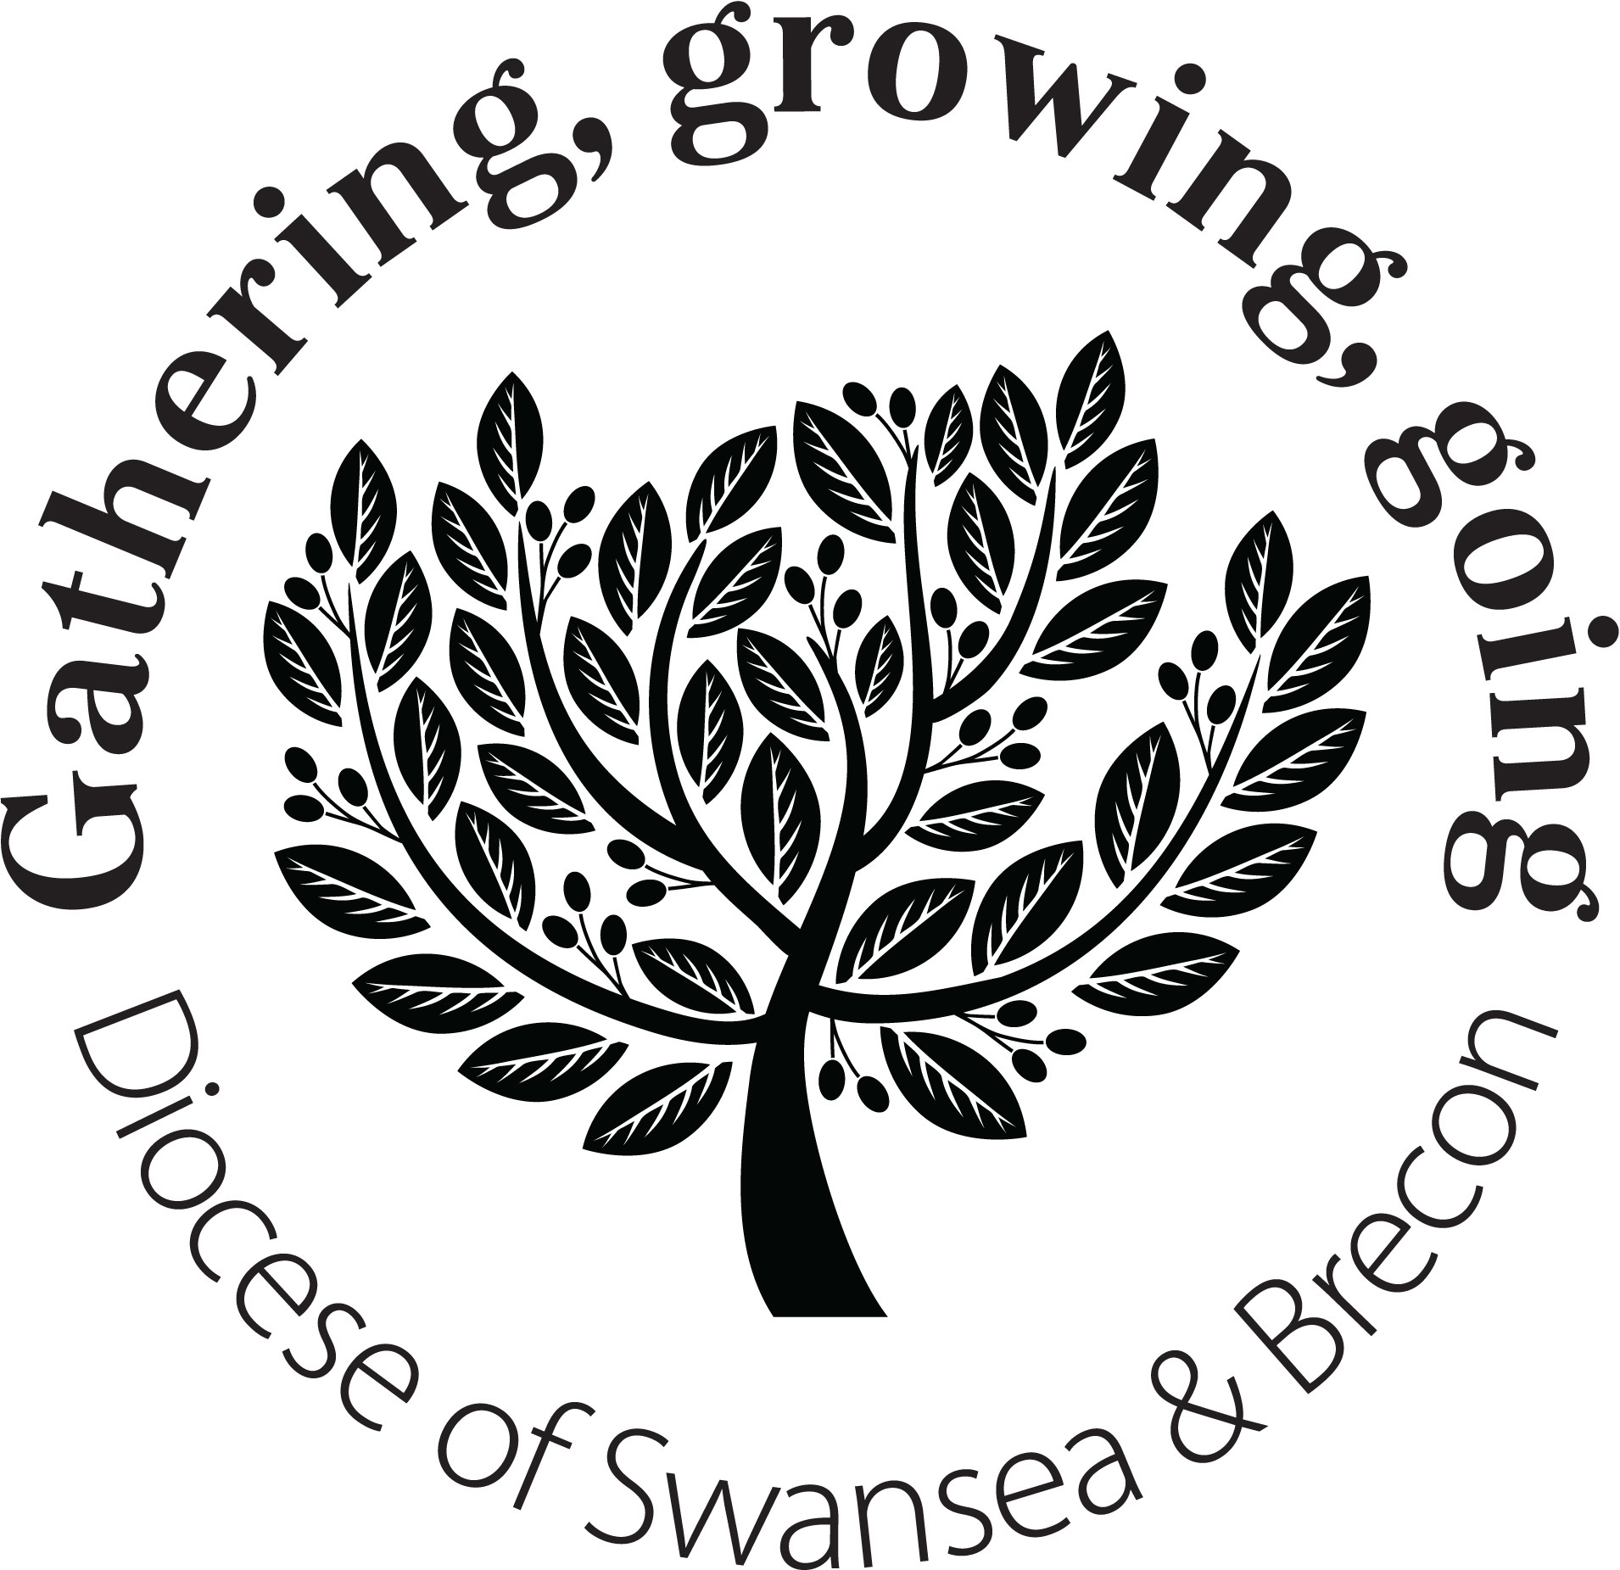
Swansea Philharmonic Choir : “Christmas Music by Candlelight” will take place on Saturday 7th December at 7.30 p.m. in St. Mary’s Church, Swansea. For details and tickets please speak to Eira.
Parish of Morriston
Weekly Bulletin
St. David’s Church
www.churchinwales.org.uk
www.stdavidsmorriston.co.uk
Registered Charity : 1131686

Vicar : Rev. Hugh Lervy

Tel. : (01792) 771329

Mobile : 07976 725644

e-mail : thevicar@lervy.net
Assistant Curate:
Rev. Andrew Perrin
Tel. 428080

Charity Coffee Morning : in aid of the Parkinson’s Society -following the morning service on Thursday 28th November. Tickets are £1 and are now available - help to sell them would be much appreciated.

Coffee Morning : next Friday in aid of Pancreatic Cancer Research. Entry is £2. It is being organised by Mair Jones. Mair has asked me to say that if anyone can provide caked to sell it would be appreciated.

Tree of Light : will be switched on with carol singing on Friday 6th December at 4.30 p.m. If you with to sponsor a bulb in memory of a loved one forms are available. Please return the form to the address given on the leaflet ( not to church). Thankyou.

Christmas Fete : will take place on Friday 6th December at 5 p.m. Throughout November we are collecting items for the raffle and for the stalls. Items required include crafts / toiletries/ tins etc. If you have any new ideas for stalls or can help out we would be VERY pleased to hear from you ! RAFFLE TICKETS NOW AVAILABLE. PLEASE TAKE A BOOK OR TWO TO SELL !

Diocesan Mission and Ministry Festival: in the Cathedral on Saturday 30th November at 12 Midday. If you would like to attend please let me know.

Deanery Advent Service : will take place here on Sunday 1st December at 6 p.m. It will be a reflection on “Change” and will be led by Canon George Bennett. All are welcome to join us for this service.

Traidcraft : the Christmas Catalogue is on the Traidcraft table at the back of church. Please take a copy - orders should be placed with Joan Lewis as soon as possible.

Advent and Christmas : leaflets are now available with details of services in the coming weeks. Please help to distribute them as widely as you can around the Parish.

