3rd November 2013

Today is the fourth Sunday before Advent ( Kingdom 1 )

Hymns at Eucharist : 676 , 212 , 314 , ( 77 , 541 , 752 ) , 551

TODAY 10.00 am Family Eucharist led by our Sunday School

Followed by tea / coffee - all welcome

11.30 am Baptism

6.00 pm Holy Eucharist for All Souls

MONDAY 9.30 am Parent and Toddler group

TUESDAY 2.00 pm Mother’s Union : Speaker : Paul Hopkins on
“The Grand Theatre”
6.30 pm Men’s Society at the Eagle

WEDNESDAY 11.00 am Funeral of Ken Paddison ( Church)
6.45 pm Diocesan Safeguarding Training Evening at
St. Illtyd’s Church, Fforestfach.
7.30 pm Bible Study Group at 2 Mynydd Garnlwydd Road
(2nd and 4th Wednesday each month)

THURSDAY 10.30 am Holy Eucharist followed by tea / coffee
6.00 pm Youth Club for school years 4,5,6 ( Crypt )
6.00 pm Clergy Surgery for booking of baptisms, banns and
weddings etc. No appointments necessary.
7.00 pm Holy Eucharist

FRIDAY 10.00 am Church working party - all welcome

NEXT SUNDAY REMEMBRANCE SUNDAY
Job. 19:23-27, 2 Thes. 2:1-17, Lk. 20:27-38
10.00 am Parish Eucharist with Sunday School

6.00 pm Evensong

Christmas Shopping trip : to Cheltenham on 7th December leaving Church at 8.30 a.m. and return from Cheltenham at 5.30 p.m. The cost will be £13.50 per person. Please see Jane Gimlett to book your place. Family and friends are welcome. £5 deposit please.

Christmas Boxes : if you wish to donate items for the Christmas “Shoeboxes” they need to be brought to church by NEXT SUNDAY. Small gifts / toiletries / toys etc. Please speak to Judith Scott for full details. Leaflets are available of the table near the door about the Charity “Samaritan Boxes”.

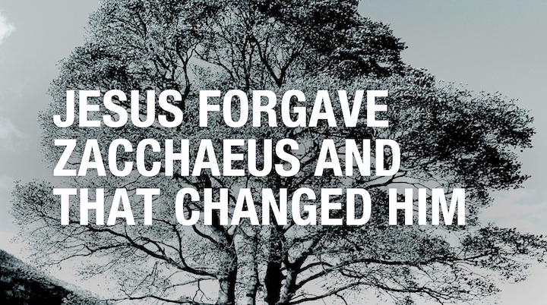
Charity Coffee Morning : in aid of the Parkinson’s Society will take following the morning service on Thursday 28th November. Tickets are £1 and are now available - help to sell them would be much appreciated.
Parish of Morriston
Weekly Bulletin
St. David’s Church
www.churchinwales.org.uk
www.stdavidsmorriston.co.uk
Registered Charity : 1131686

Vicar : Rev. Hugh Lervy

Tel. : (01792) 771329

Mobile : 07976 725644

e-mail : thevicar@lervy.net
Assistant Curate:
Rev. Andrew Perrin
Tel. 428080

Thankyou : to all who helped at the half term Craft morning.

All Soul’s Service : to remember the departed will take place at 6 p.m. TONIGHT. If you would like anyone remembered by name please print their names on the list at the back of church - but also try and join us for the service.

Remembrance Sunday : Next Sunday. An act of remembrance will take place during our 10 a.m. service.

Traidcraft : the Christmas Catalogue is on the Traidcraft table at the back of church. Please take a copy - orders should be placed with Joan Lewis as soon as possible.

Adrian and Bridget Plass : the well known Christian writers will be holding a weekend retreat in St. Paul’s Church , Sketty on 23rd / 24th November. Please ask for details or see the Diocesan Vision Website.

Home Communions : with so many still unable to join us in Church through health issues can I remind you that communion can be brought to your home if requested. Please let the Vicar know if anyone would like to be placed on the list.

Christmas Fete : will take place on Friday 6th December at 5 p.m. Throughout November we are collecting items for the raffle and for the stalls. Items required include crafts / toiletries/ tins etc. If you have any new ideas for stalls or can help out we would be VERY pleased to hear from you !

Diocesan Mission and Ministry Festival: in the Cathedral on Saturday 30th November at 12 Midday. If you would like to attend please let me know.

Deanery Advent Service : will take place here on Sunday 1st December at 6 p.m. It will be a reflection on “Change” and will be led by Canon George Bennett. All are welcome to join us for this service.

