20th October 2013

Today is the twenty-first Sunday after Trinity

Hymns at Eucharist : 636 , 69 , 420 , ( 202 , 635 , 517 ) , 684

Psalm : 121 BCP p. 625

TODAY 10.00 am Parish Eucharist with Sunday School

11.30 am Baptism

6.00 pm Evensong

MONDAY 9.30 am Parent and Toddler group

TUESDAY No Mother’s Union today.

WEDNESDAY 7.30 pm Bible Study Group at 2 Mynydd Garnlwydd Road
(2nd and 4th Wednesday each month)

THURSDAY 10.30 am Holy Eucharist followed by tea / coffee
6.00 pm Youth Club for school years 4,5,6 ( Crypt )
6.00 pm Clergy Surgery for booking of baptisms, banns and
weddings etc. No appointments necessary.

FRIDAY 10.00 am Church working party - all welcome

SATURDAY Clocks go back one hour tonight

NEXT SUNDAY Ecc. 35:12-17, 2 Tim. 4:6-18, Lk. 19:9-14
10.00 am Parish Eucharist with Sunday School

6.00 pm Evensong

PARISH NOTES

Christmas Shopping trip : to Cheltenham on December the 7th leaving Church at 8.30 a.m. and return from Cheltenham at 5.30 p.m. The cost will be £13.50 per person. Please see Jane Gimlett to book your place. Family and friends are welcome. £5 deposit please.

Thankyou : our curate Andrew and his family have asked me to convey their thanks to all for the prayers and support shown following the passing away of Andrew’s father.

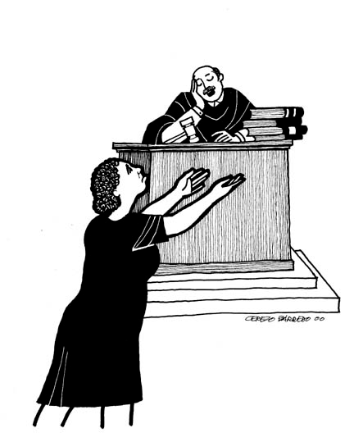
Christmas Boxes : if you wish to donate items for the Christmas “Shoeboxes” they need to be brought to church by 17th November. Small gifts / toiletries / toys etc. Please speak to Judith Scott for full details. Leaflets are available of the table near the door about the Charity “Samaritan Boxes”.
Parish of Morriston
Weekly Bulletin
St. David’s Church
www.churchinwales.org.uk
www.stdavidsmorriston.co.uk
Registered Charity : 1131686
Vicar : Rev. Hugh Lervy
Tel. : (01792) 771329
Mobile : 07976 725644
e-mail : thevicar@lervy.net

Assistant Curate:
Rev. Andrew Perrin
Tel. 428080

Evening Post Vouchers: are being collected by Ael Y Bryn Nursing Home to try and win a mini bus. If you wish to give your vouchers to this cause please pass them to Alan Penhaligan.

Half Term Craft Morning : will take place on Friday 1st November from 10 a.m. to 12 midday in the crypt. If you can help out please speak to Jill or Barbara.

Open the Book: new volunteers are being sought for those who would like to help with leading assemblies in our local schools. For details please speak to Diane Richardson or one of our existing volunteers. This is excellent outreach for us as a church - training will be given and you will be part of a team.

Bible Study Group: would anyone like to lead a Bible Study Group in Church? If this is something you would like to explore please let me know. Thankyou.

All Soul’s Service : to remember the departed will take place at 6 p.m. on Sunday 3rd November. If you would like anyone remembered by name please print their names on the list at the back of church.

Diocesan Safeguarding Training Evening : on Wednesday 6th Nov. at 6.45 p.m. in St. Illtyd’s Church Fforesfach. If you would like to attend please let me know.

Remembrance Sunday : 10th November. An act of remembrance will take place during our 10 a.m. service.

For Sale: Parachute. Only used once, never opened.

