8th September 2013

Today is the fifteenth Sunday after Trinity

Hymns at Eucharist : 120 , 541 , 626 , ( 539 , 23 , 92 ) , 503

TODAY 9.30 am Parish Eucharist with Sunday School

2.00 pm Baptism

4.30 pm Confirmation Class

6.00 pm Evensong

MONDAY 10.00 am Parent and Toddler group RESTARTS
7.30 pm Evening M.U. : Speaker : Lawrence Morrisey on
“The National Remembrance Arboretum”

TUESDAY 2.00 pm Mother’s Union Open Meeting and welcome back.
7.15 pm Council of Churches Meeting (Aenon)

WEDNESDAY 7.30 pm Bible Study Group at 2 Mynydd Garnlwydd Road
(2nd and 4th Wednesday each month)

THURSDAY 10.30 am Holy Eucharist
Followed by refreshments in the crypt
6.00 pm Clergy Surgery for booking of baptisms, banns and
weddings etc. No appointments necessary.

FRIDAY 10.00 am NEARLY NEW SALE ( See notes )
10.00 am Church working party - all welcome

SATURDAY 12.00 pm Service at Brecon Cathedral to celebrate the
90th Anniversary of our Diocese

NEXT SUNDAY Readings : Ex. 32:7-14, 1 Tim. 1:12-17, Lk. 15:1-10
9.30 am Parish Eucharist
with Sunday School WELCOME BACK PARTY
4.30 pm Deanery Conference at St. Peter’s Church, Pontardawe on
“Changing uses of Church Buildings”. followed by Deanery
worship at 6 p.m.
6.00 pm Please note there will be evening service in St. David’s.

PARISH NOTES

NEARLY NEW SALE : next Friday in the crypt from 10 a.m. to 12 midday. Items to sell can be brought to the crypt from 9 a.m.. If you can help sell items please let Rita. Barbara or Jill know. Thankyou.

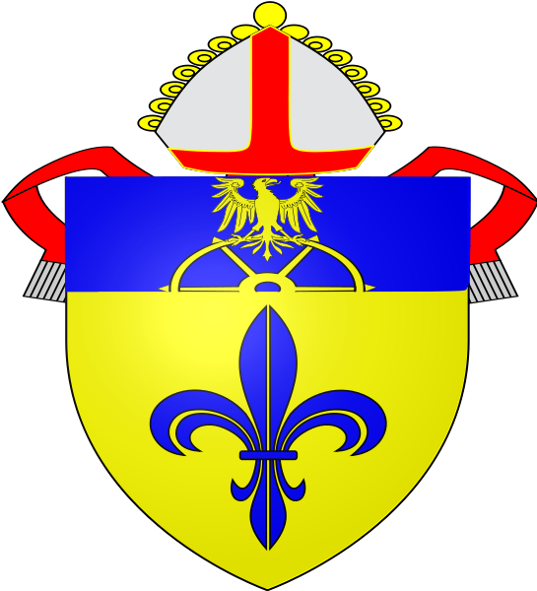

Thankyou : Elizabeth West and family would like to thank everyone for their prayers and support during their recent bereavement.
Parish of Morriston
Weekly Bulletin
St. David’s Church
www.churchinwales.org.uk
www.stdavidsmorriston.co.uk
Registered Charity : 1131686
Vicar : Rev. Hugh Lervy
Tel. : (01792) 771329
Mobile : 07976 725644
e-mail : hughlervy@sky.com

Assistant Curate:
Rev. Andrew Perrin
Tel. 428080
The Church is open Monday to Friday from 10 a.m. to 12 Midday for private prayer
and quietness.

PCC Meeting : Sunday 29th September at 4.30 p.m.

Happy “special” Birthday : to Iris for Tuesday this week. With love from all your Church family.

Youth Club : restarts on Thursday 19th September.

DON’T FORGET: that from 22 SEPTEMBER our morning service will move to 10 a.m.

200 Club Subscriptions : for the next year are now due. It is £20 for the year and should be paid by the end of September please. If you want to know details of the 200 club please ask. Family and friends are welcome to join.

Charity Coffee Morning : in aid of Ty Olwen will take place on Thursday 19th September following our mid-week 10.30 Eucharist. Tickets are now available. Please try and give your support.

Confirmation Service : Bishop John will join us at 10 a.m. on Sunday 22nd September. Do try and join us and please remember those to be confirmed in your prayers.

Induction service : Canon Dewi Roberts will be inducted as Vicar of St. Cynog’s , Ystradgynlais on Thursday 26th September at 7 p.m.

Home Communion and visiting : please let the clergy know of visits that are needed - esp. with so many currently unable to join us for worship - it is difficult keeping track of everyone !! please help !! Do keep in touch with those who are missing. In the coming weeks we will be starting training for a lay-visiting team when hopefully we will be able to make more home visits.

Harvest Festival : Sunday 6th October. 10 a.m. Family Eucharist 6 p.m. Harvest Evensong ( Guest Preacher : Rev. Steven Bunting ).

